Increase size of each picture as needed so that students can see and use images as needed.

Some Examples of Different Teachers: Can You Guess?

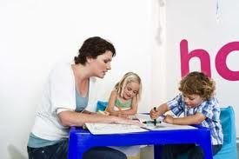
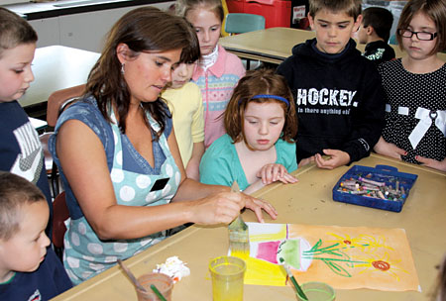
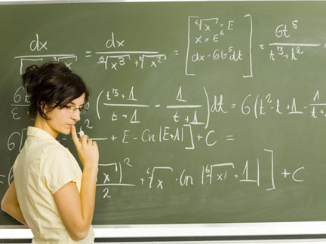
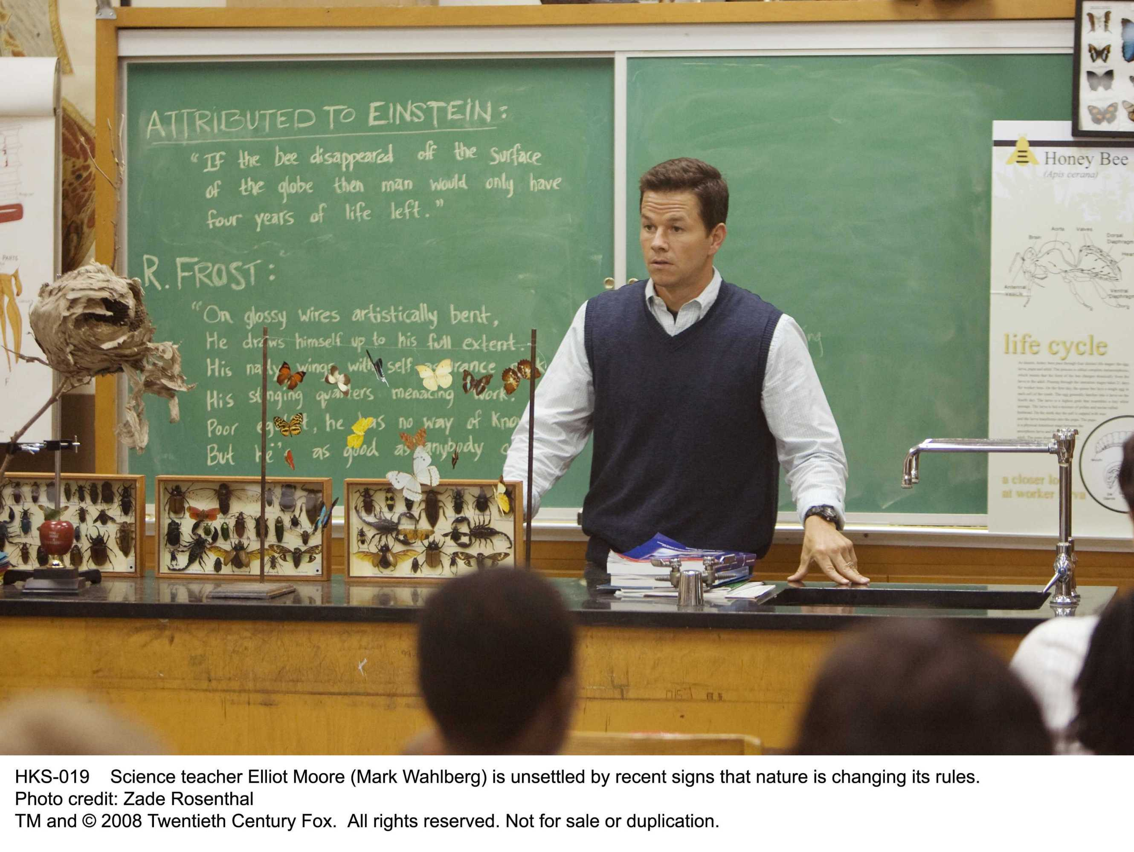
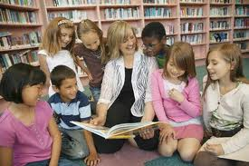
- B.
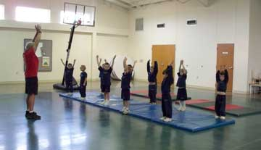

C.
D.

E. F.

Teacher | Corresponding Picture (Letter)
Physical Education
Reading
Math
Art
Science
Early Childhood (Pre-School)

