Request for Proposal
2016‐2017

Reserve Fund Grants

Fiscal Year 2017

Deadline for Submittal
March 9, 2016
5:00 p.m.

Georgia Department of Education
Division of Career, Technical and Agricultural
Education
1752 Twin Towers East
Atlanta, GA 30334

Program Description
Name of Grant Program: | Georgia Career, Technical and Agricultural Education (CTAE)  PERKINSplus Reserve Fund Grants
Authorization: | Carl D. Perkins Career and Technical Education Act of 2006 P.L.  109-270
Dissemination Date: | February 5, 2016
Deadline for Receipt of  Applications: | March 9, 2016 @ 5:00 pm (To allow for adequate implementation time for these grants, the deadline for applications cannot be extended).
Purpose: | To supplement the resources of local school systems in rural areas; areas with high percentages of career and technology education students; or areas with high numbers of career and technology education students.
Options: | Funds must be spent in accordance with Georgia’s identified options under Section 135 of the Perkins Act. Please select one of the funding options below, and submit the corresponding application for funding. NOTE: Funding levels subject to availability of federal funds.  Funding options:  1) Expand or improve LEA’s performance on any core indicator  except 6S1 and 6S2 ($15,000 maximum).  • Local school systems may apply for grant funds to support the implementation of activities to improve its performance  on any core indicator, except 6S1 and 6S2.  2) Enhance system/schools efforts to make students aware of, recruit students into and retain students in CTAE nontraditional pathways with under-represented gender enrollment in grades  9-12 ($10,000 maximum). Perkins Core Indicator 6S1 and 6S2  participation and completion in Georgia’s five identified non- traditional pathways in the following five programs:  Architecture and Construction; Education & Training; Health Science; Transportation, Distribution, & Logistics; and Science, Technology, Engineering, & Mathematics (STEM)  • Local school systems may apply for grant funds to create an awareness, recruit, and retain students in identified nontraditional program(s).  3) Local school systems may apply for grant funds to provide activities to prepare special populations for high skill, high wage, and high demand occupations that will lead to self- sufficiency ($10,000 maximum).  4) Implementing CTAE end-of-pathway assessment (FTE 0-300  ≤ $15,000; FTE 301-1000 ≤ $20,000; FTE 1000+ ≤ $25,000 maximum)  • Local school systems may apply for grant funds to purchase and administer end-of-pathway assessments for  pathway completers as required by Perkins IV legislation.  Consultant fees are capped at $30 per hour per person.

Target Populations: | Target audiences involved in the identified options include career and technology education faculty in partnership with academic  faculty members, counselors, and/or administrators involved in  CTAE programs.
Technical Assistance: | For technical assistance, please contact:  Dr. Brenda Merchant, South Region Coordinator - (404) 805-9904  Ms. Nancy Bessinger, Central Region Coordinator- (404) 805-9633  Mr. Roy Rucks, North Region Coordinator - (404) 805-7279
Eligible Applicants: | Grants are targeted to eligible recipients as defined in Section 131 of the Perkins Act and include local school systems in rural areas; areas with high percentages of career and technology education students; or areas with high numbers of career and technology education students. Final approval for awards will be determined by GADOE. GADOE reserves the right to take into consideration geographic distribution, project demonstrated readiness by the LEA, and availability of funds when making decisions.
Range of Grant Awards: | See specific application for award ranges.
Length of Grants: | One year
Estimated Program Start Date: | July 1, 2016 (ends June 30, 2017)
Fund Use: | Funds must be spent in accordance with the budget narrative of the four identified priorities.  Funds may be used for:  • Consultant services (Consulting fees are limited to $30 per hour)  • Substitute teacher fees for the activities funded in the grant application [Personnel Activity Report (PAR) required]  • Faculty honorariums (only allowable for work performed outside the regular workday) (PAR required)  • Materials and supplies to support curriculum development and professional development  • Purchasing of equipment for instruction that supports GADOE  approved CTAE Pathways (any equipment purchased with these grant funds must be inventoried and assigned to the  respective program)  Funds may not be used for:  • Salaries with the exception of honorariums and substitute pay  • Tuition  • Activities below the seventh grade  • Program maintenance at current performance levels  • Purchase of career information delivery system site licenses  • National, state, or local membership dues or fees  • Purchase of curricular materials for new programs beyond a three-year period  • Promotional items (e.g. shirts, key chains, bags, mugs)  • Construction of temporary or permanent structures  • Purchase of equipment for administrative purposes  • Purchase of equipment to support infrastructure for distance learning

Submission Requirements  and Information: | • The filenames should follow this format: FY17 Appendix X  FY17 Narrative  • Applications should be submitted through the GADOE LPlan  System at LPlan@doe.k12.ga.us, and send a copy to your  CTAE Region Coordinator.  • Complete applications must be received by 5:00 pm on March  9, 2016.  • If you have not received an email confirmation from LPlan within two working days, please contact your regional coordinator for follow-up.  • Forms requiring original signatures must be scanned and submitted through the LPlan@doe.k12.ga.us as part of the grant application.  • Incomplete applications will not be considered for funding.  • Applications received after due date and time will not be considered for funding.
Approved Applications: | • Applicants will be notified after their application has been reviewed for approval.  • Approved applications, including all supporting documents and appendices (including your Perkinsplus award letter), should be  uploaded to the “Uploaded Files” tab of the FY17 PerkinsPlus  Reserve Grant in the FY17 Consolidated Application by May  13, 2016.

Perkinsplus

Option 1
Expand or improve LEA’s performance on any core indicators except 6S1 and 6S2. The proposed budget may not exceed
$15,000.

C O M P L E T E
AP P L I C AT I O N F O R O P T I O N 1 M U S T
I N C L U D E :

☑ Appendix A – Cover Page

☑ Appendix B – Signed Assurances with
Original Signatures

☑ Grant Narrative – Questions I, II and III

☑ Appendix C – GADOE Budget Chart

☑ Appendix D – Budget Narrative
Local school systems may apply for grant funds to support the implementation of activities to improve its performance on any core indicator except 6S1 & 6S2.

Applications must address the items below.

I. Describe the activity and the need for implementation.
• Identify the activity to be implemented or improved.
• Indicate the Perkins Core Indicator(s) to be addressed.
o What is the current performance level for the indicator(s)
listed above?
• For professional development activities, include a description and identify staff involved.

II. Plan of Operation and Timeline
• List and describe the specific steps that will occur to support the successful development and implementation of the activity.
o For each step listed, include a timeline and the person responsible.

III. Key Personnel

• Identify project coordinator and team members involved in the development of the program (names, titles and roles).

Perkinsplus

Option 2
Enhance system/school’s efforts to make students aware of, recruit students into, and retain students in CTAE nontraditional pathways with underrepresented gender enrollment in grades 9-12 (Perkins Core Indicator 6S1 and 6S2 Participation and Completion in Georgia’s five identified non-traditional programs:
[Architecture and Construction; Education & Training; Health
Science; Transportation, Distribution, & Logistics; and Science, Technology, Engineering, & Mathematics (STEM)]. The
proposed budget may not exceed $10,000.

C O M P L E T E
AP P L I C AT I O N F O R O P T I O N 2 M U S T
I N C L U D E :

☑ Appendix A – Cover Page

☑ Appendix B – Signed Assurances with
Original Signatures

☑ Grant Narrative – Questions I, II and III

☑ Appendix C – GADOE Budget Chart

☑ Appendix D – Budget Narrative
Local school systems may apply for grant funds to create awareness, recruit and retain students in identified nontraditional pathway(s).

Applications must address the items below.
I. Describe your proposed efforts to make aware, recruit and retain students in identified nontraditional pathway(s).
• Identify the activity to be implemented or improved.
• Indicate the Perkins Core Indicator(s) to be addressed.
o What is the current performance level for the indicator(s) listed above?
• For professional development activities, include a description and identify staff involved.

II. Plan of Operation and Timeline

• List and describe the specific steps that will occur to support the successful development and implementation of the activity.
o For each step listed, include a timeline and the person responsible.

III. Key Personnel
• Identify project coordinator and team members involved in the development of the program (names, titles and roles).

Georgia Department of Education
February 5, 2016
Page 6

Perkinsplus

Option 3
Local school systems may apply for grant funds to provide activities to prepare special populations for high skill, high wage and high demand occupations that will lead to self-sufficiency. The proposed budget may not exceed $10,000.

C O M P L E T E
AP P L I C AT I O N F O R O P T I O N 3 M U S T
I N C L U D E :
To provide activities to prepare special populations for high skill, high wage, and high demand occupations that will lead to self- sufficiency.

Applications must address the items below.

☑ Appendix A – Cover Page

☑ Appendix B – Signed Assurances with
Original Signatures

☑ Grant Narrative – Questions I, II and III

☑ Appendix C – GADOE Budget Chart

☑ Appendix D – Budget Narrative
I. Describe the activity and the need for implementation.
• Identify and describe the activity that will be implemented and the details of how it will be implemented.
• For professional development activities, include a description and identify staff involved.

II. Plan of Operation and Timeline
List and describe the specific steps that will occur to support the successful implementation of the activity.
• For each step listed, include a timeline and the person responsible.

III. Key Personnel
Identify team members involved in the development of the program (names, titles and roles).

Georgia Department of Education
February 5, 2016
Page 7

Perkinsplus

Option 4
Implementing End-of-Pathway Assessments. The proposed budget is based on October 2015 CTAE FTE count. Budget Levels: FTE 0-
300 ≤ $15,000; FTE 301-1,000 ≤ $20,000; FTE 1000+ ≤ $25,000.

C O M P L E T E
AP P L I C AT I O N F O R O P T I O N 4 M U S T
I N C L U D E :

☑ Appendix A – Cover Page

☑ Appendix B – Signed Assurances with
Original Signatures

☑ Grant Narrative – Questions I, II and III

☑ Appendix C – GADOE Budget Chart

☑ Appendix D – Budget Narrative

☑ Appendix E – CTAE FY2017 EOPA Funding Worksheet
Local school systems may apply for grant funds to purchase end-of- pathway assessments for pathway completers as required by Perkins IV legislation.

• Grant funds may be used for assessment preparation, purchase of assessments, and assessment administration.
• Test participants must meet testing requirements established by GADOE.
• LEA participants are required to submit assessment results, identify test participants, as well as demographic data to
GADOE via the Student Records process.

Applications must address questions below.

I. Describe the activity and the plan for assessment.

• Identify the assessment, the pathway and the amount to be allocated.
• Systems should complete the “CTAE FY2017 EOPA
Funding Worksheet” and submit it as Appendix “E” of the
grant application.
• Any requests for supplies/materials over $250.00 which are not itemized will default to a maximum allotment of $250.00.
• Funds requested for EOP Assessments cannot be modified at a later date for any other purpose. Any unused funds must
be returned by notifying DOE through LPlan
(lplan@doe.k12.ga.us).

II. Plan of Operation and Timeline

• List and describe the specific steps that will occur to support the successful development and implementation of the activity.
• For each step listed, include a timeline and the person responsible for the activity.

III. Key Personnel
• Identify team members involved in the development of the program (names, titles and roles).

Georgia Department of Education
February 5, 2016
Page 8

Appendix “A”
Proposal Cover Page

PERKINSplus Grant
FY 2017

Appendix “A”
Proposal Cover Page

Grant Option Number: Click here to enter text. Grant Amount Requested: Click here to enter text. System Name: Click here to enter text.
System Number: Click here to enter text.

Contact Information

Name: Click here to enter text.
Email Address: Click here to enter text.
Day Phone Number: Click here to enter text.

APPENDIX “B”

PERKINSplus Grant

Perkins IV Reserve Grant Application Assurances

Fiscal Year 2017

The grant applicant hereby assures that:

1. All programs, services, and activities covered by this Grant Application will be operated in accordance with state and federal laws, regulations, and approved rules as established by the State Board of Education and the State Plan for Career and Technical Education.

2. Funding will be allocated in accordance with state and federal laws, regulations, and approved rules as established by the State Board of Education and is targeted toward preparing students for high- skill, high wage, and high-demand occupations and/or secondary to postsecondary transition activities.

3. Expenditures will be in compliance with the standard accounting procedures and guidelines established by the State Board of Education, federal legislation and CTAE Grant Budget Guidance.

4. Grant funds will not be expended in any manner other than as outlined in the budget section of the approved grant application.

5. Federal Perkins IV funds will supplement, and will not supplant, non-federal funds expended to carry out the activities of the grant.

6. Permission will be granted to use this grant proposal and its results, if funded, for informational purposes for other education agencies.

7. If required by the Application, all teams will be allowed release time to meet and plan the project.

8. By signing this assurance, I certify to the best of my knowledge and belief that the report is true, complete, and accurate, and the expenditures, disbursements and cash receipts are for the purposes and objectives set forth in the terms and conditions of the Federal award. I am aware that any false, fictitious, or fraudulent information, or the omission of any material fact, may subject me to criminal, civil or administrative penalties for fraud, false statements, false claims or otherwise.

System Name System Number

CTAE Director (Original Signature) Date

Superintendent (Original Signature) Date

APPENDIX “C”

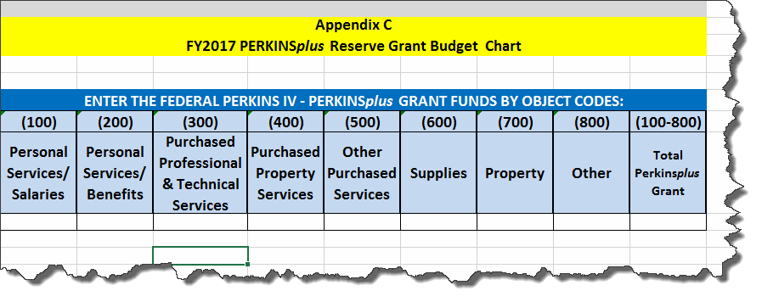

APPENDIX "D"

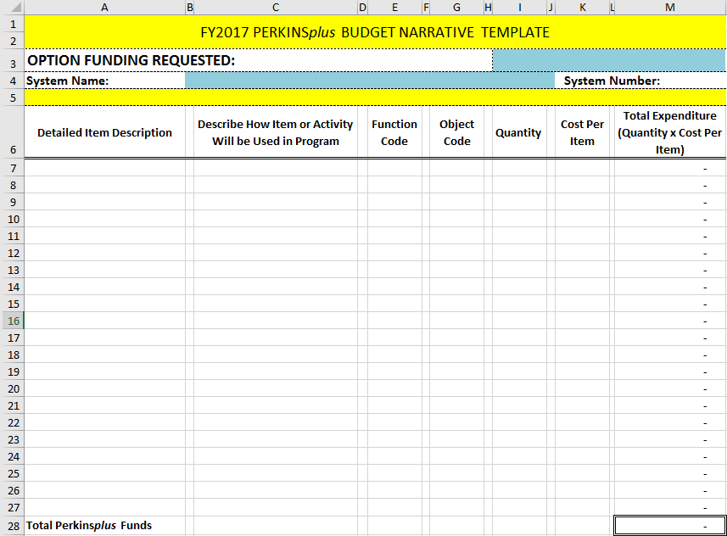
APPENDIX “E”

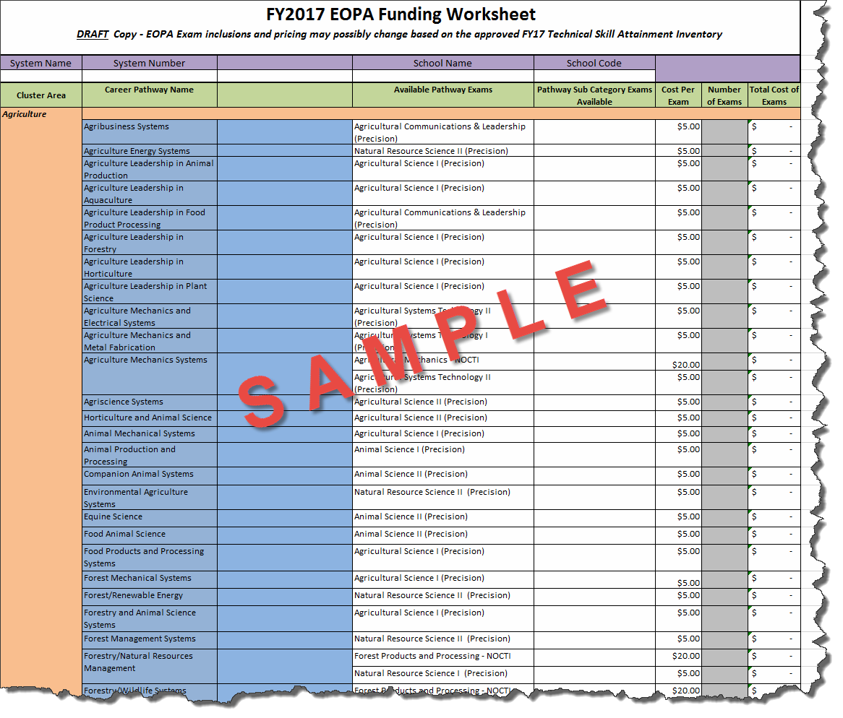

APPENDIX “F”

GEORGIA DEPARTMENT OF EDUCATION CTAE Perkinsplus GRANT
SCORING RUBRIC FOR OPTIONS 1-4

Using the following rubric, reviewers will assign numerical scores and prepare comments. The review team will meet to determine consensus.

 | Level 3  Meets All Criteria | Level 2  Meets Some Criteria | Level 1  Meets Few or No Criteria
A. Activity  description and the use of data to support the need for the activity. | The proposed activity is clearly and thoroughly described, and the performance data proves the need for the activity.  25-15 | There is a limited description of the proposed activity, and the performance data provides limited support for the activity.  14-6 | The proposed activity is not clearly identified, and little or no performance data are included to support the need for the activity.  5-0
25 Points
B. Plan of Operation and Timeline | A detailed timeline, including specific steps in the implementation process is included. Persons responsible are listed. An explanation is given as to how the implementation process will be evaluated for success.  10-6 | A timeline that includes some specific dates is included. Persons responsible are listed. A limited explanation is given as to how the implementation process will be evaluated for success.  5-1 | The timeline does not exist or is very limited and includes few specific dates. No explanation is given as to how the implementation process will be evaluated for success.  0
10 Points
C. Key Personnel | Key personnel are identified by name, title, and role.  5-4 | Few key personnel are identified by name, title, and role.  3-1 | No key personnel are identified.  0
5 Points
D. Budget  Narrative | Budget is clear, reasonable and cost effective. Budget narrative itemizes expenses in detail by completing all items requested on the “Budget Narrative Template.”  Budget calculations are correct.  50-30 | Budget is reasonable and cost effective. Budget narrative identifies expenses and provides general explanation. Budget contains a few errors with some items missing from “Budget Narrative Template.”  29-15 | Budget is not clear, reasonable and/or cost effective. Budget narrative does not provide detailed explanation of expenditures. Budget contains errors and/or is completed incorrectly.  14-0
50 Points
E. Grant Budget  Chart | Budget Chart is complete. All funds requested are budged to the appropriate object code.  10-6 | Budget Chart is incomplete or needs revision. Items are not charged to the appropriate object code.  5-1 | Budget Chart not completed or contains errors and is completed incorrectly.  0
10 Points
System Name: |  | Evaluator: | Total Points:

APPENDIX “G” Personnel Activity Report (PAR) Sample

