Conversations Around Collaboration
Follow-Up Activity for “If You Build It, They Will Come”

The purpose of the assignment to building capacity in your district to collaborate to provide transition support and services for your students beginning in elementary school. We may however, ask you all to share during the breakout groups.

This activity has been designed to begin to address some of the issues identified through the activities provided in the September 9th session. This activity is not meant to be completed alone. Work with your entire team (All participants from the session), if possible. If not, at least work with your grade band participants (Elementary, Middle, or High School). Complete each activity and make a note of what you have discovered during the process. This assignment will not be collected.

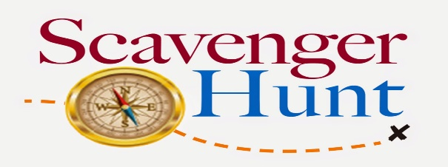
This Photo by Unknown Author is licensed under CC BY-NC-ND
Directions: Use the Transition website to complete the scavenger hunt below. Please note that there are 4 sections to the transition website (Main page, Best Practices, Self-Determination, Compliance). Click through the entire website to find what you need.
Scavenger Hunt:
- Find a listing of all of the professional development that will be provided for the 2020-2021 school year. Choose a webinar you think you might want to attend. Why did you choose it?
- Find guidance for Transition Assessments. Choose an assessment listed that can be used in addition to YouScience. How would you use that resource?
- Pick a handout from the 2020-2021 Best Practices Forum or ASPIRE IDEAS from the IDEAS from the field for implementing Student-led IPEs. What did you pick? How can you use this resource for elementary, middle and high school students?

Next Session: November 4th, 1:00pm-2:30pm (I’m Just A Bridge Bill on the CTAE Pathway)

