What Do YOU Know?

Circle the one best answer to complete the statements below. We will discuss later.

1. A reimbursable meal is:

a. similar to corn meal, but thicker

b. a school tray that always includes fat free milk

c. a lunch or breakfast that meets Federal nutrition requirements

d. a rebate from the grocery company

2. Five (5) full components must be _________ or _________ to every student for a reimbursable meal.

C:\Users\carrie.davis\AppData\Local\Microsoft\Windows\Temporary Internet Files\Content.IE5\N4VV68PZ\MC900264260[1].WMF

a. fruit or vegetable

b. green or red

c. lean or low sodium

d. served or offered

3. An example of a “**food** component” at lunch is:

a. hamburger

b. ½ cup to 1 cup of veggies per day, dependent on grade

c. fruit, vegetable, meat/meat alternate, grains, milk

d. choice of 2 fruits, 3 veggies, and 2 milks

4. An example of a “**full** component” at lunch is:

a. hamburger

b. ½ cup to 1 cup of veggies per day dependent on grade

c. fruit, vegetable, meat/meat alternate, grains, milk

d. choice of 2 fruits, 3 veggies, and 2 milks

5. An example of a “**food item**” at lunch is:

a. hamburger

b. ½ cup to 1 cup of veggies per day dependent on grade

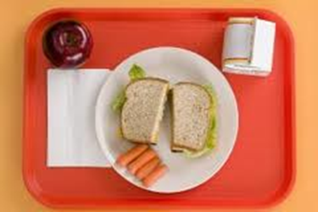

c. fruit, vegetable, meat/meat alternate, grains, milk

d. selection from 2 fruits, 3 veggies, and 2 milks

6. An example of **choice** in a school lunch is:

a. hamburger, cheeseburger, veggie burger

b. selection of 2 fruits, 3 veggies, and 2 milks

c. vending machine, lunch from home, school lunch

d. both a and b

7. The “Serve” option for a reimbursable lunch means:

a. the meal must be taken out to the student’s table

b. student may decline one or two food components at lunch

c. choice of 2 fruits, 3 veggies and 2 milks

d. cashier must see 5 full components on the student’s tray at the point of

service (POS)

8. Offer vs. Serve option for a reimbursable lunch is:

a. an alternative way to start a tennis match

b. a way to offer more food choices on school menus

c. an option designed to decrease food waste and give students flexibility

d. required in all schools in Georgia

9. The minimum amount of fruit required in every reimbursable lunch is:

a. 1/2 cup

b. 3/4 cup

c. 1 cup

d. varies dependent on grade of the student

10. List 3 ways you can make sure a reimbursable meal is served to each child.

__________________________________________________________________

__________________________________________________________________

__________________________________________________________________

Additional notes and ideas:

___________________________________________________________________

___________________________________________________________________

___________________________________________________________________

___________________________________________________________________

___________________________________________________________________