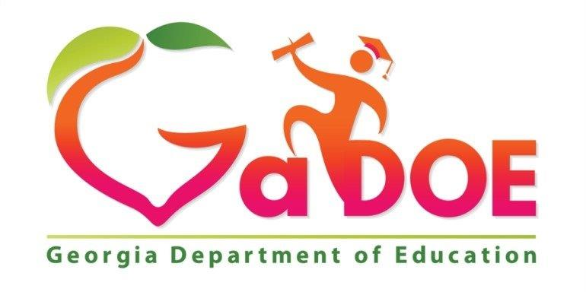
Georgia Department of Education
ESOL & Title III Unit

Required Home Language Survey

Dear Parent or Guardian:

In order to provide your child with the best possible education, we need to determine how well he or she speaks and understands English. This survey assists school personnel in deciding whether your child may be a candidate for additional English language support. Final qualification for language support is based on the results of an English language assessment.

Thank You

Student Name (required information):

__________________________________________________________________

Language Background (required information):

- Which language does your child best understand and speak? _____________________________________________________________

- Which language does your child most frequently speak at home?
_____________________________________________________________

- Which language do adults in your home most frequently use when speaking with your child?
_____________________________________________________________

Language for School Communication (not required):

- In which language would you prefer to receive all school information?
_____________________________________________________________

____________________________________ _______________
Signature of Parent/Guardian/Other Date

