Summary of Evaluation Tools

There are three evaluation tools that can be considered by Local Educational Agencies (LEAs) to complete the annual evaluation of the content and effectiveness of the Title I Parental Involvement Policy. Remember that using multiple methods will result in a better analysis of your Title I Parental Involvement Programs and Policy. Refer to the chart below for a summary of the evaluation tools.

Evaluation Tool | Focus Group   | Surveys  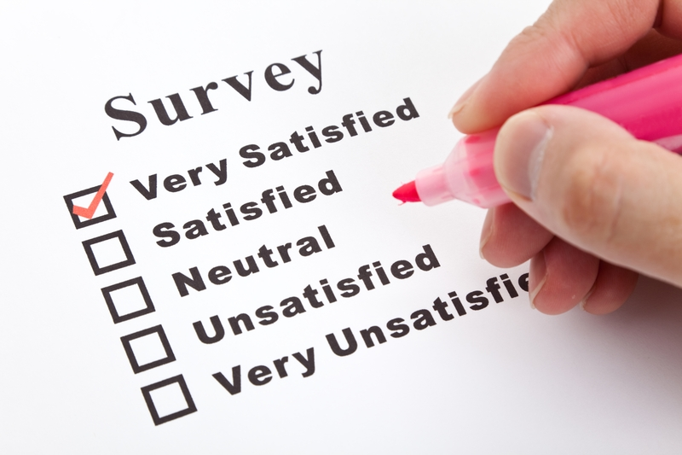 | Open Discussion Forum  
Target Audience | Title I Parents | Title I Parents | Title I Parents
Description | Focus groups are small groups of parents who come together in a confidential setting for structured evaluation to gather data on parent involvement policy and programs. | Surveys, which can be administered in multiple ways, are a commonly used method for collecting parent feedback in an anonymous format about parent involvement policy and programs. | Open Discussion Forums are similar to town hall meetings, by providing large groups of parents the opportunity to provide feedback on parent involvement policy and programs.
Time Consumption | Focus groups are the most time consuming because multiple meetings will need to be administered to ensure all parents have the opportunity to participate and provide feedback.  (Most Time Consuming) | Surveys are easy to administer but can consume large amounts of time during the data collection process.  (Less Time Consuming) | Open Discussion Forums are the least time consuming because they capture large amounts of parent input in a limited time period.  (Least Time Consuming)
Advantages | - Allows you to observe and hear parent expressions firsthand.  - Fosters an open and safe environment that encourages parents to engage in discussion and interact among themselves.  - People are willing to talk longer face-to-face versus filling out a form or talking on the phone.  - Schools/Districts can implement a focus group without the need for excessive costs. | - Allows parents and families to respond at their leisure rather than in the moment they are contacted or while in a group setting.  - Commonly viewed as less intrusive and more private than other evaluation methods.  - One of the most effective ways to give all parents an opportunity to be part of the evaluation process.  - You will get more accurate answers to sensitive questions because it’s confidential. | - Cost-effective method to gain massive input when striving to evaluate the school’s policy and plan in a short amount of time.  - Allows for a large audience or group of parents to participate.  - Multiple meetings can be held to accommodate various schedules.  - Provides the opportunity to get direct feedback.
Disadvantages | - Limits the number of opinions at one time that could come from having a larger or wider audience.  - Group conversation may be dominated by only a few parents.  - The group could be dominated by only a few parents, which would result in only their opinions being heard.  - The facilitator would have to find a centralized location to have the meetings, send out notices about the focus group and make arrangements for parents without transportation to attend. | - Not all parents may be able to participate due to low literacy levels.  - Requires persistence with follow-up and tracking to ensure high response rate.  - Some surveys require parents to have access to a computer to participate.  - Mailing surveys can get expensive with the costs associated with postage, labels, copies and envelopes.  - You cannot engage in face to face interaction to gauge the conversation and determine sincerity. | - Finding a centralized location to host a large meeting outside of the school due to uncertainty about the size of your audience.  - Leading the meeting may be difficult to facilitate and ensure you allot time for a majority of parents to comment.  - It could be hard to regain control of the group once it is lost.  - The cost of transportation and childcare can cause this cost-effective meeting to become expensive if it’s held multiple times.

