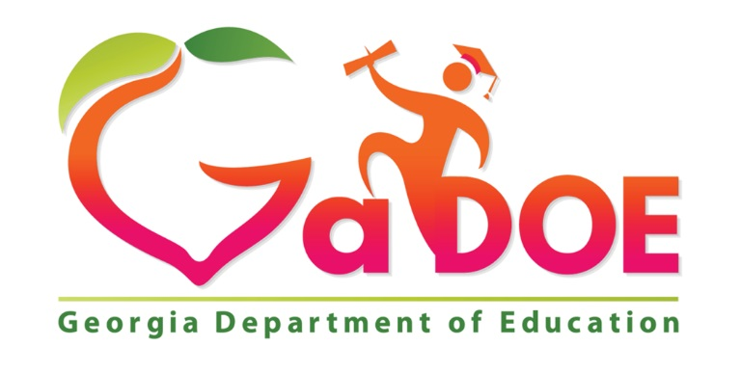

BUILDING CAPACITY FOR INVOLVEMENT

Title I, Part A, Section 1118 (e) of the Elementary and Secondary Education Act of 1965 requires that the six “shalls” stated in the law under Building Capacity for Involvement are met as well as documented. The law also provides eight additional “mays” (that are not required, but are allowable) to ensure meaningful capacity building in parents. The six “shalls” stated in the law are:

(1) SHALL provide assistance to parents of children served by the school or local educational agency, as appropriate, in understanding such topics as the State's academic content standards and State student academic achievement standards, State and local academic assessments, the requirements of this part, and how to monitor a child's progress and work with educators to improve the achievement of their children;

(2) SHALL provide materials and training to help parents to work with their children to improve their children's achievement

(3) SHALL educate teachers, pupil services personnel, principals, and other staff, with the assistance of parents, in the value and utility of contributions of parents, and in how to reach out to, communicate with, and work with parents as equal partners, implement and coordinate parent programs, and build ties between parents and the school;

(4) SHALL, to the extent feasible and appropriate, coordinate and integrate parent involvement programs and activities with Head Start, Reading First, Early Reading First, Even Start, the Home Instruction Programs for Preschool Youngsters, the Parents as Teachers Program, and public preschool and other programs, and conduct other activities, such as parent resource centers, that encourage and support parents in more fully participating in the education of their children;

(5) SHALL ensure that information related to school and parent programs, meetings, and other activities is sent to the parents of participating children in a format and, to the extent practicable, in a language the parents can understand;

(14) SHALL provide such other reasonable support for parental involvement activities under this section as parents may request.

The National PTA Standards for Family-School Partnerships, which the State Board of Education adopted in 2010 as Georgia's Family Engagement Standards, provides an effective framework for carrying out the six SHALLS, the eight MAYS under the law, and a school or district’s Title I parent involvement policy/program.

Therefore, the “shalls” are the activities you must be sure to implement and the Family Engagement Standards are the framework to help ensure effective parent involvement policy and plans.

The Georgia Department of Education

Parent Teacher Association (PTA) National Standards for Family-School Partnerships

Standard 1: WELCOMING ALL FAMILIES INTO THE SCHOOL COMMUNITY: Families are active participants in the life of the school, and feel welcomed, valued, and connected to each other, to school staff, and to what students are learning and doing in class.

Standard 2: COMMUNICATING EFFECTIVELY: Families and school staff engage in regular, two-way, meaningful communication about student learning.

Standard 3: SUPPORTING STUDENT SUCCESS: Families and school staff continuously collaborate to support students’ learning and health development both at home and at school, and have regular opportunities to strengthen their knowledge and skills to do so effectively.

Standard 4: SPEAKING UP FOR EVERY CHILD: Families are empowered to be advocates for their own and other children, to ensure that students are treated fairly and have access to learning opportunities that will support their success.

Standard 5: SHARING POWER: Families and school staff are equal partners in decisions that affect children and families and together inform, influence, and create policies, practices, and programs.

Standard 6: COLLABORATING WITH THE COMMUNITY: Families and school staff collaborate with community members to connect students, families, and staff to expanded learning opportunities, community services, and civic participation.

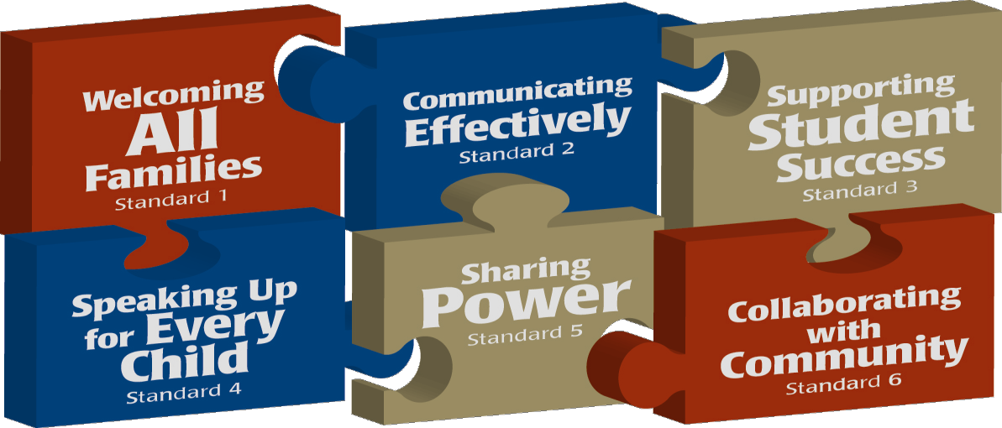

Reference:

National Parent Teacher Association (PTA). (2009). PTA National Standards for Family-School Partnerships: An Implementation
Guide. Retrieved from http://www.pta.org/2757.asp

The Georgia Department of Education

The National PTA Standards for Family-School Partnerships provide strategies for Title I schools to build parent capacity as required by the Elementary and Secondary Education Act (ESEA) of 1965. The Crosswalk for Parent Engagement tool puts this work in a context that is easy to understand and family-friendly language in order to assist schools, parents, and communities in understanding the law by aligning the PTA Standards with the six “shalls” and eight “mays” stated in the law.

Building Parent Capacity: A Crosswalk for Parent Engagement
Title I Parental Involvement – Section 1118(e)  14 Activities to Build Capacity for Parental Involvement | PTA National Standards for Family-School Partnerships  6 Standards to Build Family-School Partnerships for Student Success
BUILDING CAPACITY FOR INVOLVEMENT – To ensure effective  involvement of parents and to support a partnership among the school involved, parents, and the community to improve student academic achievement, each school and local educational agency assisted under this part – | FAMILY-SCHOOL PARTNERSHIPS – Framework for how and what parents, schools, and communities can do together to support student success.
(1) SHALL provide assistance to parents of children served by the school or local educational agency, as appropriate, in understanding such topics as the State's academic content standards and State student academic achievement standards, State and local academic assessments, the requirements of this part, and how to monitor a child's progress and work with educators to improve the achievement of their children; | Standard 3: Supporting Student Success – Families and school staff continuously collaborate to support students’ learning and healthy development both at home and at school, and have regular opportunities to strengthen their knowledge and skills to do so effectively.
(2) SHALL provide materials and training to help parents to work with their children to improve their children's achievement | Standard 3: Supporting Student Success – Families and school staff  continuously collaborate to support students’ learning and healthy development both at home and at school, and have regular opportunities to strengthen their knowledge and skills to do so effectively.

The Georgia Department of Education

(3) SHALL educate teachers, pupil services personnel, principals, and  other staff, with the assistance of parents, in the value and utility of contributions of parents, and in how to reach out to, communicate with, and work with parents as equal partners, implement and coordinate parent programs, and build ties between parents and the school; | Standard 1: Welcoming All Families Into the School Community – Families are active participants in the life of the school, and feel welcomed, and connected to each other, to school staff, and to what students are learning and doing in class.  Standard 2: Communicating Effectively – Families and school staff engage in regular, two-way and meaningful communication about student learning.
(4) SHALL, to the extent feasible and appropriate, coordinate and  integrate parent involvement programs and activities with Head Start, Reading First, Early Reading First, Even Start, the Home Instruction Programs for Preschool Youngsters, the Parents as Teachers Program, and public preschool and other programs, and conduct other activities, such as parent resource centers, that encourage and support parents in more fully participating in the education of their children; | Standard 3: Supporting Student Success – Families and school staff  continuously collaborate to support students’ learning and healthy development both at home and at school, and have regular opportunities to strengthen their knowledge and skills to do so effectively.
(5) SHALL ensure that information related to school and parent programs, meetings, and other activities is sent to the parents of participating children in a format and, to the extent practicable, in a language the parents can understand; | Standard 2: Communicating Effectively – Families and school staff engage in regular, two-way and meaningful communication about student learning.
(6) may involve parents in the development of training for teachers,  principals, and other educators to improve the effectiveness of such training; | Standard 4: Speaking Up for Every Child – Families are empowered to be advocates for their own and other children, to ensure that students are treated fairly and have access to learning opportunities that will support their success.  Standard 5: Sharing Power – Families and school staff are equal partners in decisions that affect children and families and together, inform, influence, and create policies, practices, and programs.

The Georgia Department of Education

(7) may provide necessary literacy training from funds received under this part if the local educational agency has exhausted all other reasonably available sources of funding for such training; | Standard 3: Supporting Student Success – Families and school staff  continuously collaborate to support students’ learning and healthy development both at home and at school, and have regular opportunities to strengthen their knowledge and skills to do so effectively.
(8) may pay reasonable and necessary expenses associated with local parental involvement activities, including transportation and child care costs, to enable parents to participate in school-related meetings and training sessions; | Standard 1: Welcoming All Families Into the School Community – Families are active participants in the life of the school, and feel welcomed, and connected to each other, to school staff, and to what students are learning and doing in class.  Standard 3: Supporting Student Success – Families and school staff continuously collaborate to support students’ learning and healthy development both at home and at school, and have regular opportunities to strengthen their knowledge and skills to do so effectively.
(9) may train parents to enhance the involvement of other parents; | Standard 4: Speaking Up for Every Child – Families are empowered to be advocates for their own and other children, to ensure that students are treated fairly and have access to learning opportunities that will support their success.
(10) may arrange school meetings at a variety of times, or conduct in-home conferences between teachers or other educators, who work directly with participating children, with parents who are unable to attend such conferences at school, in order to maximize parental involvement and participation | Standard 2: Communicating Effectively – Families and school staff engage in regular, two-way and meaningful communication about student learning.  Standard 3: Supporting Student Success – Families and school staff continuously collaborate to support students’ learning and healthy development both at home and at school, and have regular opportunities to strengthen their knowledge and skills to do so effectively.
The Georgia Department of Education

(11) may adopt and implement model approaches to improving parental involvement; | All Standards:  Standard 1 – Welcoming All Families Into the School Community  Standard 2 – Communicating Effectively  Standard 3 – Supporting Student Success  Standard 4 – Speaking Up for Every Child  Standard 5 – Sharing Power  Standard 6 – Collaborating with Community
(12) may establish a districtwide parent advisory council to provide  advice on all matters related to parental involvement in programs supported under this section; | Standard 5: Sharing Power – Families and school staff are equal partners in decisions that affect children and families and together, inform, influence, and create policies, practices, and programs.
(13) may develop appropriate roles for community-based organizations and businesses in parent involvement activities; and | Standard 6: Collaborating with Community – Families and school staff collaborate with community members to connect students, families, and staff to expand learning opportunities, community services, and civic participation.
(14) SHALL provide such other reasonable support for parental  involvement activities under this section as parents may request. | Standard 3: Supporting Student Success – Families and school staff  continuously collaborate to support students’ learning and healthy development both at home and at school, and have regular opportunities to strengthen their knowledge and skills to do so effectively.  Standard 5: Sharing Power – Families and school staff are equal partners in decisions that affect children and families and together, inform, influence, and create policies, practices, and programs.

