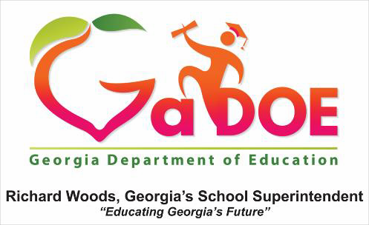

2017 Affirmation of Meaningful/Timely Consultation and Equitable Services
Attach this form to the FY18 Title I Budget Attachment Tab when submitting your budget.

School District:

Federal Program(s):

Private School:

Directions: Both School Officials (private and public) must initial on either the YES or NO line for each statement below:

We acknowledge that for the school year the following occurred at the private school with federal programs:

YES_ NO Timely and meaningful consultation occurred regarding to the needs and services of the eligible children and their teachers and families.

YES_
NO Services began at the time requested and agreed upon by the private school official.

YES_
NO The LEA provided instructional and equitable services.

YES_
NO Both parties agree that satisfactory services were provided during the
school year.

Signature Private School Official: Date:

Signature Public School Official:
Date:

Comments:

Georgia Department of Education
July 2017

