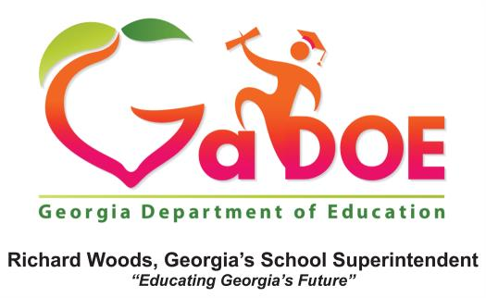

February 2017,

Dear Colleague:

On December 10, 2015, President Obama signed into law the Every Student Succeeds Act (ESSA), which reauthorized the Elementary and Secondary Education Act of 1965 (ESEA). The ESSA makes a number of changes to the equitable services requirements for private school students in Title I and Title VIII of the ESEA. The following affirmation form, titled FY17 Private School Initial Consultation and Notification of Intent for FY18 Provision of Services was created to collect some of this new information on private schools as outlined in the ESSA.

This affirmation form documents that an initial consultation was held with each private school, and if that private school’s intent is to continue with on-going consultation to plan for equitable services for the FY18 school year. Therefore, the LEA will use a separate form for each private school that attended the initial consultation and/or decided to continue with the consultation.

This form asks for the private school official’s contact information at the top and signature at the bottom. Another requirement is for both the LEA and private school officials to initial in two places. In Part 1 of the form, both will initial if the initial consultation did or did not occur. In Part 2, initials are scribed to document bilateral opinion as to whether the intent is to continue or not to continue the on-going consultation. If the LEA has no private schools participating in equitable services in FY18, then Part 2 also contains a check box to indicate this, and the LEA will upload only this one form in the consolidated application (ConApp).

Once the LEA has an initialed and signed form from each private school that participated in Part 1 and
Part 2, the LEA will scan the forms as one document. That one document should be uploaded into the ConApp and saved under the “Attachment Tab.” We ask that you name the uploaded file as: “LEA Name-Private Schools Initial Consultation Forms”. We also request that you email your Title I Area Specialist when you upload this form. The due date is by July 31, 2017. In future years, this form will be submitted by the LEA by December.

Should you have additional questions, please contact your Title I Area Specialist.

FY17 Private School Initial Consultation and Notification of Intent for FY18 Provision of Services
Affirmation of Initial Consultation and Intent Notification

Local Education Agency (LEA)
Private School
Private School Address
Private School Phone | Email:
Private School Official
LEA Federal Program Official | Phone:
Federal Program(s) offering services to Private Schools (Place an “X” in each program where the Private School listed above intends to consult with the LEA on possible services):
Title I, Part A , Title II, Part A , Title III, Part A , Title I, Part C , Title IV, Part A , Title IV, Part B

(Title IA- Improving basic programs operated by LEAs) (Title IIA- Supporting effective instruction)
(Title IIIA- English language acquisition, language enhancement, and academic achievement) (Title IC- Education of migratory children) (Title IVA- Student support and academic enrichment) (Title IVB- 21st Century Community Learning Centers)

Directions: Both School Officials (private and public) must initial under either YES or NO for each statement. Both School Officials must also sign and date this document, which must then be scanned and attached to the Consolidated Application in the Portal no later than July 31, 2017 (even if no private school participation – See Part 2 below).

Part 1: Timely and Meaningful Consultation Affirmation – Initial Consultation

Official | Yes | No | Consultation Requirements (ESSA Sections 1117 and 8501)
Private School |  |  | The initial consultation for the 2017-2018 school year has occurred between the LEA and Private School. Date _______________ (Should take place prior to October 31st)
Public School

Part 2: Notification of Intent to Participate in FY18
This checked box indicates that the LEA has no private schools participating in equitable services in FY18.

Official | Yes | No | Intent Notification (ESSA Section 1117)
Private School |  |  | The Private School intends to continue consultation throughout FY17 and participate in FY18 equitable services. It is the responsibility of the LEA to design, develop, and implement the services provided to the private school students, after on-going consultation with the private school.
Public School

Signature Private School Official
Printed Name and Title of Private School Official
Date
Signature Public School Official
Printed Name and Title of Public School Official
Date
Comments:

Include additional pages for comments if needed

Include additional pages of comments if needed

