Fiscal Year |  | Date Prepared
LEA Name |  | LEA Coordinator

Georgia LEAs should conduct an annual comprehensive needs assessment. This worksheet is intended to guide LEAs through examining LEAs as they align with the Title II, Part A Program Purposes and Allowable Use of Funds; the worksheet is not required. The results of this worksheet may be included in a comprehensive district needs assessment or completed at the program level. For monitoring purposes, LEA records should include a needs assessment that is inclusive of all Title II, Part A required components. Source documentation and accompanying summary or analysis data should be kept on file for LEA and State monitoring of program implementation. The following pages will walk LEA coordinators through the questions that should be considered when conducting a needs assessment that includes Title II, Part A components. Remember that while stakeholder involvement is required, stakeholders should be in the process where appropriate.

The needs assessment is intended to examine each component and reveal strengths and areas where there is room for improvement. The needs assessment should help the LEA to identify and prioritize needs, determine strategies to address the needs and allocate resources for the strategies. The LEAs prioritized needs will be included in and/ or inform the 1) Equity Action Plan, 2) Comprehensive LEA Improvement Plan (CLIP), 3) The Budget, 4) Monitoring & Measuring of Effectiveness, and 5) Monitoring Records.

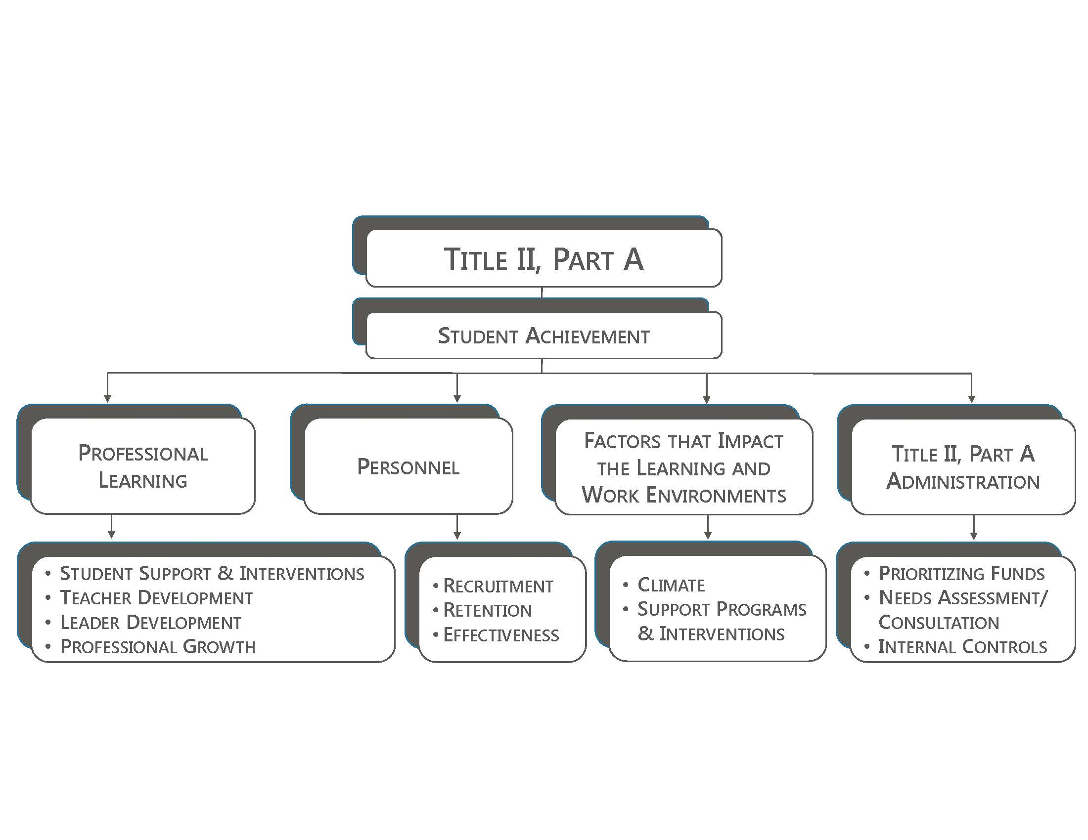
The contents of this template were developed under a grant from the U.S. Department of Education. However, those contents do not necessarily represent the policy of the U.S. Department of Education, and you should not assume endorsement.

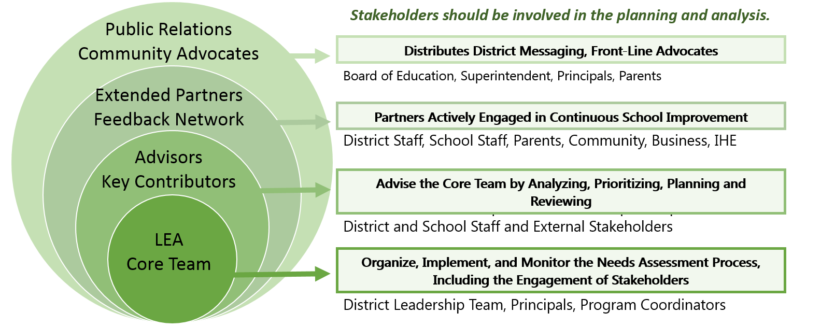
LEA Core Team | Advisors  Key Contributors | Extended Partners  Feedback Network | Public Relations  Community Advocates

Student Achievement
Suggested Sources of Documentation: Local Assessments, National Assessments, State Assessments
Suggested Stakeholders to Include: BOE, Business Partners, Community Partners, Families, District Staff, School Staff, Students
Guiding Questions | LEA Summary and Analysis
  - In which content areas, grade levels, subgroups do student achievement results indicate room for improvement?
  - How do current student achievement results for cohorts compare with past student achievement results for the same cohorts?
  - Is the LEA monitoring student cohort progress to ensure groups of students, especially poor and minority, are not assigned to inexperienced, ineffective teachers for two consecutive grade levels or content courses?
  - If applicable, how do LEA student achievement results compare with neighboring LEA, RESA Region, State and National student achievement results?
Possible Actions and Funding Sources | Data Sources

Professional Learning: Overarching
Guiding Questions | LEA Summary and Analysis
  - Are you required to meet any professional learning directives (LEA, State, Federal)? For example, does the LEA have any schools designated for school improvement?
  - Is professional learning in the LEA personalized and evidenced-based that is focused on improving teaching and student learning and achievement (for a detailed definition of ‘evidence-based’ please reference ESSA Section 8501)?
  - In your LEA, what are most effective methods for delivering professional learning (Job-Embedded/ Coaching, Professional Learning Communities (PLCs), Online Modules, Consultants, Train the Trainer)? Does the effectiveness of the delivery depend on the topic?
  - How is the LEA measuring and monitoring effectiveness of the current professional learning? Can the results of the professional learning provided be tied to student achievement results? In reviewing results, should the LEA make any changes?
Possible Actions and Funding Sources | Data Sources

Professional Learning
Suggested Sources of Documentation: Demographic Data, PL Course Schedule, PL Evaluations, PL Focus Walks, PL Participation, Stakeholder Surveys, Student Achievement Data, Student Attendance, Student Discipline, TKES/ LKES Observations
Suggested Stakeholders to Include: Business Partners, Community Partners, Curriculum Director, Institutions of Higher Educations, PL Director, Principals, RESA, Teachers, SpEd Director, Student Support Personnel (and Other School Leaders)
Guiding Questions | LEA Summary and Analysis
Student Support and Interventions
  - What are the professional learning needs of school personnel relative to student support and interventions (teachers, principals, other school leaders, specialized instructional support personnel, and paraprofessionals)?
  - What are the professional learning needs of participating private school leaders and teachers relative to student support and interventions?
  - Have you considered what professional learning the LEAs teachers may need to support students in job programs and to prepare students for post-secondary education and the workforce (CTAE/ Work-based learning, STEM, etc.)? Have you solicited input from graduates, parents, business partners and institutions higher education?
  - Do school personnel require professional learning on effectively engaging parents, families and community partners and coordinating services between school and community?
  - Do school personnel have the training and resources to meet the diverse needs of student learners? (ESOL, Exceptional Education, Gifted, RtI, etc.)
  - Do school personnel require professional learning on the culture and economics of students the LEA is serving?
  - Do school personnel require professional learning in classroom management strategies that are effective in meeting the needs of diverse student learners?
  - Do school personnel require training to support the identification of students who are gifted and talented, including high ability students who have not been formally identified for gifted education services? Do all students have access, in representative numbers, to appropriate services/ course offerings such as gifted, IB, and AP? Do school personnel require training for implementing instructional practices that support the education of these students?
  - Does the LEA currently, provide in-service training to school personnel in the following areas addressed in ESSA?
  - Techniques and supports for student referral for effectively linking children to appropriate treatment and intervention services in the school and community (trauma, mental illness, etc.)
  - Forming partnerships between internal and external mental health programs/ organizations
  - Addressing issues related school conditions for student learning, such as safety, peer interaction, drug and alcohol abuse and chronic absenteeism
  - Preventing and recognizing child sexual abuse
  - Ensuring individual student privacy is protected (FERPA)

Teacher Development
  - What are the professional learning needs of teachers relative to content and pedagogy?
  - What are the professional learning needs of participating private school teachers relative to content and pedagogy? How is this determined?
  - Does the LEA currently, provide evidence-based professional learning in the following areas addressed in ESSA?
  - Integrating technology into curricula and instruction
  - Using data to improve student achievement
  - Developing, selecting and implementing assessments to support student learning (formative, summative, classroom-based, assessment data analysis)

Leader Development
  - What are the professional learning needs of leaders (principals, assistant principals and other school instructional leaders including coaches, mentors and evaluators) relative to becoming and remaining effective leaders in their current leadership positions?
  - What are the professional learning needs of participating private school leaders relative to becoming and remaining effective leaders in their current leadership positions? How is this determined?
  - Does the LEA currently, provide evidence-based professional learning in the following areas addressed in ESSA?
  - How to accurately differentiate performance, provide useful feedback and use evaluation results to inform decision-making about professional learning, improvement strategies and personnel decisions.
  - Integrating technology into curricula and instruction
  - Using data to improve student achievement
  - Developing, selecting and implementing assessments to support student learning
(formative, summative, classroom-based, assessment data analysis)

Professional Growth
  - What are the professional learning needs of school personnel relative to advancement and leadership opportunities (pay differentiation, multiple career paths)?
  - Does the LEA promote growth and multiple career paths, such as instructional coaching and mentoring (including hybrid roles that allow instructional coaching and mentoring while remaining in the classroom), school leadership and involvement with school improvement and support?
  - Are any of the professional growth professional learning opportunities offered in alignment with recommended practices addressed in ESSA, such as teacher and school leader residency programs and/ or teachers, principal or other school leader preparation academies?
Possible Actions and Funding Sources | Data Sources
Private School Needs | Possible Private School Actions

Personnel
Suggested Sources of Documentation: Exit Surveys, HR Feedback, Induction Feedback, MySPA, Staff Attendance, Stakeholder Surveys, TEM/ LEM Scores, TKES Observations, LKES Observations
Suggested Stakeholders to Include: HR Director, PL Director, Principals, Superintendent, Teachers, Title II, Part A Coordinator
Guiding Questions | LEA Summary and Analysis
Recruitment
  - What are your LEA’s recruitment needs? Do you have vacancies? In which schools, grade levels, content areas? Have you analyzed recruitment data by content course, grade level, schools, staff demographics (minority, experience), and student needs (ELL, Gifted, Special Ed)? Which content courses, grade levels or schools are difficult to staff? Why? Is there an area in which targeted recruitment could increase teacher effectiveness or experience? Is there an area in which targeted recruitment could increase student achievement?
  - Do all teachers and paraprofessionals hold State required qualifications for their current assignments? If a teacher does not meet the State required qualifications for the teacher’s current assignment, could recruitment needs be met through reassignment? Is testing or additional coursework required? Do qualification challenges occur at higher rates at certain schools or in schools serving certain populations or in certain content courses or grade levels? If so, why?
  - What are the LEAs current recruitment activities? Does the LEA recruit qualified individuals from other fields to become teachers, principals, or other school leaders, including mid-career professionals from other occupations, former military personnel, and recent graduates of institutions of higher education with records of academic distinction who demonstrate potential to become effective teachers, principals, or other school leaders?
  - What is the effectiveness of LEA’s current recruitment activities? How many new candidates were hired as a result of job fairs, student teaching, or advertising, etc.?
  - Are highly effective and experienced teachers and leaders equitably distributed across schools? Are highly effective and experienced teachers equitably distributed across school content courses and grade levels? Do teachers need to be recruited to address any inequities?

Retention
  - What is the LEAs current retention/ attrition rate? How does this compare over time (past 3 years)? Have you analyzed retention data by content courses, grade levels, schools, staff and student demographics? Are there particular areas that are difficult for retention? Do you have the same high needs areas as the State?
  - Does the LEA require exit surveys to determine the causes for personnel (teachers, principals and other school leaders) attrition? If so, are there any areas of concern?
  - Does the LEA have a plan for supporting teachers, principals and other school leaders through the use of induction and mentoring programs? Does the plan provide adequate support for new teachers or principals, struggling veteran teachers or leaders, or teachers serving special needs students?
  - How effective are the LEA’s current retention strategies? How do you know?

Effectiveness
  - What is the current state of implementation for teacher and leader evaluations in the LEA? Is additional professional learning on implementation required for teachers, leaders, and/ or evaluators?
  - What do teacher and leader self-assessments, observations and supporting documentation reveal as strengths and weaknesses? Is corresponding professional learning currently being offered? If so, to what extent is it personalized and monitored for growth?
  - Has the LEA established performance goals and objectives for teachers and leaders at the district level, school level and/ or in particular grades or content areas? If so, is progress being monitored? Is the effectiveness of activities being measured?
  - If your LEA employs struggling teachers, how many, in which schools, grades and/ or content areas? What supports does the LEA provide? How does the LEA ensure struggling teacher performance is improving? How does the LEA use the results of teacher and leader evaluations to support retention decisions?
Possible Actions and Funding Sources | Data Sources

Factors That Impact The Learning and Working Environment
Suggested Sources of Documentation: Attendance Data, CCRPI, Demographic Data, Discipline Data, Program Data, Stakeholder Surveys
Suggested Stakeholders to Include: BOE, Business Partners, Community Partners, District Leaders, Families, Institutions of Higher Education, School Leaders, Students, School Staff
Guiding Questions | LEA Summary and Analysis
Climate
  - What areas do LEA climate survey results indicate as strengths and weakness?
  - What other LEA data reveals additional information about the current climate among school personnel? What is the LEA’s staff attendance rate by job group and location?
  - What other internal or external factors might have affected district or school data and/ or results of district/ or school data?
  - Internal: resource allocation, documentation and monitoring, technology and software, communication, internal controls, personnel assignment/ performance
  - External: geographic location, population demographics (employment, education, median income), local/ state/ national economy, natural disasters, state and federal policy changes

Support Programs and Interventions
  - Evidence- Based Class Size Reduction
  - Do all classes across elementary schools and within school grade levels have equivalent class sizes? Do all content courses have equivalent class sizes within individual middle and high schools and across your LEA?
  - Based on student achievement data, have you identified specific student cohorts that would benefit from reduced class size?
  - Services Provided by Effective School Library Programs
  - What instructional services are currently provided by school library programs? Is the service effectively supporting student achievement? In which areas could the instructional services be improved in order to promote student achievement?
  - SWD/ EL Programs and Activities
  - Does the LEA have programs and activities that increase the ability of teachers to effectively teach children with disabilities, including children with significant cognitive disabilities, and English learners, which may include the use of multi-tier systems of support and positive behavioral intervention and supports, so that such children with disabilities and English learning can meet the challenging State academic standards?
Possible Actions and Funding Sources | Data Sources

Title II, Part A Administration
Suggested Sources of Documentation: Audit Reports, Effectiveness Data, Equity Data, Internal Controls, Monitoring Reports, Program Data, School Data, School Improvement School List, Stakeholder Surveys
Suggested Stakeholders to Include: Curriculum Director, Federal Programs, Finance Director, HR Director, PL Director, Principals, SpEd Director, Student Support Personnel, Title II, Part A Coordinator
Guiding Questions | LEA Summary and Analysis
Prioritizing Funds
  - Does the LEA have a fiscal requirement to provide professional learning (LEA, State, Federal)? For example, does the LEA have any schools designated for school improvement?
Needs Assessment/ Consultation
  - What is the current process for conducting a comprehensive needs assessment? Have all programs priorities been addressed? What role stakeholders play in generating, collecting, summarizing and/ or analyzing the data? Are any actions required to strengthen the process?
Internal Controls
  - Are there policies/ procedures/ processes involved in implementation or data collection? If so, have they impacted data results? Do any adjustments need to be made?
  - Have any needs been revealed through audit or monitoring reports?
Possible Actions and Funding Sources | Data Sources

Further Data Analysis
Guiding Questions | LEA Summary and Analysis
    - How can the data and corresponding results be presented in a way that allows stakeholders to engage knowledgably in discussions, in setting priorities, and determining strategies?
    - What results can be determined from the data collected? What implications can be drawn from the results? Does the LEA need to conduct a further root cause analysis in any particular area?
    - Are there patterns evident in the data that indicate trends across cohorts, schools, neighboring districts, RESA regions, the state and the nation? Are any of the results illogical, unusual or contradictory?

Possible Actions and Funding Sources | Data Sources

Program Component | Data Says We Need… | The Strategy We Chose to address the need…
Professional Learning:
- Student Supports and Interventions
- Teacher Development
- Leader Development
- Professional Growth
Personnel:
- Recruitment
- Retention
- Effectiveness
Factors that Impact the Learning and Work Environment:
- Climate
- Support Programs and Interventions
Title II, Part A Administration
- Prioritizing Funds
- Needs Assessment/ Consultation
- Internal Controls

Prioritizing Needs | Prioritized Title II, Part A Program Needs
- How is each NEED tied to student achievement?  - How can the goals of the Title II, Part A program support the LEA’s identified needs?  - What are the implications for not prioritizing or addressing a need? Could it impact student achievement and/or other stakeholders, increase risk, or decrease revenue?  - Which needs align to the mission and vision of the district/ school?  - Which needs are the most urgent according to data collected? How might deadlines impact the prioritization of needs? Are any equally important? Are any required to be addressed?  - Are there multiple needs that can be effectively addressed through overlapping program purposes and objectives, interventions and/ or funding streams?  - What difficulties (fiscal, personnel, time, effort, implementation quality) would need to be considered in addressing a particular need?  - If chosen, are there strategies and or resources readily available to address the need? | 1.
 | 2.
 | 3.
 | 4.
 | 5.

Using the Equity Data Profile provided by the Georgia Department of Education and the LEA comprehensive needs assessment, correlate equity action strategies with the LEA’s equity needs. In the right hand column select only TWO Equity Interventions as a priority focus for improvement which will be for monitoring and reporting purposes. Both selections should be based on the LEAs equity needs and at least one selection must be based on the LEA’s Equity Data Profile.
Program Component | Corresponding Equity Interventions  to Support Equitable Access to an Excellent Education | Two Equity Interventions for Monitoring
Professional  Learning | PL-1. Provide Targeted School Personnel Training on Student Supports and Interventions  PL-2. Provide Targeted Teacher Development on Content and Pedagogy  PL-3. Provide Targeted School Leader Development  PL-4. Offer Professional Growth Opportunities Designed to Produce Teachers and/ or School Leaders Prepared to Promote the Success of All Students | ☐ PL-1  ☐ PL-2  ☐ PL-3  ☐ PL-4
Personnel | P-1. Identify & Recruit Effective Teachers & School Leaders  P-2. Support the Retention of Effective Teachers  P-3. Support the Retention of Effective School Leaders  P-4. Equitably Distribute Effective Teachers in High Needs Schools  P-5. Equitably Distribute Effective Leaders in High Needs Schools  P-6. Schedule Teachers for In-field Assignments | ☐ P-1  ☐ P-2  ☐ P-3  ☐ P-4  ☐ P-5  ☐ P-6
Factors that Impact the Learning and Working Environment | E-1. Schedule Class Size Reduction Teachers at a Level That is Evidence Based  E-2. Provide Equitable Access to Student Support Programs and Interventions  E-3. Promote the Engagement and Education of Parents, Families, Community and Business Partners  E-4. Evaluate and Monitor the Working Environment in Support of a Positive School Climate | ☐ E-1  ☐ E-2  ☐ E-3  ☐ E-4
Title II, Part A  Administration | A-1. Include a Cross- Representation of Stakeholders for Equitable Involvement in the Needs Assessment  A-2. Implement and Follow Protocols that Support Practices which Promote Equitable Access to Excellent Educators  A-3. Prioritize the Distribution and Coordination of Federal Funds to Promote Equitable Educational Opportunities | ☐ A-1  ☐ A-2  ☐ A-3  ☐ A-4

FY17 Template for Determining the Effectiveness of Title II, Part A Funded Strategies
Title II, Part A  Funded Component(s) & Equity Interventions | Title II, Part A Prioritized Needs Being Addressed | Title II, Part A Funded Strategies Selected to Address Prioritized Needs | Data to be Collected to Measure and Monitor Effectiveness of Funded Strategies | Person(s) Responsible for Collecting Coordinating and Analyzing Data | Timeline for Collecting Coordinating and Analyzing Data

