Health Education

Georgia Standards of Excellence
Grade 5

SAMPLE Instructional Frameworks
Let’s Commit Unit Goal Setting and Violence
Prevention
(GSE 5.6)

Georgia Department of Education August 202

Table of Contents

Grade 5 Sample Map 3
Instructional Unit Plan Goal Setting and Violence Prevention HE GSE 5.6 5
Let’s Commit! Setting Goals to Prevent Violence 9
Let’s Commit! Setting Goals to Prevent Violence (2) 13
Bullying Is Bad; It Makes Others Feel Sad 19
Dream Big! Set Goals! 26
Assessment Setting Goals 33

Health Education Instructional Map

 | Georgia’s Health Education Standards - Grade 5
 | Grade 5 Sample Map
 | HE GSE 5.2 |  | HE GSE 5.3 |  | HEGSE 5.4 |  | HE GSE 5.5 |  | HE GSE 5.6 |  | HE GSE 5.7 |  | HE GSE 5.8
 | Let’s Look!  Analyzing Influences for Health |  | Let’s Explore!  Accessing Information Health |  | Let’s Talk!  Communication For Health |  | Let’s Choose!  Making Healthy Decisions for Health |  | Let’s Commit!  Setting Goals for Health |  | Let’s Go!  Practicing Health |  | Let’s Promote! Advocating for Health
 | Fifth-grade students will examine how the family, peers, culture, and media influence personal and family health. Students will begin to examine their values, beliefs, and perceived norms as they relate to health behaviors. |  | Fifth-grade students will describe school and community services that promote healthy living. |  | Fifth-grade students will demonstrate the ability to organize and convey information and feelings as the basis for strengthening interpersonal interactions and reducing or avoiding conflict. Students will analyze verbal and nonverbal communication skills, to maintain healthy personal relationships. |  | Fifth-grade students will identify health-related situations and analyze the importance of seeking assistance before making a decision. |  | Fifth-grade students will set personal health goals, track the progress of the goals, and identify resources to assist them in achieving the goals. |  | Fifth-grade students will perform healthy behaviors and avoid and/or reduce risky behaviors. |  | Fifth-grade students will express opinions on health issues and encourage others to adopt health-enhancing behaviors.
 | 4-5 Lessons |  | 4-5 Lessons |  | 4-5 Lessons |  | 4-5 Lessons |  | 4-5 Lessons |  | 4-5 Lessons |  | 4-5 Lessons
 | HE 5.1: Core Concepts (5.1.a, 5.1.b, 5.1.c, 5.1.e, 5.1.f)  HE 5.2: Analyzing Influences  (5.2.a, 5.2.b, 5.2.c) |  | HE 5.1: Core Concepts  (5.1.a, 5.1.b, 5.1.c)  HE 5.3: Accessing Information  (5.3.a, 5.3.b,5.3.c) |  | HE 5.1: Core Concepts  (5.1.a, 5.1.c, 5.1.f 5.1.g)  HE 5.4: Interpersonal  Communication  (5.4.a, 5.4.c) |  | HE 5.1: Core Concepts  (5.1.a, 5.1.c, 5.1.d, 5.1.f 5.1.h, 5.1.i)  HE 5.5: Decision Making  (5.5.a, 5.5.b, 5.5.c, 5.5.d, 5.5.e, 5.5.f) |  | HE 5.1: Core Concepts (5.1.a,5.1.c, 5.1.d, 5.1.f, 5.1.h, 5.1.i)  HE 5.6: Goal  Setting  (5.6.a, 5.6.b) |  | HE 5.1: Core Concepts (5.1.a,5.1.c, 5.1.d, 5.1.f, 5.1.g, 5.1.h)  HE 5.7: Self-Management  (5.7.a, 5.7.b, 5.7.c) |  | HE 5.1: Core Concepts  (5.1.a,5.1.c, 5.1.f, 5.1.h, 5.1.i)  HE 5.8: Advocacy  (HE5.8.a, HE5.8.b)
 | The concepts in each unit are presented based on a skill progression.
Key Concepts
How medications can help when used correctly.  Risks of inappropriate use of prescription medicine, alcohol, and marijuana.  Short- and long-term effects of illicit drug use, misuse of prescription or over-the- counter medications, and inappropriate use of alcohol or marijuana.  Influence of family, peers, community have on ATOD use.  Impact of family, culture, peers, media  and technology on ATOD use. |  | Relationship between healthy eating and physical activity.  Identify foods that are high in sugars, sodium, saturated or trans-fat.  Components and benefits of a healthy meal.  Concept and benefit of healthy eating and energy levels.  How to locate valid and reliable nutrition information.  Characteristics of reliable food advertising  and nutrition information. |  | Benefits of good personal care practices.  Proper care for vision and hearing.  Difference between infectious and non- infectious diseases and how to prevent the spread of germs.  Effective verbal and nonverbal communication skills to enhance personal health and wellness.  How to ask for assistance to improve personal health and wellness.  Effective peer resistance skills to reduce participation in behaviors that can negatively affect personal health and  wellness. |  | Ways to reduce risk of injuries in a motor vehicle, around water, from animal and insect bites, in a fire, and when riding a bike.  Ways to prevent injuries in the home, community, and at school.  How sharing or posting personal information about self or others on social media sites can negatively impact personal safety of self and others.  Identify situations that may need a decision related to safety and injury prevention.  Decide when assistance is needed in an unsafe situation and who to turn for help.  Choose a healthy option when making a  decision related to safety and injury prevention. |  | Relationship of self-control, anger management to violence prevention.  Benefits of non-violent ways to resolve issues.  Connection between aggression, bullying and teasing.  Consequences of violence.  Importance of trusted adults and seeking help.  Set goals to avoid violence.  Identify resources that can help achieve a personal goal to prevent violence. |  | Changes that occur during puberty.  Characteristics of healthy relationships.  Common infectious diseases – what they are, how they are spread, and how to avoid them being spread.  Why it is wrong to tease or bully others based on gender identity or other personal characteristics, and where to turn for help.  Internal and external reproductive body  parts using medically accurate terms.  Strategies to maintain responsible personal health. |  | Characteristics of feelings and emotions.  Healthy ways to express emotions and feelings.  The concept of mental and emotional well-being and health.  Differences and similarities of self- efficacy, self-respect, and self-awareness.  Types of bullying and teasing. Where to go for help and how to respond.  How/When to seek assistance from a trusted adult.  Healthy ways to cope with challenging situations.  Advocate for healthy mental and  emotional health behaviors.

Health Education Unit Plan

Instructional Unit Plan Goal Setting and Violence Prevention HE GSE 5.6
Course:  Fifth Grade  Health Education |  | Unit Focus: Goal Setting and Violence Prevention |  |  | Pacing: 4 – 5 lessons
Healthy Behavior Outcomes (HBO): |  | - Manage interpersonal conflict in nonviolent ways.  - Manage emotional distress in nonviolent ways.
Georgia Standards of Excellence and Grade Level Expectations: |  | GSE HE.5.1 Core Concepts |  |  | GSE HE 5.6 Goal Setting
 |  | HE5.1.a | Recognize the relationship between healthy behaviors and disease prevention. |  | HE5.6.a | Identify strategies to avoid physical fighting and violence.
 |  | HE5.1.c | Describe and apply the basic health concept of mental and emotional well-being. |  | HE5.6.b | List healthy options and possible consequences to a health-related issue or problem.
 |  | HE5.1.d | Describe and apply the basic health concept of personal hygiene and safety.
 |  | HE5.1.f | Identify trusted adults and when it might be important to seek health care or emergency help for themselves or others.
 |  | HE5.1.h | Distinguish between tattling, reporting aggression, bullying, cyberbullying, and violence (physical and/or sexual) and how to report these instances.
 |  | HE5.1.i | Identify strategies to avoid physical fighting and violence.
Skill Pedagogy Steps:  These steps represent the research-based, sequential methodology needed to teach skills effectively in health education. |  | #1. Introduce the Skill  - Provide students with a definition.  - Discuss the relevance of the skill to their health and their lives.  - Explain the educational outcomes of the skill.  #2. Present Skill Cues/Critical Elements  #3. Model the Skill  - Provide students with the opportunity to observe the skill being applied effectively.  - Correct misconceptions about what the skill is and how to perform it.  #4. Practice and Feedback  - Encourage verbal rehearsal and action.  - Provide opportunities for practice in real-life, relevant situations with coaching and feedback.  #5. Assess the Skill and Support Transfer  - Evaluate student performance.  - Provide opportunities for personal practice (students practice the skills in real life outside the classroom).  Reference: Benes, S. & Alperin, H. (2022). The essentials of teaching health education: Curriculum, instruction, and assessment (2nd Edition). Champaign, IL: Human Kinetics, Inc.
Skill Model Used in Unit: |  | Goal Setting Skill Cues  Step 1 – Identify an Area of Growth  Step 2 – Create a SMART Goal  Step 3 – Make a Plan  Step 4 – Look Back & Learn |  |  | 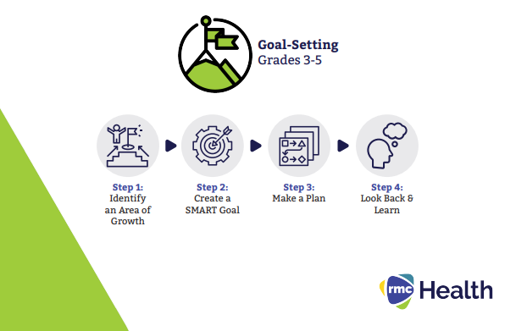  (RMC Health)
Example Assessments
Diagnostic  Gauge where students are in their learning prior to the beginning of the lesson. |  | Formative  Gauge student progress/growth through ongoing and periodic observation and/or checks for understanding. |  |  | Summative  Gauge student mastery of standards.
- Observation  - Instant activities |  | - Strategic questioning  - Peer feedback  - SMART Goal Worksheet  - Writing Prompts  - Acting Against Bullying Exercise  - Wheel Decide Review |  |  | - Health Goals Packet
Essential Questions for Unit
- How can goal setting help you prevent violence in your life?
- How can the skill of goal setting be applied to other situations in your life?
- What are some examples of violence?
- How can you express anger and resolve conflict without violence?
Lesson Title | Lesson Objectives |  |  | Skill Pedagogy Steps |  |  | Instructional Activities
#1 – Ready, Set, GOAL! | - Define goal setting  - Identify steps for effective goal setting  - Discuss the characteristics of SMART goals.  - Discuss the relevance of goal setting to violence prevention |  |  | #1. Teacher introduces skill – Why is goal setting important in adolescence? |  |  | - Padlet  - My Dream
#2 – Ready, Set GOAL 2 | - Goal Setting Cues:  Step 1 – Identify an Area of Growth  Step 2 – Create a SMART Goal  Step 3 – Make a Plan  Step 4 – Look Back & Learn  - Identify health-related situations that might require a thoughtful decision. (HE5.6.a) |  |  | # 1. Introduction Continued  #2. Teacher provides skill cues and critical elements for goal setting.  # 3. Model the skill of goal setting. |  |  | - SMART Goal Worksheet
Lesson Title | Lesson Objectives |  |  | Skill Pedagogy Steps |  |  | Instructional Activities
#3 – Bullying is Bad; It Makes Others Feel Sad | - Recognize the relationship between healthy behaviors and disease prevention (HE5.1.a)  - Describe and apply the basic health concept of mental and emotional well-being. (HE5.1.c)  - Describe and apply the basic health concept of personal hygiene and safety. (HE5.1.d)  - Identify trusted adults when it might be important to seek health care or emergency help for themselves or others (HE5.1.f)  - Distinguish between tattling, reporting aggression, bullying, cyberbullying, and violence (physical and/or sexual) and how to report these instances. (HE5.1.h)  - Identify strategies to avoid physical fighting and violence (HE5.1.i) |  |  | Functional Health Information - Violence Prevention  Determine prior violence prevention knowledge |  |  | - Video from StopBullying.gov  - Understanding Bullying  - Is It Teasing or Bullying?  - Acting Against Bullying  - Bullying & Feelings Wordle  - Reasons For Fighting  - Role Play Activity  - Dealing with Bullies
#4 – Dream Big! Set Goals! | - Identify strategies to avoid physical fighting and violence (HE5.1.i)  - Set a personal health goal and track progress toward its achievement (HE5.6.a)  - Identify and utilize resources to assist in achieving a personal health goal. (HE5.6.b) |  |  | #4. Students practice the steps of goal setting regarding violence prevention |  |  | - Review  - What Motivates You Instagram  - Get Goaling! Setting Goals to Help Prevent Violence  - Ticket Out the Door
Lesson Title | Lesson Objectives |  |  | Skill Pedagogy Steps |  |  | Instructional Activities
#5 – Final Assessment | - Set a personal health goal and track progress toward its achievement (HE5.6.a)  - Identify and utilize resources to assist in achieving a personal health goal. (HE5.6.b) |  |  | #4. Students practice the steps of goal setting  #5. Students receive feedback and reinforcement of skill development |  |  | - Wheel Decide Unit Review  - My Goals Booklet

Health/Grade 5

Sample Health Learning Plan:

Big Idea/ Topic

Let’s Commit! Setting Goals to Prevent Violence

Essential Question
How can the skill of goal setting help prevent violence?
How can the skill of goal setting be applied to other situations in my life?

Standard Alignment
HE5.6a Set a personal health goal and track progress toward its achievement.

Instructional Design
Skill Model Used in Unit: | Goal Setting Skill Cues  Step 1 – Identify an Area of Growth  Step 2 – Create a SMART Goal  Step 3 – Make a Plan  Step 4 – Look Back & Learn | (RMC Health)

Lesson Purpose:
The purpose of this lesson is to introduce the skill of goal setting.

Skill Pedagogy Steps:
# 1 – Teacher introduces skill – Why is goal setting important in adolescence?
# 2 – Teacher provides skill cues and critical elements for goal setting.
# 3 – Model the skill of goal setting.

Instant Activity:
As students enter, have them respond to the question: What is a goal?
You can use https://padlet.com/ to create an interactive poll
If used the students can place their responses on a teacher created padlet.
What words do you notice are used the most to describe a goal?

Focused Learning:
Introduction – Let the students know that this is the start of the goal setting and violence unit. At the end of the unit, they will set their own goals related to violence prevention.

Activity #1: My Dream
Teacher: How do you see yourself in the future? What would you like to accomplish? What are your hopes and dreams? The answer to these questions reflects your goals in life. Goals are things you aim for that take planning and work. Making plans help you achieve your goals. For example, you might have a goal to go to college. To reach that goal, you will plan what courses you take in high school so that you can graduate and attend college. You will also work hard to earn grades that will get you into college.

Create a vision board. Students can use the template provided or create their own.
A vision board is a visual representation of the students goals. Students should include hope, dreams, and goals. The vision board will help students organize their thoughts around goals. The visual will strengthen the connection for students. Prepare an example. Examples from previous student work can also be shared.
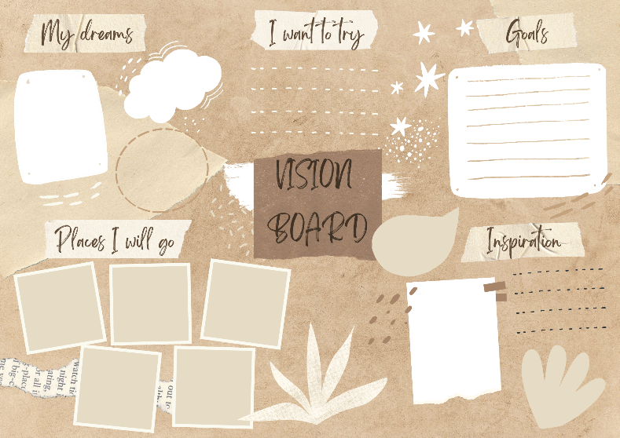

Activity #2: Goal–Setting Steps – After the vision board is complete, guide the students through the goal setting steps. Use the graphic below to help model the steps of the goal setting process for the students. The teacher should choose an area of growth from their “vision board,” and model how the students should properly set goals, plan, and look back and learn.

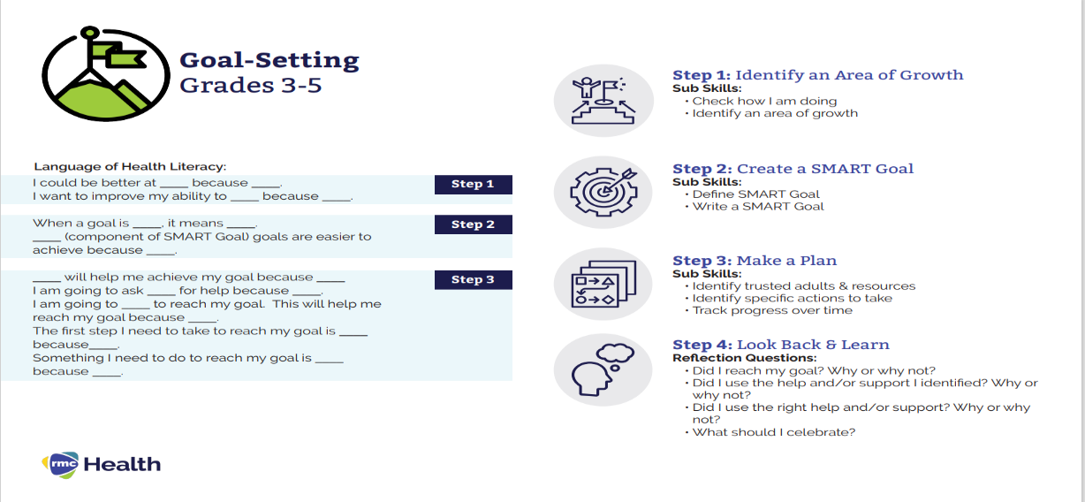
(RMC Health)
Activity #3: Student Cue Cards
Give each student 2 pieces of printer paper and a pair of scissors. Have students cut the pieces of paper in half hamburger style. Have students write 1 step of goal setting on each piece of paper and decorate it however they want. Allow students to staple their papers together in order of how the skill cues work. Students will display this cue book whenever they are working on something to show what step they are displaying.

Evidence of Student Success
Sample Assessments

Diagnostic  Gauge where students are in their learning prior to the beginning of the lesson. | Formative  Gauge student progress/growth through ongoing and periodic observation and/or checks for understanding. | Summative  Gauge student mastery of standards.
Observation  Instant Activity | Strategic questioning

 | Student Learning Supports
Language Used in the Lesson: |  | - Goals  - Goal monitoring  - Vision Boards
Differentiation: |  | - Select groups ahead of time.  - Have someone from the community come in and talk to the students about how they achieved their goals.
Materials: |  | - Handouts for notes  - Vision Board  - Paper for skill cue cards

Resources/Engaging Families
- 5 Facts About Goal Setting (for Teens) - Nemours KidsHealth
- Sanderson, Melissa. “Essential Health Skills.” (2023). Goodheart-Wilcox Company, Inc.
- Benes, Sarah Sparrow and Alperin, Holly, "Essentials of Teaching Health Education: Curriculum, Instruction, and Assessment" (2016). Books and Monographs.

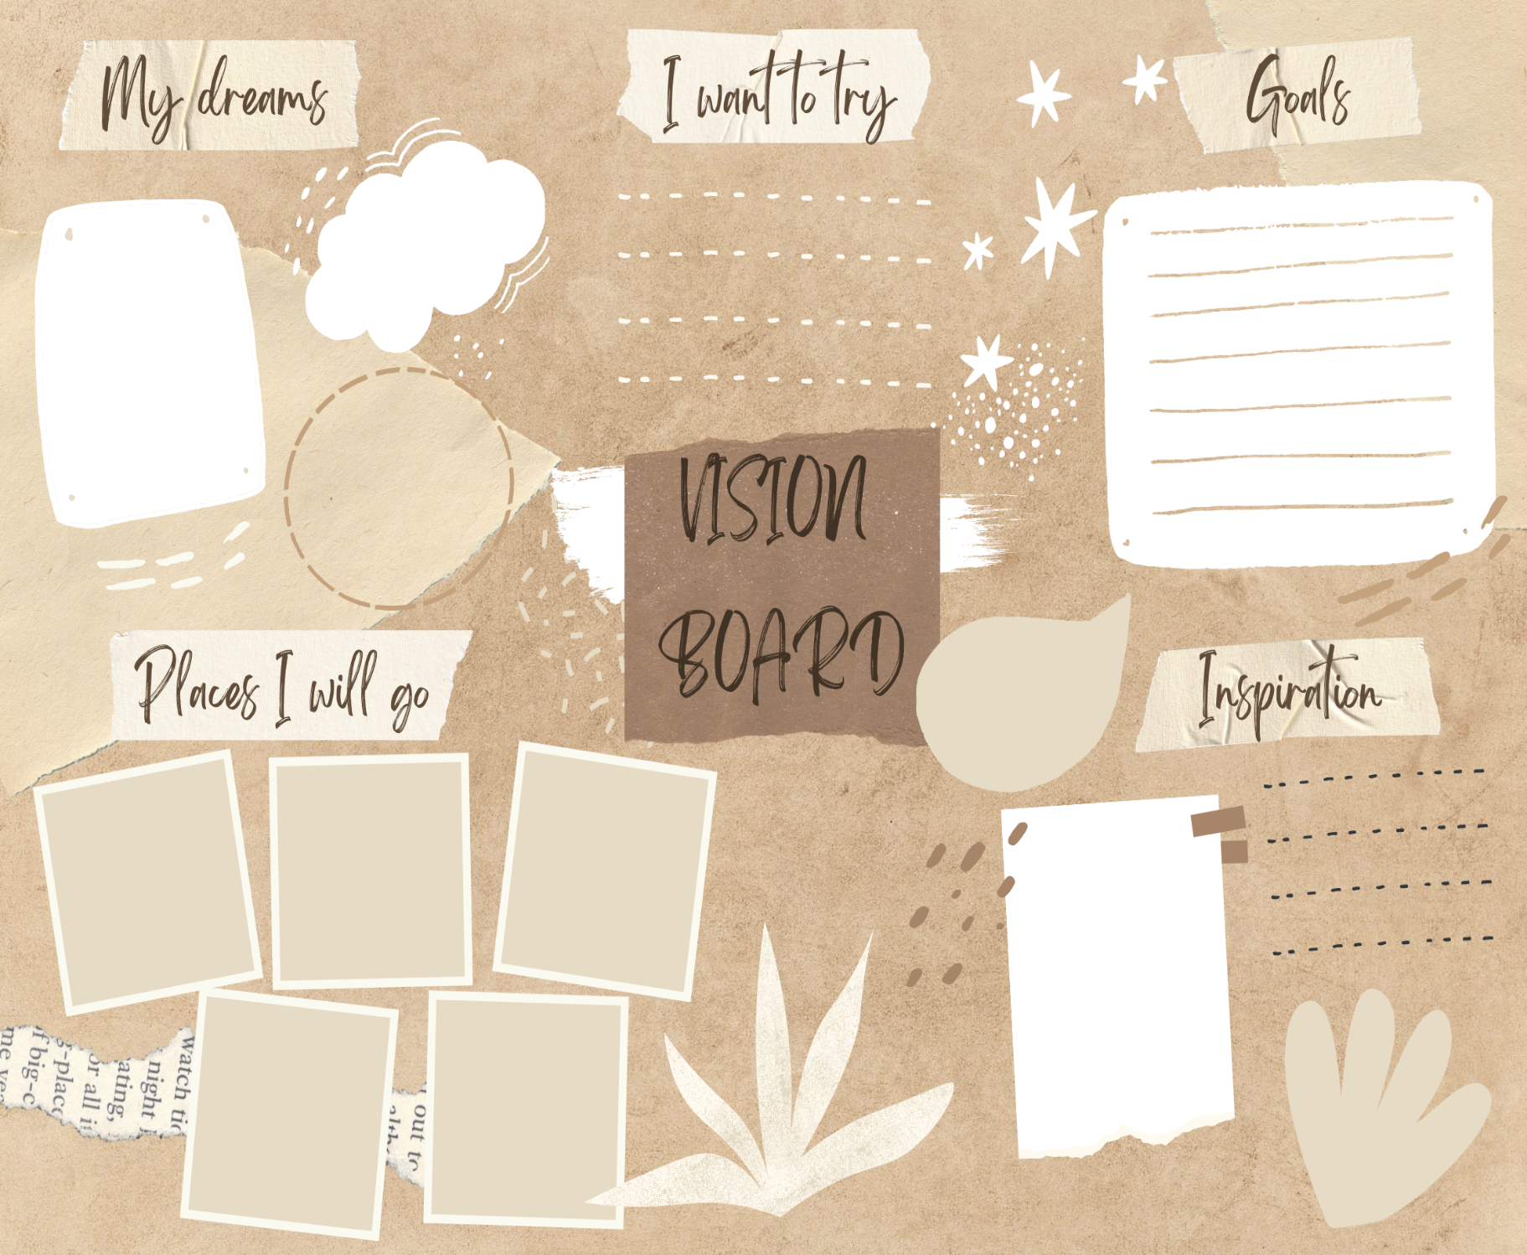

Health/Grade 5

Sample Health Learning Plan:

Big Idea/ Topic

Let’s Commit! Setting Goals to Prevent Violence (2)

Essential Question
How can the skill of goal setting help prevent violence?
How can the skill of goal setting be applied to other situations in my life?

Standard Alignment
HE5.6a Set a personal health goal and track progress toward its achievement.

Instructional Design
Skill Model Used in Unit: | Goal Setting Skill Cues  Step 1 – Identify an Area of Growth  Step 2 – Create a SMART Goal  Step 3 – Make a Plan  Step 4 – Look Back & Learn | (RMC Health)
Skill Pedagogy Steps:
Step #2: Present Skill Cues/Critical Elements
Step #3: Model the Skill

Lesson Purpose:
The purpose of this lesson is to introduce the skill cues, have the students engage with the skill cues and model the skill.

Instant Activity:
As students enter, have them respond to the question. What is a goal? You can use https://www.mentimeter.com/ to create an interactive poll or https://padlet.com/
If used the students can place their responses on a teacher created padlet.
What words do you notice are used the most to describe a goal?

Focused Learning:
Activity #3: SMART Goal Worksheet
Review the cues. Have student use their created vision boards, as the teacher guides them through the goal setting steps. Teacher needs to model the steps of the goal setting process for the students. The teacher should choose an area of growth from their “vision board,” and model what the students need to do to properly set goals, plan, and look back and learn. Model with both short term and long-term goals.

Step 1: Identify an Area of Growth- choose three items from their vision board.
Step 2: Create a SMART Goal – review the characteristics of a SMART goal. Students should complete the SMART goal worksheet. Have students complete a long- and short-term goals.

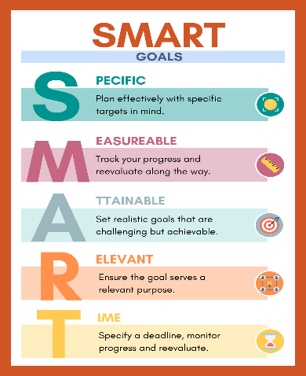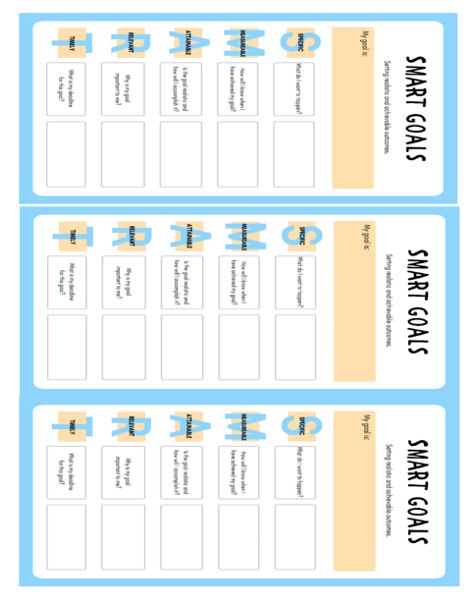

Step 3: Make a Plan – have the students talk with a partner about plans to achieve their goals.
Step 4: Look Back & Learn – this is what you would do after a certain period. Discuss short-term goals, long-term goals, and goal monitoring.

Closing:
Teacher: Discuss how having a vision of what you want to do and who you want to be can help keep you motivated to work toward your goals.
How do you create and implement a good a health goal? SMART, Plan and Look Back.
How can setting goals help you throughout life?

Evidence of Student Success
Sample Assessments
Diagnostic  Gauge where students are in their learning prior to the beginning of the lesson. | Formative  Gauge student progress/growth through ongoing and periodic observation and/or checks for understanding. | Summative  Gauge student mastery of standards.
Observation  Instant Activity | Strategic questioning

 | Student Learning Supports
Language Used in the Lesson: |  | - Goals  - Goal monitoring  - SMART goal  - Long term goal  - Short term goal |  | - Long term goal  Short term goal
Differentiation: |  | - Select groups ahead of time.  - Have someone from the community come in and talk to the students about how they achieved their goals.
Materials: |  | - SMART GOAL Poster  - SMART Goal worksheet

Resources/Engaging Families
- 5 Facts About Goal Setting (for Teens) - Nemours KidsHealth
- Sanderson, Melissa. “Essential Health Skills.” (2023). Goodheart-Wilcox Company, Inc.
- Benes, Sarah Sparrow and Alperin, Holly, "Essentials of Teaching Health Education: Curriculum, Instruction, and Assessment" (2016). Books and Monographs.

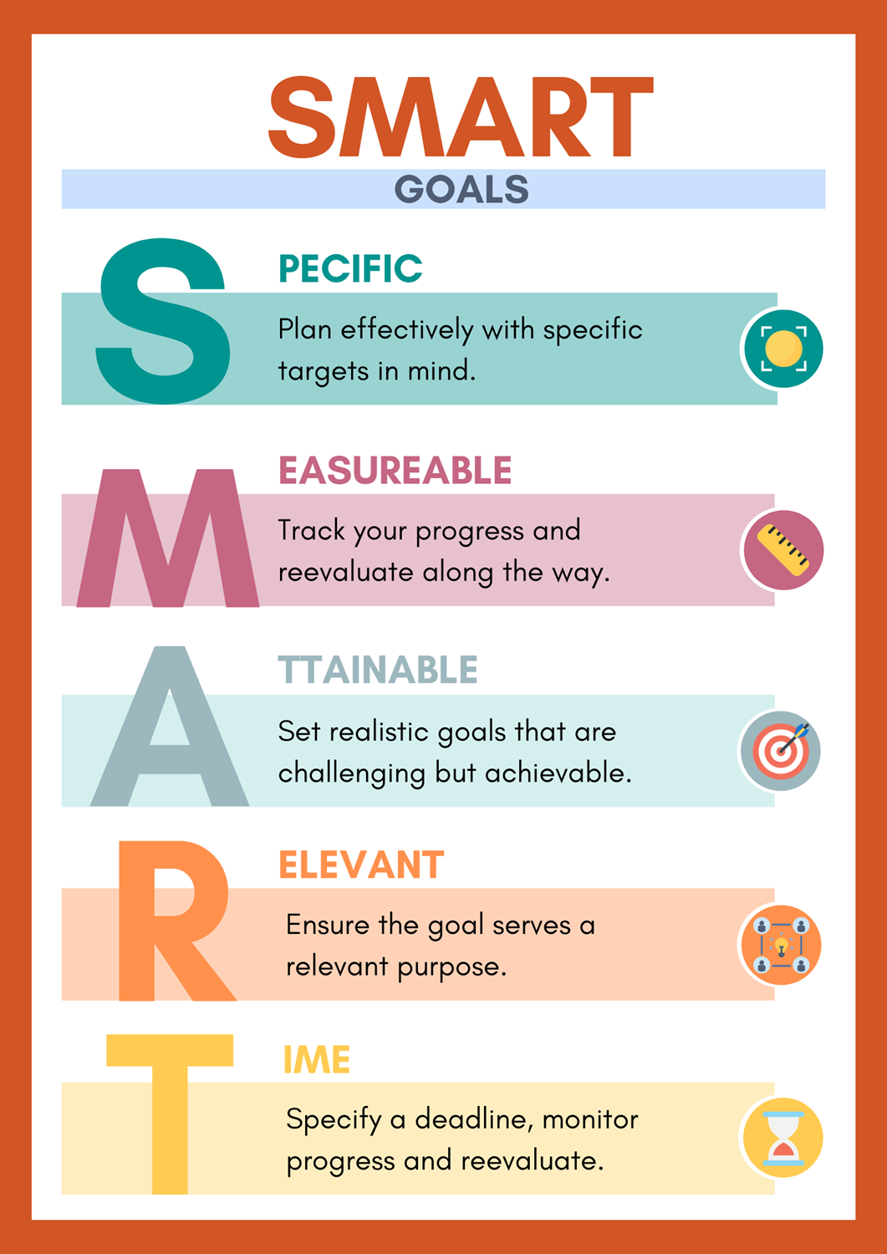
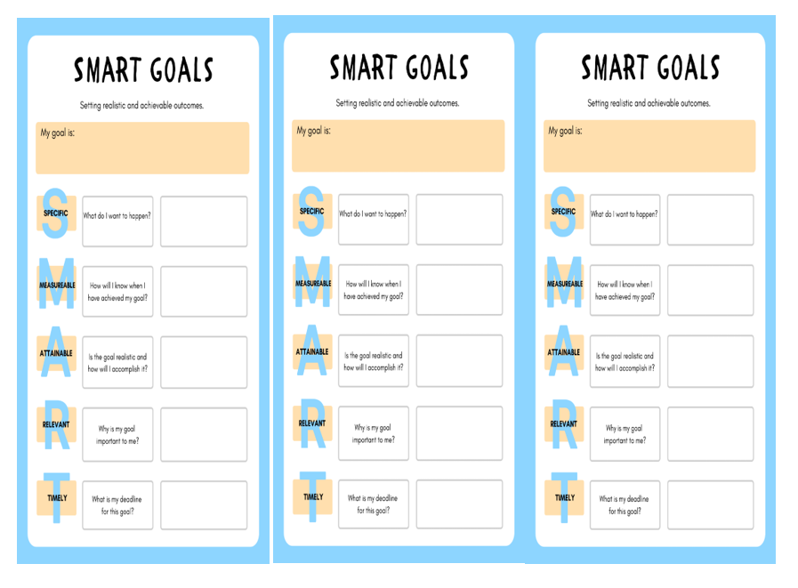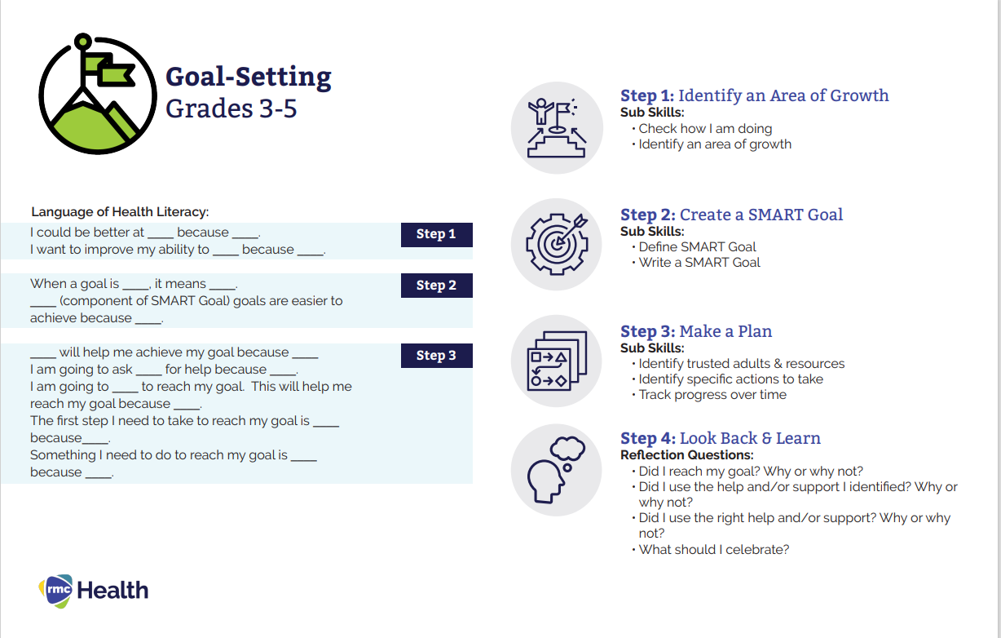

Health/Grade 5

Sample Health Learning Plan:

Big Idea/Topic

Bullying Is Bad; It Makes Others Feel Sad

Essential Questions
What is the difference between bullying and teasing?
What are reasons why people bully others?
Why is it wrong to tease or bully others based upon personal characteristics?

Standard Alignment
HE5.1.c Describe and apply the basic health concept of mental and emotional well-being.
HE5.1.d Describe and apply the basic health concept of personal hygiene and safety.
HE5.1.f Identify trusted adults and when it might be important to seek health care or emergency help for themselves or others.
HE5.1.h Distinguish between tattling, reporting aggression, bullying, cyberbullying, and violence (physical and/or sexual) and how to report these instances.

Instructional Design
Skill Model Used in Unit: | Goal Setting Skill Cues  Step 1 – Identify an Area of Growth  Step 2 – Create a SMART Goal  Step 3 – Make a Plan  Step 4 – Look Back & Learn | (RMC Health)
Skill Pedagogy Steps:
Functional Health Information on bullying

Lesson Purpose:
The purpose of this lesson is to learn about bullying and that it can affect young people and their health.

Instant Activity:
Show the short video from StopBullying.gov - https://www.stopbullying.gov/resources/kids/kid-videos/melanies-friends
Deliver a short quiz at the end of the movie with the class. As the students are taking the quiz, ask questions about the answer choices. Why would each answer be wrong?

Focused Learning:
Introduction:
Activity #1: Understanding Bullying
Teacher: Bullying is when one person hurts another on purpose more than once. The hurt can be physical, verbal, emotional, or social. It can happen in person or online. Bullying someone online is called cyberbullying. Have students complete the “What Bullying Means to Me” Writing Prompts.

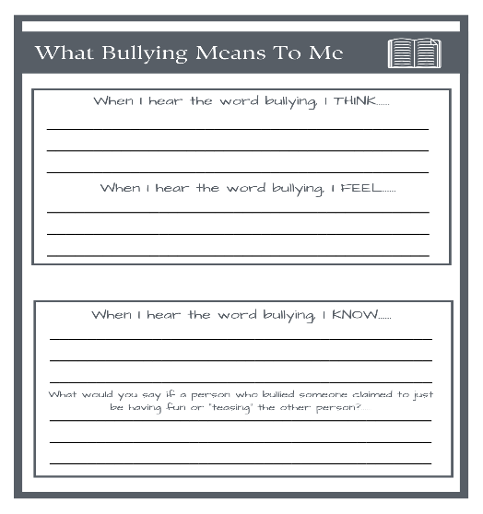
After students have completed the writing prompts discuss what bullying means to students? How do you feel about bullying and what do you already know?

Activity #2 – Is it Teasing or Bullying?
Ask the students the following questions and have them hold up one finger if they think it is teasing and two fingers if they think it is bullying.
• Meant to be fun – teasing
• Done on purpose to hurt someone – bullying
• Has more power than the person being hurt - bullying
• Happens between friends – teasing
• Doesn’t hurt someone’s feelings – teasing

Reminder:
Teasing:
• Teasing happens between friends or people who like each other.
• Teasing is meant to be fun, not to hurt someone’s feelings.
• If teasing appears to hurt someone’s feelings or makes the person
being teased upset, friends will stop and say they are sorry.

Bullying:
• Bullying is done on purpose to hurt someone.
• Often the person doing the bullying has more power than the person
being bullied.
Summarize:
Sometimes people tease each other to have fun or get a reaction. There’s
nothing wrong with teasing between friends who like each other when
both people enjoy it and understand that it isn’t meant to hurt the
person being teased.
Sometimes teasing can go too far. When friends notice that their teasing
has hurt another person’s feelings, they stop and say they are sorry.
They don’t let teasing hurt their relationships.
Bullying is done on purpose to hurt someone. The bully doesn’t stop if
the other person becomes upset or feels hurt.

Activity #3: Acting Against Bullying
Teacher: Discuss the difference between a bully, a target, and a bystander. The purpose of the role play is to understand these differences. Divide the class into groups and give them one of the bullying scenarios in the PowerPoint to act out. You can also cut out the scenarios, place them on index cards and pass them out to the groups. bullying scenarios.pptx

Role Play Criteria:
Prior to role play discuss them four roles: bully, victim, bystander, and adult.
Discuss the difference is how the person in each role might feel during bullying situation.

Set guidelines for all classroom role playing activities:
Role players behavior: Eye contact, gestures, voice; specific language to be used and language not to be used profanity and slang. No physical contact.

Discuss the role of a trusted adult and when you should report bullying. What is the difference between tattling and reporting aggression?

Key Points:
Tattling
1. No one is hurt or injured.
2. The person did it by accident and is sorry.
3. You can solve this on your own.
4. Your goal is to get someone in trouble
Telling
1. Someone is hurt and needs help.
2. The person did it on purpose to be mean.
3. Nothing you have done has stopped it.
4. You cannot solve this without an adult’s help.
5. Your goal is to keep someone safe.

Activity #4: Bullying & Feelings
Teacher: Create a wordle - Make Your Own Wordle (strivemath.com) and have the students guess the words of how bullying can make people feel. (Helpless, ashamed, frustrated, lonely, embarrassed, etc.). You can also have students put in the words to the wordle and have their classmates’ guess. This game can be played as a class, or in small groups. Discuss healthy ways to express emotions. We will discuss in more detail in lesson four.

Activity # 5: Dealing with Bullies
Teacher: Play or read “Dealing with Bullies” podcast.
https://kidshealth.org/en/kids/bullies.html
Discuss how to deal with a bully. The best strategies to use and those to avoid a bully.
Ignore, stand up for yourself, do not bully back, don’t hit or escalate it to violence, don’t show you are upset, plan ahead on how to react, tell an adult

Closing:
Teacher: What did you learn from these activities? What roles do bystanders play in bullying? What can you do if you see someone being bullied? How can being bullied make you feel? What goal could you set when placed in these sorts of situations? How can having a goal help you manage these sorts of situations?
Formats for discussion: Whole class discussion; small group; written response.

Evidence of Student Success
Sample Assessments
Diagnostic  Gauge where students are in their learning prior to the beginning of the lesson. | Formative  Gauge student progress/growth through ongoing and periodic observation and/or checks for understanding. | Summative  Gauge student mastery of standards.
Observation  Instant Activity | Bullying Writing Prompt  Acting Against Bullying  Wordle Creator | No summative assessment for this lesson.

 | Student Learning Supports
Language Used in the Lesson: |  | - Bullying  - Cyberbullying  - Teasing  - Bystander  - Feelings  - Solution  - Tattling
Differentiation: |  | - Select groups ahead of time.  - Students can write about the bullying scenarios instead of acting them out.
Materials: |  | - Handouts for notes  - Bullying scenario PowerPoint  - Bullying writing Prompt

Resources/Engaging Families
- Stop Bullying.Gov
https://www.stopbullying.gov/
- “Dealing with Bullies” podcast.
https://kidshealth.org/en/kids/bullies.html
- Benes, Sarah Sparrow and Alperin, Holly, "Essentials of Teaching Health Education: Curriculum, Instruction, and Assessment" (2016). Books and Monographs.
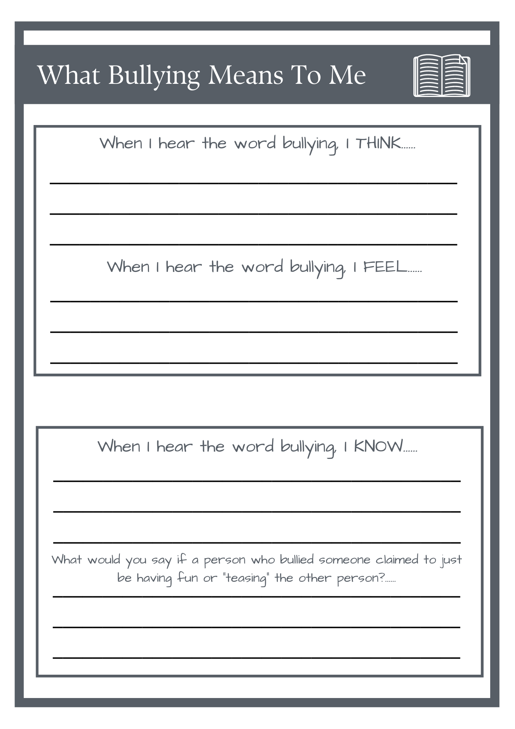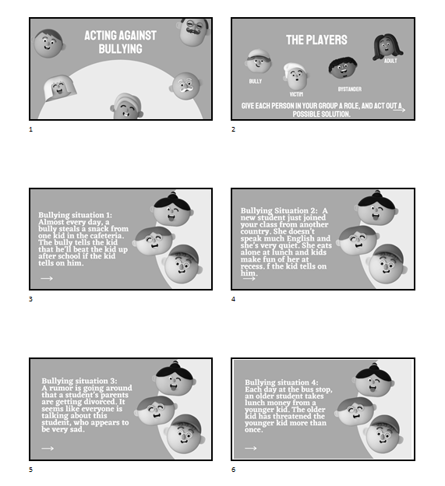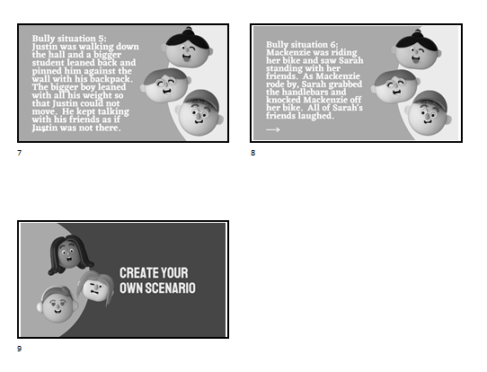

Health/Grade 5

Sample Health Learning Plan:

Big Idea/ Topic

Dream Big! Set Goals!

Essential Questions
How can making a goal help to avoid having bullying lead to violence?
What are some strategies to help you achieve a goal to avoid violence?

Standard Alignment
Identify strategies to avoid physical fighting and violence. (HE5.1.i)
Set a personal health goal and track progress toward its achievement. (HE5.6.a)

Instructional Design
Skill Model Used in Unit: | Goal Setting Skill Cues  Step 1 – Identify an Area of Growth  Step 2 – Create a SMART Goal  Step 3 – Make a Plan  Step 4 – Look Back & Learn | (RMC Health)
Skill Pedagogy Steps:
# 4 – Students practice the steps of goal setting regarding violence prevention.

Lesson Purpose:
The purpose of this lesson builds on the foundation set in the previous two lessons to help the students recognize the importance of violence prevention. Students will connect goal setting skills to violence prevention.
Instant Activity:
After the students take their seats, have them write their response to the following prompt: “What motivates you? Write down three things that will motivate you to accomplish your goals.”

Focused Learning:
Introduction
Activity #1: Review
Teacher: Ask students about what information they have learned so far in this unit. What have they learned about goal setting? What have they learned about violence prevention? Today we are going to
think about what motivates you to achieve a goal, and review our vision boards from lesson one, and create goals.
Activity #2 – What Motivates You?
Teacher: What does motivation mean? How can motivation help people achieve a goal? Ask for responses and write them on the board. Using the template below have the students create an “Instagram Post” that has a motivational quote on it and a picture. You can look on the internet for examples of motivational quotes, or use the ones on Canva - 30 inspirational quotes for students
30 inspirational quotes for students (canva.com)

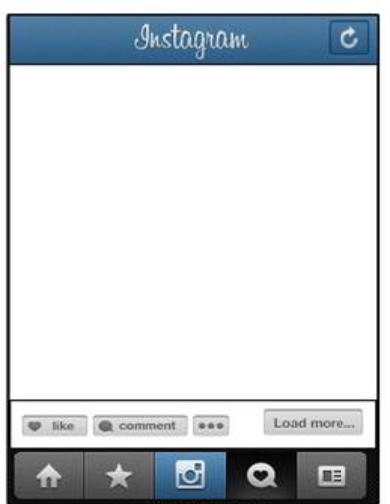

Activity #3 Get Goaling! Setting Goals to Prevent Violence – In addition to personal goals, we are going to make goals to help with bullying and how to avoid it turning into violence. Think about what we learned in the last lesson regarding strategies and fill out the brainstorming worksheet.
Teacher: Think about a bullying situation that led to conflict that you have had at school or at home. Let students share their stories with a peer or aloud with the group. If they have never had a bullying turn conflict situation, have they witnessed one and wish they did something to help? The students will produce a SMART goal to help them stay violence free.

If there is time, let the students share their goals with each other.

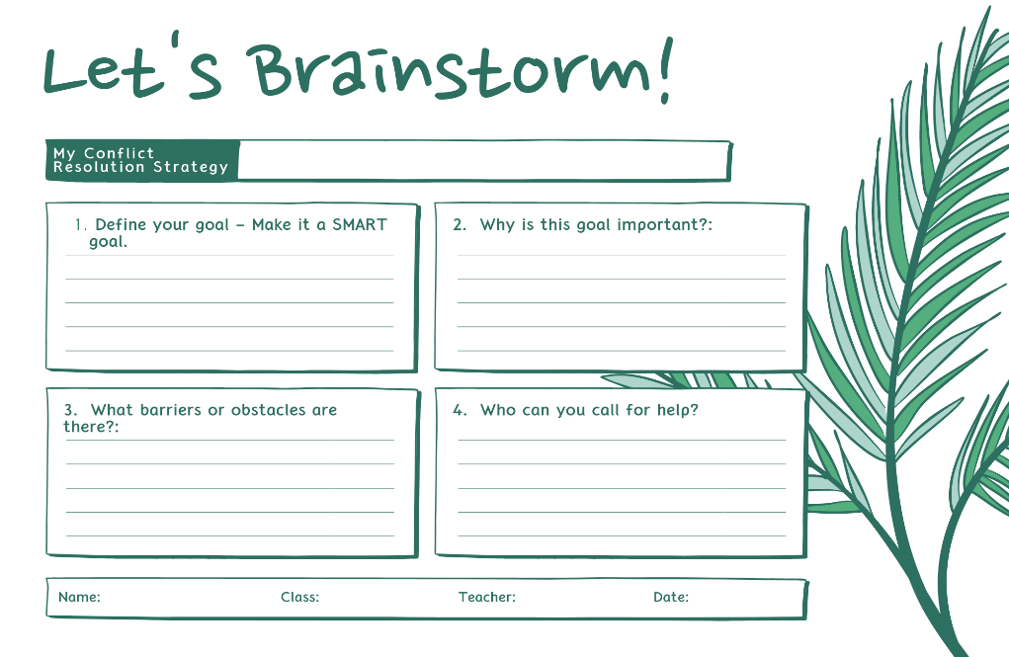
Closing: Teacher: Ticket out the door activity. Give each student a slip to fill out and they have to give it to you to leave class today. Use their responses to gauge knowledge and comprehension.

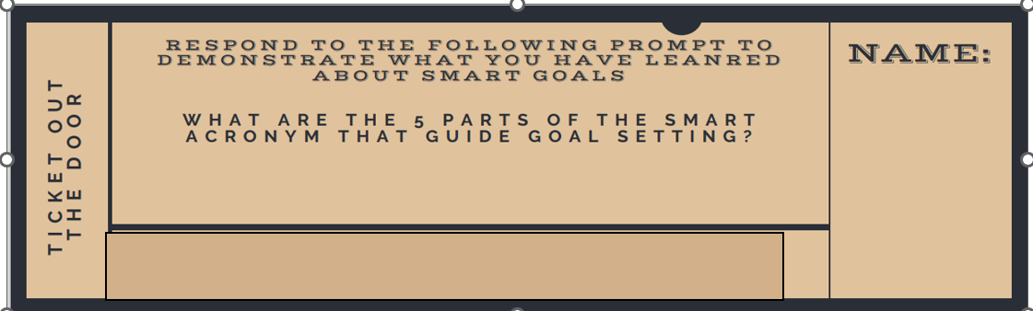

Evidence of Student Success
Sample Assessments
Diagnostic  Gauge where students are in their learning prior to the beginning of the lesson. | Formative  Gauge student progress/growth through ongoing and periodic observation and/or checks for understanding. | Summative  Gauge student mastery of standards.
Observation  Strategic Questioning | Motivation Instagram  SMART goal | No summative assessment in this lesson.

 | Student Learning Supports
Language Used in the Lesson: |  | - Motivate  - SMART goal  - Violence  - Strategy
Differentiation: |  | - Select groups ahead of time  - Provide access to materials either through handouts or images online.  - Allow students to create their Instagram posts on the worksheet or with an online tool.  - Allow students to take their assignments home to complete
Materials: |  | - Completed vison board from lesson one  - Instagram Template  - Brainstorm Sheet  - Ticket Out the Door

Resources/Engaging Families
- Stop Bullying.Gov https://www.stopbullying.gov/
- “Dealing with Bullies” podcast.
https://kidshealth.org/en/kids/bullies.html
- Benes, Sarah Sparrow and Alperin, Holly, "Essentials of Teaching Health Education: Curriculum, Instruction, and Assessment" (2016). Books and Monographs.

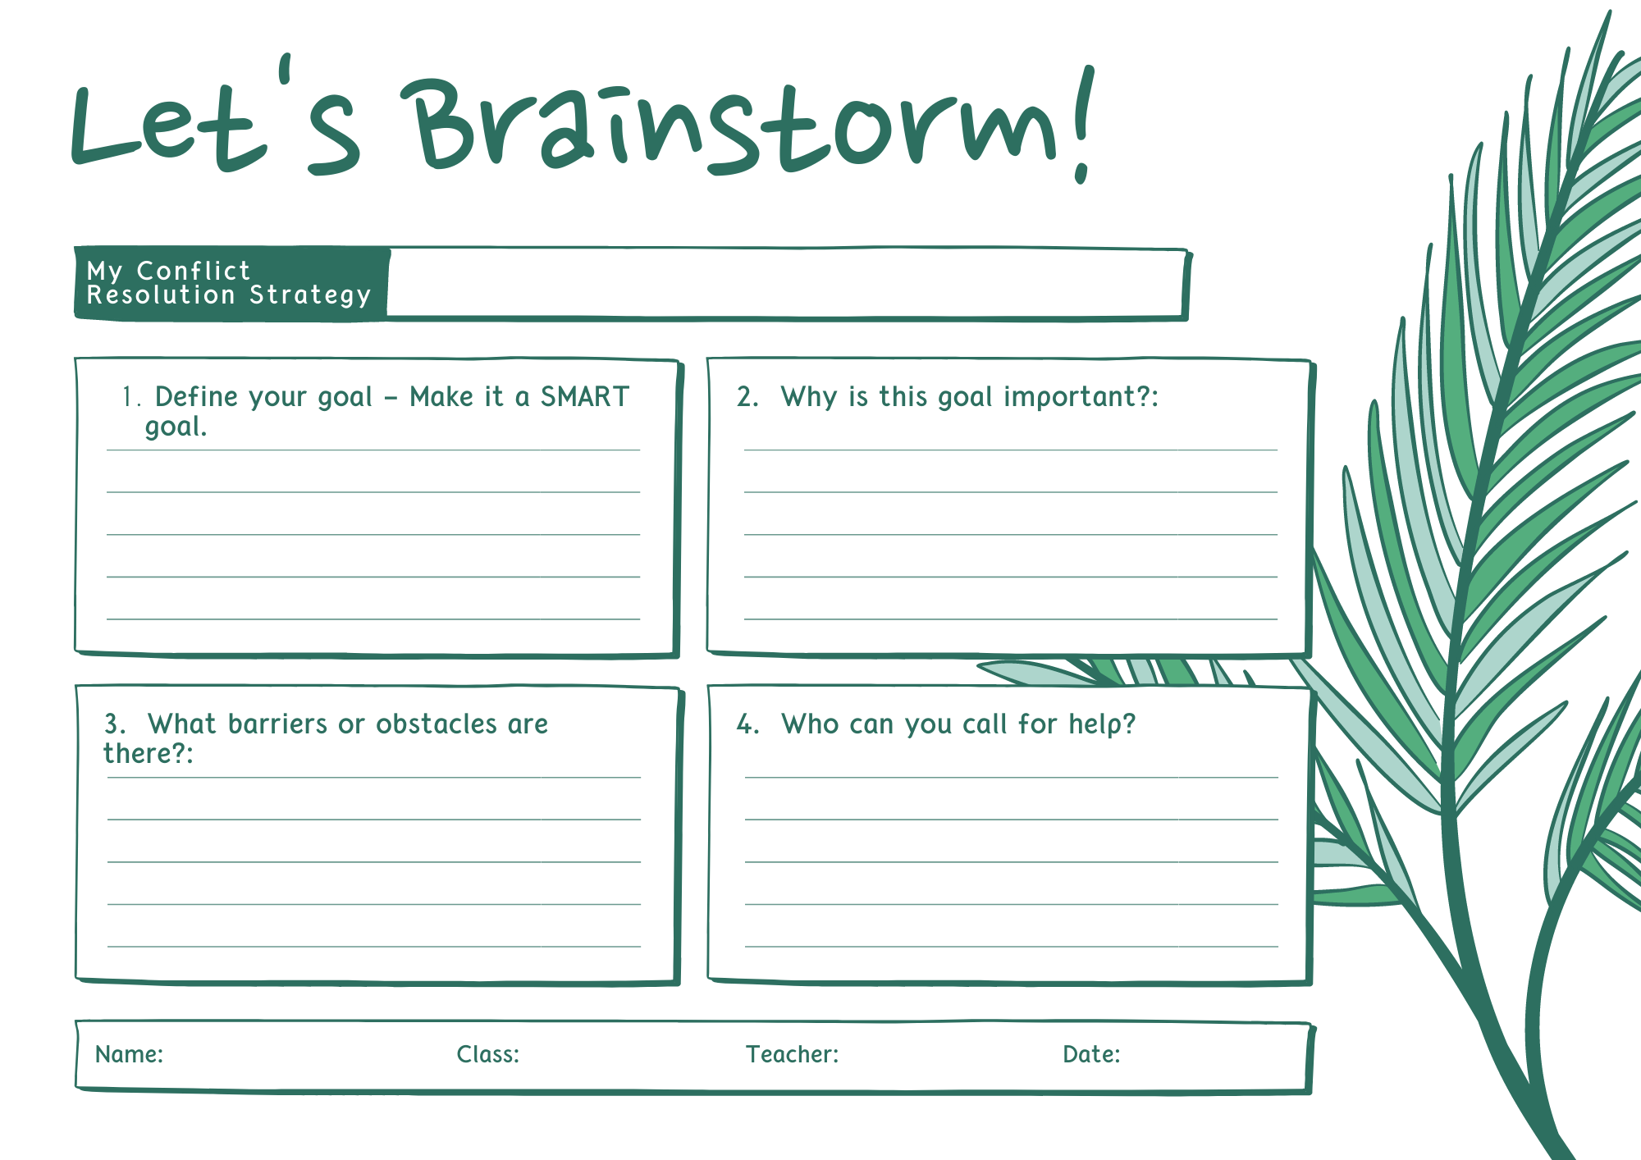

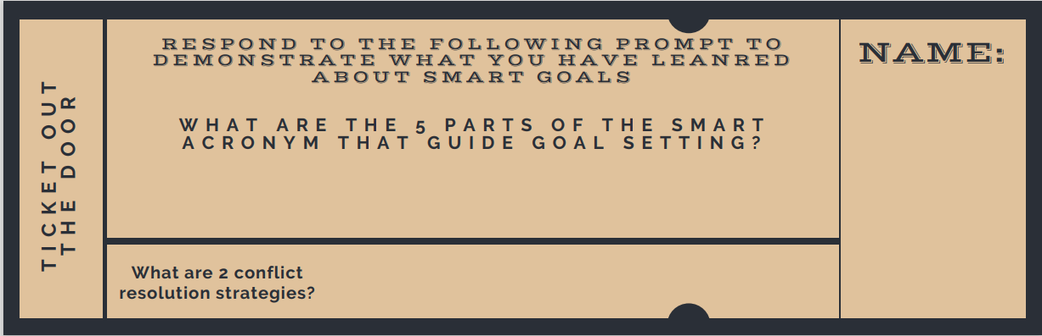

Health/Grade 5

Sample Health Learning Plan:

Big Idea/ Topic

Assessment Setting Goals

Essential Question
How can goal setting help prevent violence?
How can the skill of goal setting be applied to other situations in my life?
How can a short-term goal help you achieve your long-term goals?

Standard Alignment
HE5.6a Set a personal health goal and track progress toward its achievement.

Instructional Design
Skill Model Used in Unit: | Goal Setting Skill Cues  Step 1 – Identify an Area of Growth  Step 2 – Create a SMART Goal  Step 3 – Make a Plan  Step 4 – Look Back & Learn | (RMC Health)
Lesson Purpose:
Throughout this unit, students have worked through various goal-setting activities and learned about violence prevention strategies. We will review all prior information and set some short-term goals that can be measured to ensure students understand the goal-setting process.

Skill Pedagogy Steps:
#4. Students practice the steps of goal setting
#5. Students receive feedback and reinforcement of skill

Instant Activity:
Wheel Decide Unit Review
Teacher: This is the end of our violence and goal-setting unit. Let’s review what you learned and see what you remember. Go to Wheel Decide Review
You can also create your own “wheel decide” https://wheeldecide.com/
You can play this as a class or share the link with the students and they can play on their own, with a partner, or in a group.
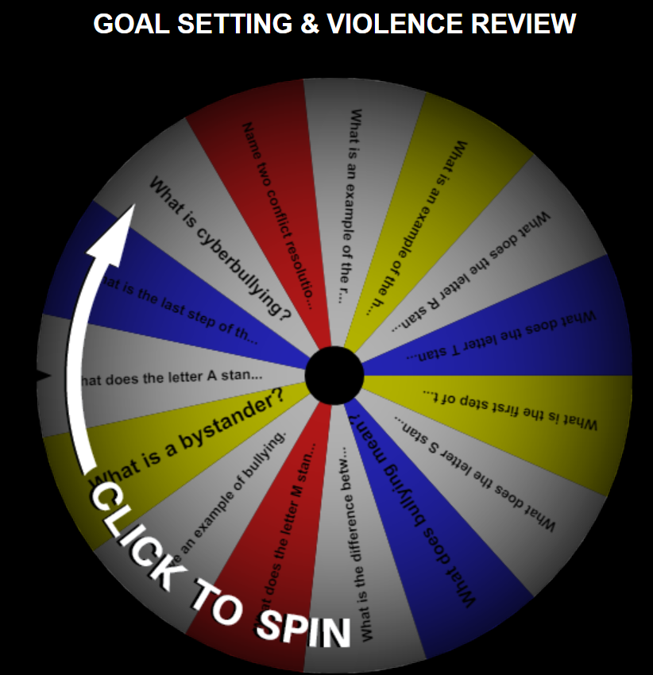
Focused Learning:
#1: Tracking Your Goals
Teacher: Students should have four SMART goals by now. They wrote goals in lesson one, and in lesson four. Those goals may be both long and short-term goals. Today, we are going to make one long-term goal and three short-term goals to track the progress toward achievement.

Reminder, a short-term goal is something you work toward that you can reach in a short amount of time. A long-term goal is something you work toward that takes a longer amount of time.

Directions:
Explain to the students that we are going to track our progress toward the achievement of three short-term goals. Give each student the “My Goals Booklet” and give them at least two weeks to complete it. The entire booklet is at the end of this document. Students need to create a personal health goal, a school goal, and a conflict resolution goal. Students should work through the goal-setting cues that have been taught in this unit.

On the cover page, have the students write their motivational quote from lesson four.
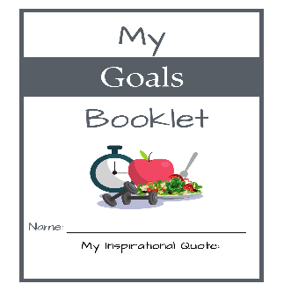
There is one long-term and two short-term goal sheets. Students need to: identify an area of growth; create their SMART goal; set a plan for the next ten days; and track their progress.
- Violence Prevention Health Short-Term Goal – for example, for the next 7 days, each time I feel angry count to ten to calm down.
- School Short-Term Goal – for example, study each night, practice my math facts, read for 30 minutes, etc.
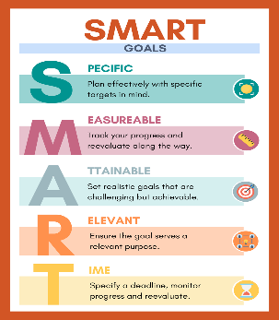
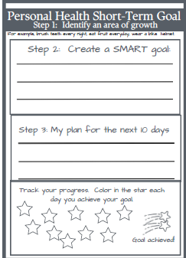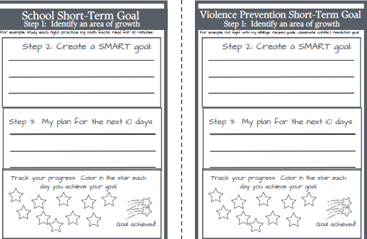
Students should monitor their goals for 10 days. If they achieve their goal on a day, the students should color in the star on each sheet.

Reflection Sheets - After 10 days, have the students complete the last three sheets – “step 4 - look back and learn”. There are reflection questions to answer for each short-term goal.

Post or provide the skill cues for students to view as they complete the reflection.

Sharing - After the students have completed their Goals Booklet (including the ten-day goal monitoring and completing the look back and learn reflections), allow the students to share their progress. Students can share in a variety of modes, including partner discussion, whole-class discussion, and one-on-one conferencing.

Grading Rubric:
There is a grading rubric for the Health Goals Booklet at the end of this document.
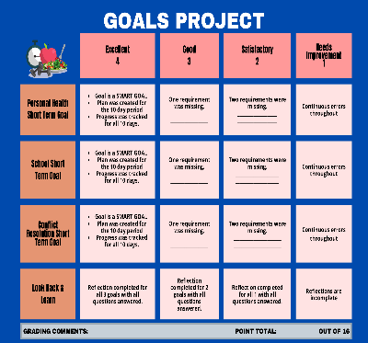

Closing:
Teacher:
Throughout this unit, we have spent time exploring the process of goal setting, specifically around our behaviors related to violence prevention. This important skill can also be used in other areas of our lives. Where do you see that you could use this skill in your life?

Allow the students to share their responses to the questions.

Evidence of Student Success
Sample Assessments
Diagnostic  Gauge where students are in their learning prior to the beginning of the lesson. | Formative  Gauge student progress/growth through ongoing and periodic observation and/or checks for understanding. | Summative  Gauge student mastery of standards.
Observation  Strategic questioning | Wheel Decide Review | Goal setting packet

 | Student Learning Supports
Language Used in the Lesson: |  | - Violence  - SMART goal  - Long-term goal  - Reflect  - Bullying  - Bystander  - Short-term goal  - Achieve  - Cyberbullying  - Conflict Resolution  - Strategy  - Monitoring
Differentiation: |  | - Instead of using Wheel Decide, have the students share what they have learned in this unit.  - Students can work alone, with a partner, or in a group.  - Students can fill out the health goals booklet or create a presentation with the same information.
Materials: |  | - Health Goals Booklet  - Project Rubric

Resources/Engaging Families
Sanderson, Melissa. (2023). Essential Health Skills. Goodheart-Wilcox Company, Inc.
Wheel Decide (https://wheeldecide.com/)

