**Welcome to the GaDOE Fine Arts Community!**

The Georgia Department of Education has launched a new, innovative platform to provide Fine Arts teachers, administrators, and GaDOE staff the opportunity to collaborate, connect, and share thoughts and resources as well as encouragement for the 2020-2021 school year! The instructions below will help guide you in the creation of your account and navigating to the communities that you are interested in. We look forward to connecting and collaborating with you! Join today!

**To Get Started:** Visit the [**GaDOE Community**](http://community.gadoe.org/) website.

**Step 1:** To get started, select **Create an Account** and follow the prompts for setting up a new account on the platform. **Be sure to use a DOE, RESA, or district email account** for GaDOE Community!

**Step 2:** Once you have completed your account you are now ready to join a group! Navigate to the **Groups section**.

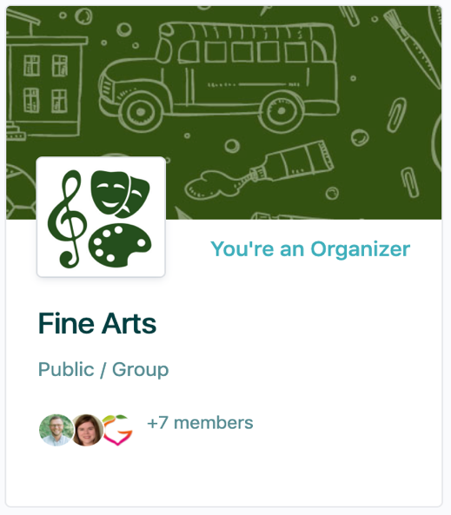

**Step 3:** This is the main Fine Arts group. This group will have updates, feeds, and discussions from the GaDOE Fine Arts Department.

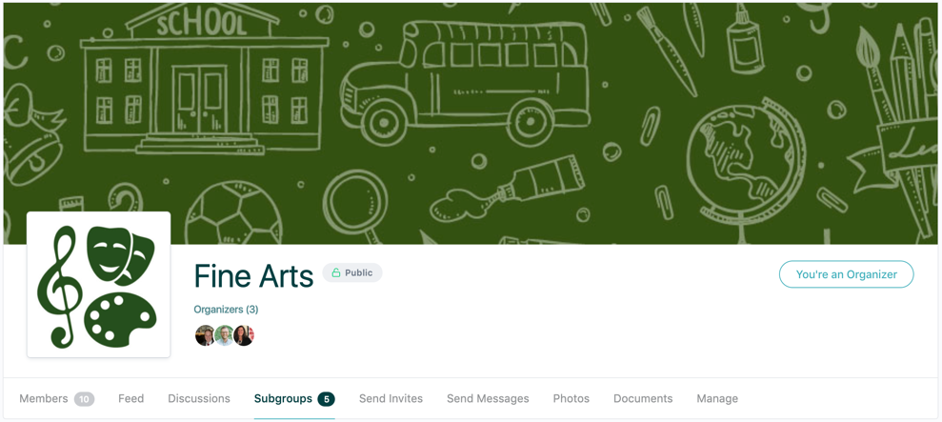

These menu items will help you interact and communicate with other members of our online community. For more information on the navigation pane, take a look at the [GaDOE Community Navigation Video](https://spark.adobe.com/video/xT4ZvNYDhulox).

Within the main Fine Arts GaDOE Community, there are several Fine Arts subgroups that you can join as well to continue connecting and collaborating with other Georgia Fine Arts teachers and administrators within your respective Fine Arts content areas.

**FINE ARTS SUBGROUP COMMUNITIES:**

The following are grade-level and content-specific subgroups within each of the five Fine Arts Subgroup Communities. These groups are available to join for more specified support, discussion, collaboration with like-minded teachers across the state of Georgia!

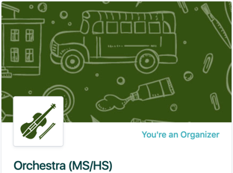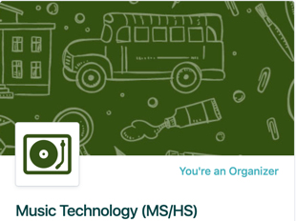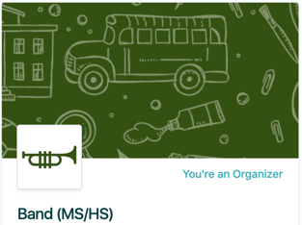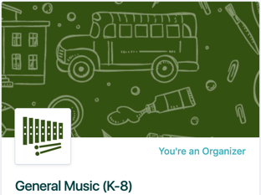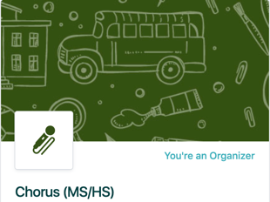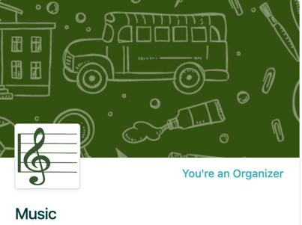

**MUSIC COMMUNITIES:**

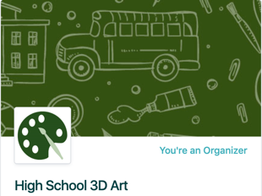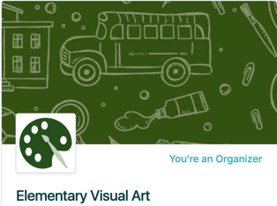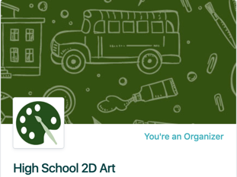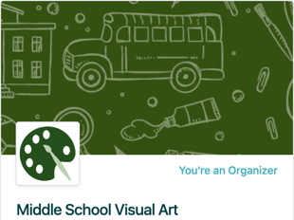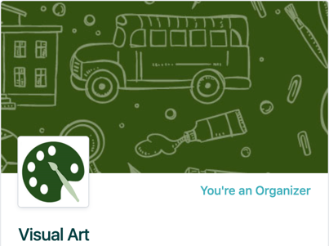

**VISUAL ART COMMUNITIES:**

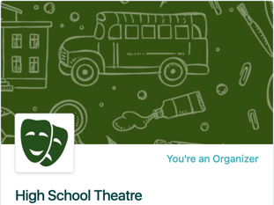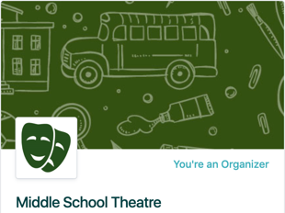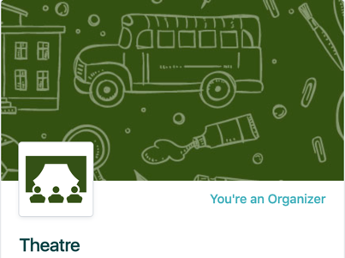

**THEATRE COMMUNITIES:**

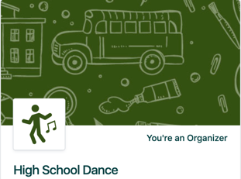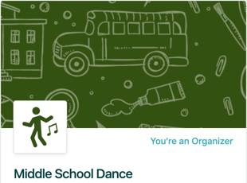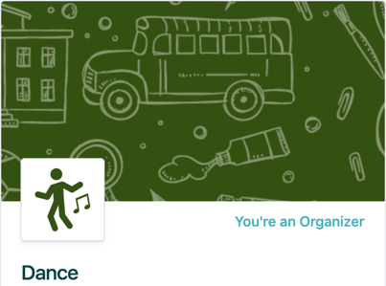

**DANCE COMMUNITIES:**

**MEDIA ART COMMUNITY:**

