**The Georgia Department of Education has launched a new innovative platform to provide the opportunity for health and physical education teachers and administrators and GaDOE staff to collaborate, connect and share thoughts and resources as well as encouragement for the 2020-2021 school year! The instructions below will help guide you in the creation of your account and navigating to the communities that you are interested in. We look forward to connecting!**

**Welcome to the GaDOE Health & P.E. Community!** 

Step 1: [Visit the GaDOE community website via this link.](http://community.gadoe.org/wp-login.php?redirect_to=http%3A%2F%2Fcommunity.gadoe.org%2F&bp-auth=1&action=bpnoaccess) (community.gadoe.org)

You will see the following screen:

Step 1: To get started, select **Create an Account** and follow the prompts for setting up a new account on the platform.

Step 2: Once you have completed your account you are now ready to join a group! Navigate to the **Groups section**.

This is our main page and will have updates and feeds of the latest info. ES, MS and HS pages are subcategories under this page. Georgia’s HPE page is a stand-alone community for HPE teachers and administrators.

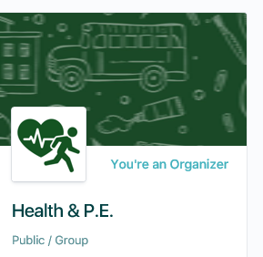

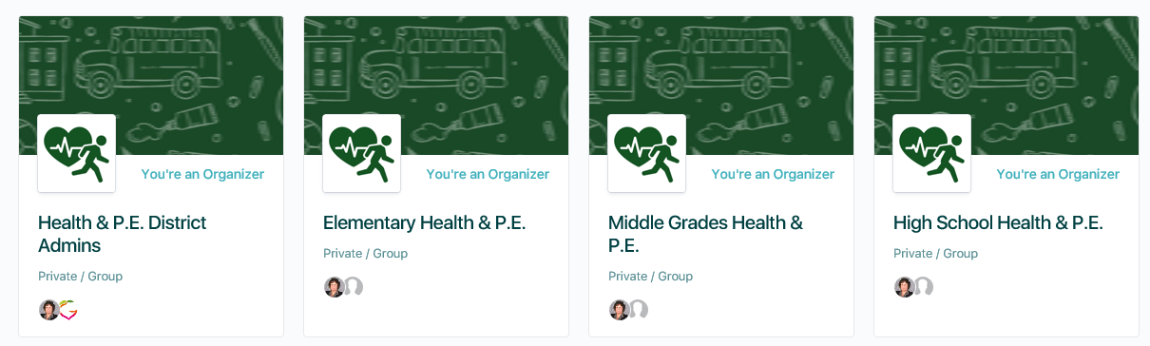

**Each group has a brief description provided and when you join a group…you will see the following menu:**

**Join us today and let’s start collaborating!**