





Volume 1 (Click to change text) ( Name) School
March 2012


If you could only sense how important you are to the lives of those you meet how important you can be to the people you never dream of. There is something of yourself that you leave at every meeting with another person. ~ Fred Rogers

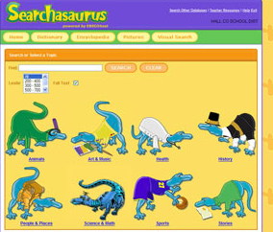


Literary Birthdays
Dr. Seuss March 2
Leo Dillon March 2
Patricia MacLachlan March 3
Suse MacDonald March 3
Meindert DeJong March 4
Dav Pilkey March 4
Mem Fox March 5
Ezra Jack Keats March 11
Diane Dillon March 13
Marguerite de Angeli March 14
Mitsumasa Anno March 20
Bill Martin, Jr. March 20
David Wisniewski March 21
Randolph Caldecott March 22
Anna Sewell March 30

Read a Book, Read a Winner!

The fun of reading isn’t just the book; it’s also in telling your friends about it! This site lets kids give their opinions of books they’ve read so others can find good reading material quickly!
http://www.worldreading.org/




Searchasaurus: Primary/Elementary Search provides an animated search interface with a dinosaur theme in an effort to encourage students to enhance and develop basic search methodologies. This interface provides access to several EBSCO databases, including Primary Search and Book Collection: Nonfiction.
www.galileo.usg.edu (Ask you Media Specialist for the password)

