What is Assistive Technology
Assistive Technology (AT) is any item or piece of equipment that is used to increase, maintain or improve the functional capabilities of individuals with disabilities in all aspects of life, including at school, at work, at home and in the community. Assistive Technology ranges from low tech to high tech devices or equipment.
- Low tech AT are devices or equipment that don't require much training, may be less expensive and do not have complex or mechanical features. For example:
  - handheld magnifiers
  - large print text
  - using paper and pen to communicate
  - canes and walkers
  - reachers/grabbers
  - specialized pen or pencil grips and much more

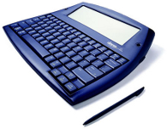
- AT devices or equipment that range in the middle of the continuum may have some complex features, may be electronic or battery operated, may require some training to learn how to use and are more expensive than the low-tech devices. Some examples include:
  - talking spell checkers
  - manual wheelchairs
  - electronic organizers
  - Closed Caption Televisions (CCTV's)
  - amplifiers
  - books on CD
  - environmental control units (ECU)
  - alternate mouse or keyboard for the computer and much more

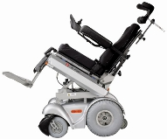
- High Tech AT refers to the most complex devices or equipment, that have digital or electronic components, may be computerized, will likely require training and effort to learn how to use and cost the most. Examples include:
  - power wheelchairs and scooters
  - digital hearing aids
  - computers with specialized software such as voice recognition or magnification software
  - electronic aids to daily living
  - digital hands-free headsets
  - voice activated telephones
  - communication devices with voices
  - bluetooth integration
  - digi-drive technology (operating a vehicle with a joystick)

