Instructions for Imputing Your Information into This News Release:
(See corresponding number images on the screenshot below)
- At top of your screen, click on the “Review” tab.
- Then click on “Restrict Editing”.
- The sidebar will then appear to the right of your document. This feature will enable you to enter your data and remove the highlighted brackets.
- Click on “Find Next Region I Can Edit” and enter your specific information. Continue to click on “Find Next Region I Can Edit” and enter information until all fields designed for your input are complete.
- Once all fields have your data as intended then uncheck the box “Highlight the regions I can edit”. The brackets and highlight are now gone. You can print page 2 if desired.
- Click once again on “Restrict Editing” and the sidebar will go away. You should now have a clean document with your unique information. Save your edited document.

NOTE – If you reopen the saved document, the brackets and highlight will reappear. Follow steps 1, 2 & 5 above to make them disappear.

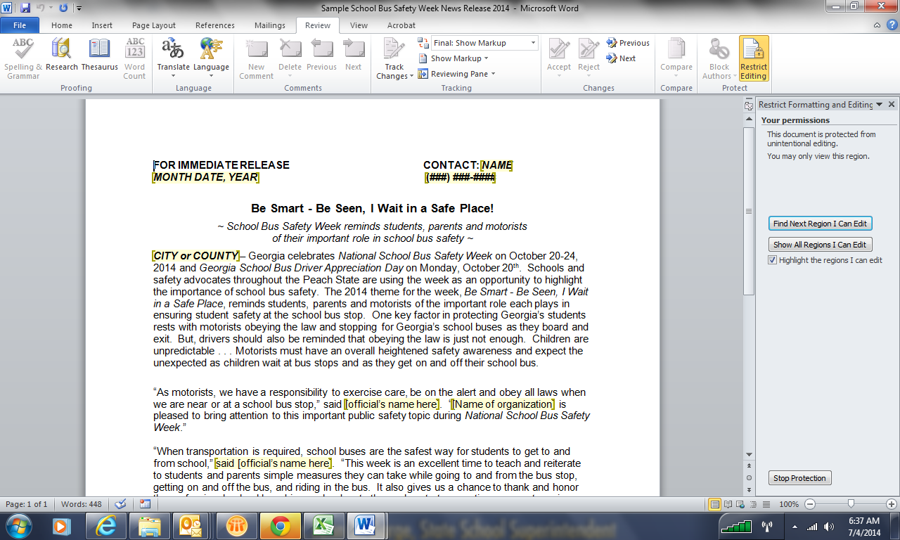
4
1
6
5
3
2
FOR IMMEDIATE RELEASE

Contact – Name
Date – XX/XX/14
Phone – (###) ###-####

Be Smart - Be Seen, I wait in a safe place!
~ School Bus Safety Week reminds students, parents and motorists
of their important role in school bus safety ~
CITY or COUNTY – Georgia celebrates National School Bus Safety Week on October 20-24, 2014 and Georgia School Bus Driver Appreciation Day on Monday, October 20th. Schools and safety advocates throughout the Peach State are using the week as an opportunity to highlight the importance of school bus safety. The 2014 theme for the week, Be Smart - Be Seen, I wait in a safe place, reminds students, parents and motorists of the important role each plays in ensuring student safety at the school bus stop. One key factor in protecting Georgia’s students rests with motorists obeying the law and stopping for Georgia’s school buses as they board and exit. But, drivers should also be reminded that obeying the law is just not enough. Children are unpredictable . . . Motorists must have an overall heightened safety awareness and expect the unexpected as children wait at bus stops and as they get on and off their school bus.

“As motorists, we have a responsibility to exercise care, be on the alert and obey all laws when we are near or at a school bus stop,” said official’s name here. “[Name of organization] is pleased to bring attention to this important public safety topic during National School Bus Safety Week.”

“When transportation is required, school buses are the safest way for students to get to and from school,” said Mr. or Ms. official’s last name here. “This week is an excellent time to teach and reiterate to students and parents simple measures they can take while going to and from the bus stop, getting on and off the bus, and riding in the bus. It also gives us a chance to thank and honor the professional school bus drivers who devote themselves to transporting our most precious cargo.”

For years, school buses have provided safe access to learning for Georgia’s school children through secure and dependable transportation to schools. The safety of the yellow school bus is unparalleled by any other means of automotive transportation. School buses are equipped with more safety features than any other vehicle and are required to meet numerous safety specifications, including state and federal requirements. In addition, all public school bus operators receive rigorous, specialized training on a variety of topics before they can take the wheel behind the big yellow bus.

More than one million students ride the school bus in Georgia twice each day, with more than 26 million school children transported in 480,000 school buses nationwide.

