Directions for Using the Reports Feature
in the ConApp for Title I Budget

Directions for downloading Title I budget into Excel:
- Login to Portal
- Select Consolidated Application/Reports/Reports
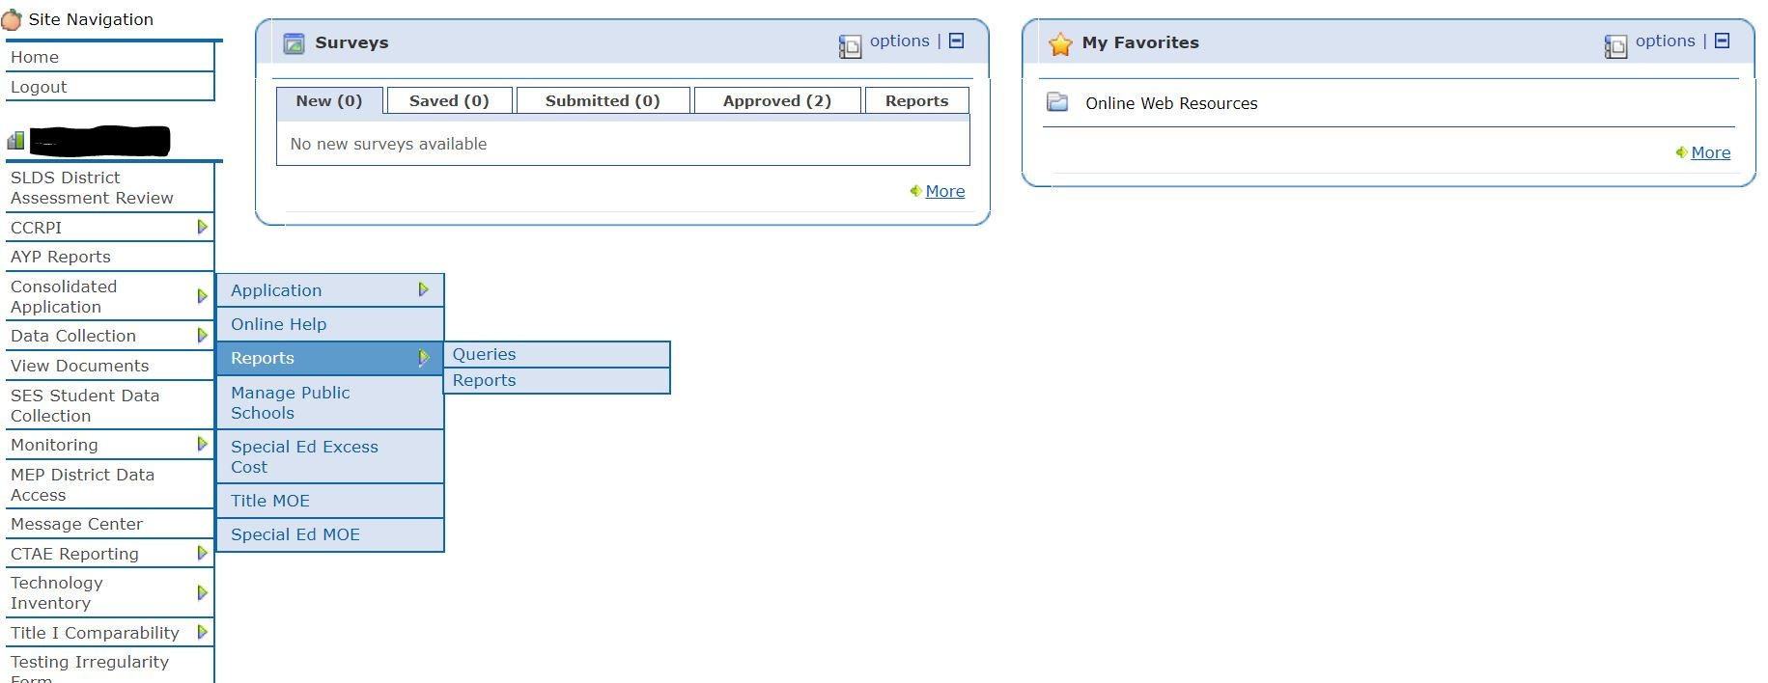
- Drop Down Menu-Report Category/Budget Reports and Report Name/Budget Export to Excel 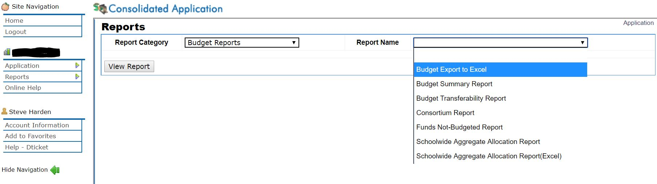
- Select Fiscal Year/Program-Title I-A, Improving the Academic Achievement-Original or Current Budget Amendment/Select View Report
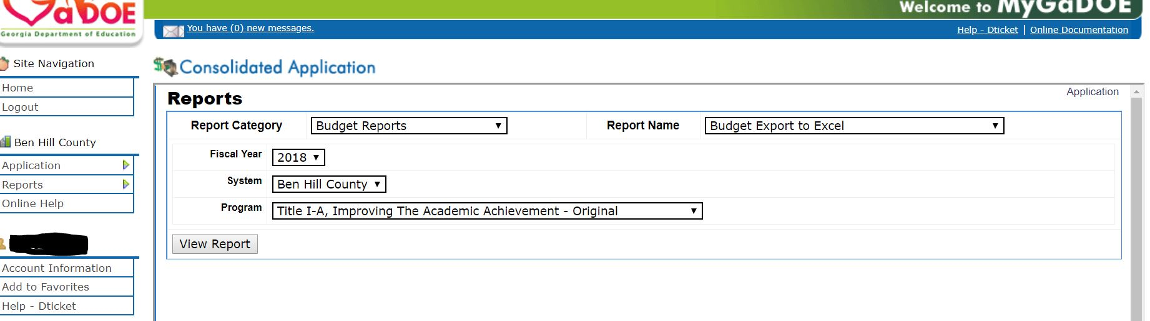

- Budget Downloads into an Excel File-Bottom Left Corner of Screen-Click to Open Excel Document
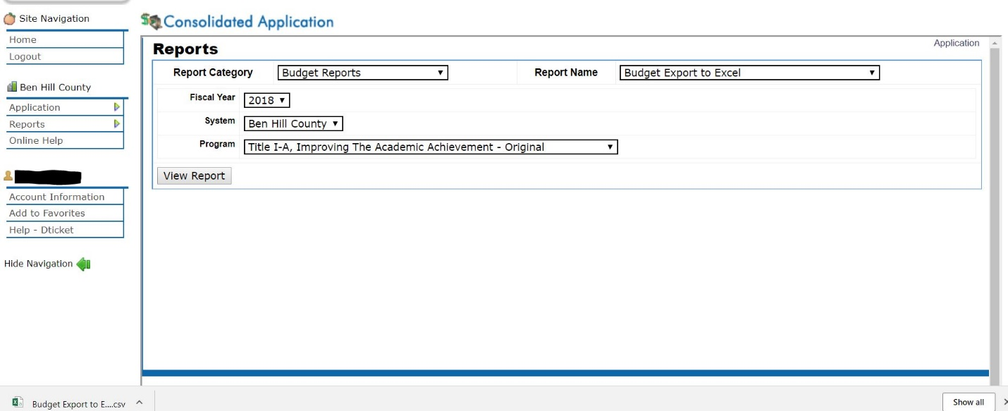

- When the Excel document opens, save the file as an Excel Worksheet not as a CSV file.
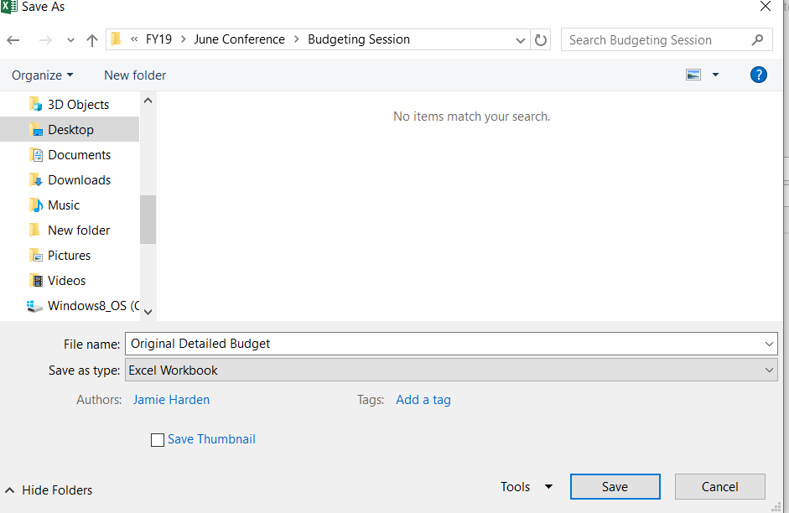

The following steps can be used to sort the data by school/set asides:
- Select the Sort & Filter Tab/Select Custom Sort
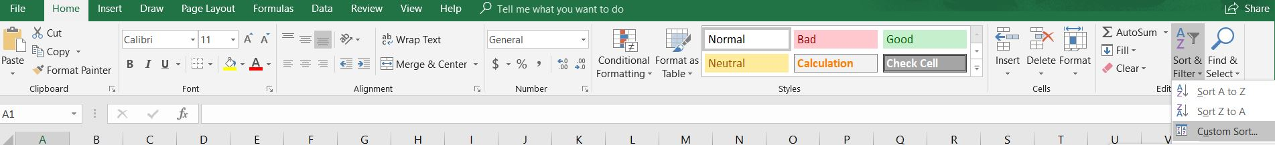

- Sort by School/Select Add Level/Then by Function/Select Add Level/Then by Object/Select Add Level/Then by Description/Click Ok

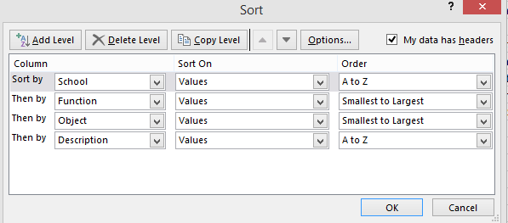

- Spreadsheet has been sorted based on the criteria in Step 2. This will be the entire Title I Budget.

- At this point, check each school’s allocation to ensure the detailed budget matches the school allocation tab.

- Click and highlight the cells under the “Amount” column for each school. The amount budgeted to the school in the detailed budget can be found at the bottom of the spreadsheet.

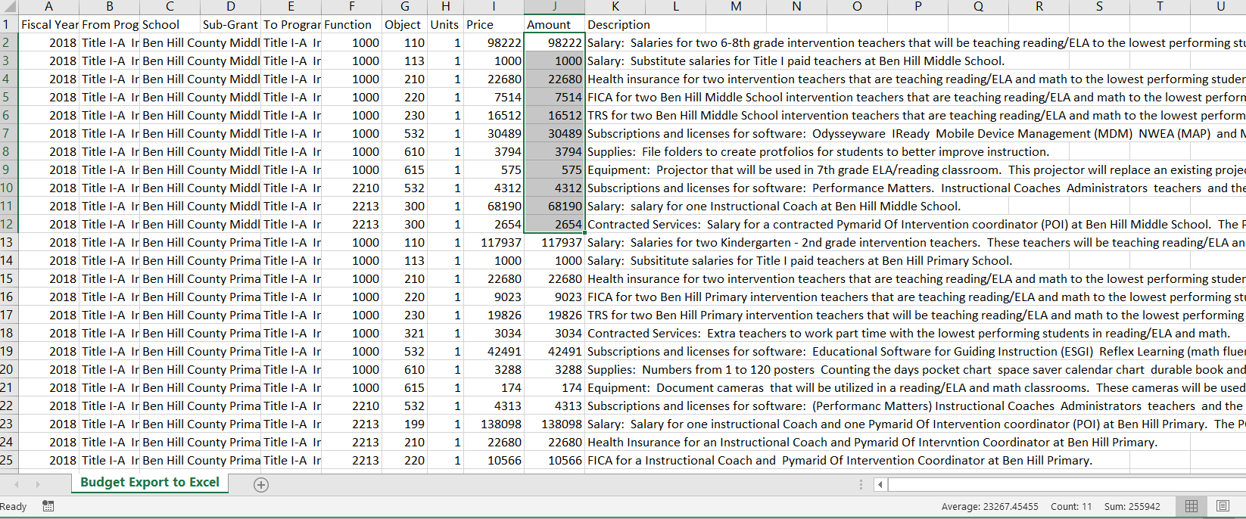
The sum of the highlighted cells.

- Set Asides can be checked the same way. Set asides will be sorted by School Column under the title Title I-A Improving the Academic Achievement, Function, Object, and Description. If you used the same beginning phrase for each of the set asides (Example: Administrative Set Aside or Required Parent Engagement Set Aside), the spreadsheet will be sorted with same phrases in the description together. Follow directions included in Step 5. This is helpful when checking the amounts on the set asides tab to the amounts in the detailed budget.
The following directions can be used to filter the data from the detailed budget:
- Download the detailed budget into an excel document (Use the steps provided above)

- Click Sort & Filter Button/Select Filter

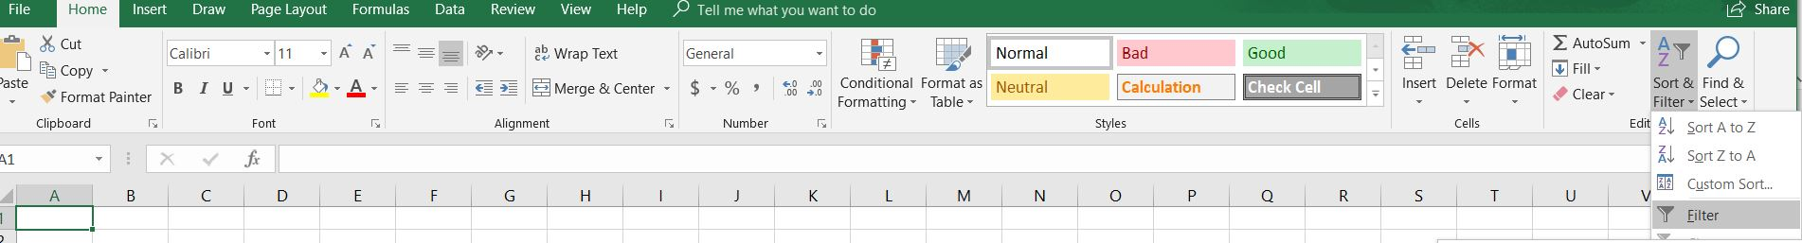

- Once the Filter has been activated, the column headers will have drop-down buttons. Using these buttons, you can set your filter options.

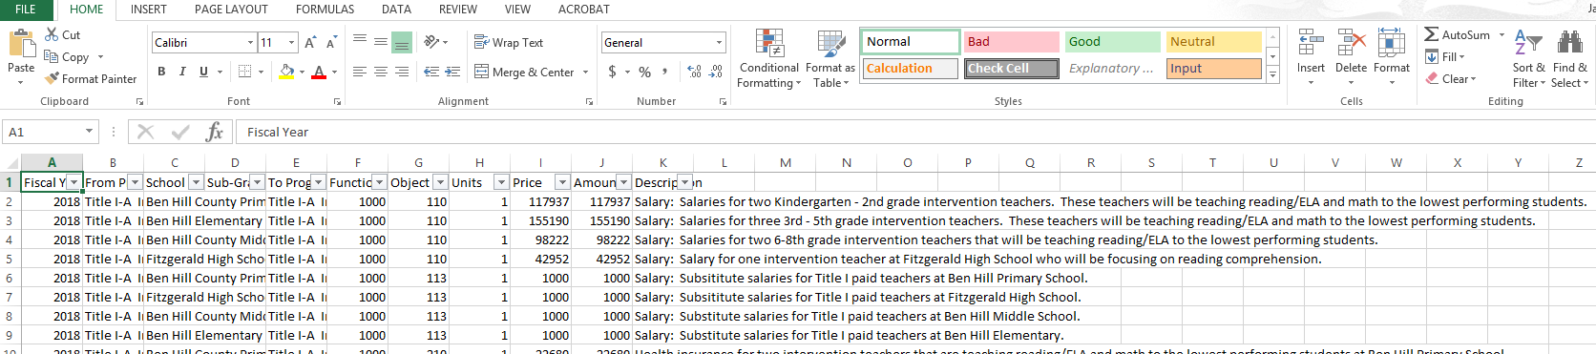

- The filter menu appears.
- Uncheck the boxes next to the data you don’t want to view or uncheck the box next to Select All to quickly uncheck all.
- Check the box next to the school you want to view.

- Click Ok. All other schools will be filtered, or temporarily hidden. Only the school selected will be visible.
- Ben Hill Middle School was the only school selected. The other schools are hidden.
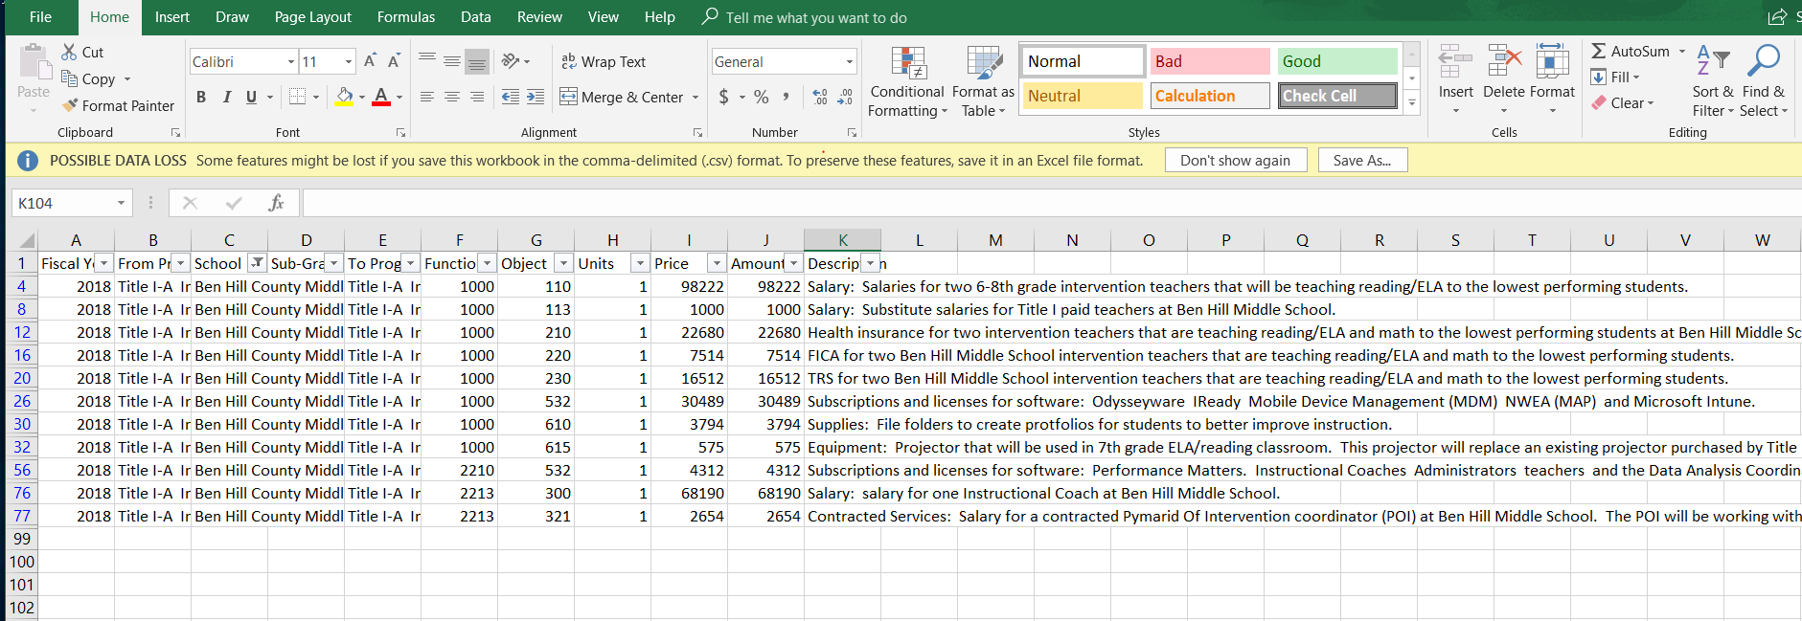
- Click and highlight the cells under the “Amount” column for filtered school. The amount budgeted to the school in the detailed budget can be found at the bottom of the spreadsheet. This total should match the school’s allocation on the school allocation tab.

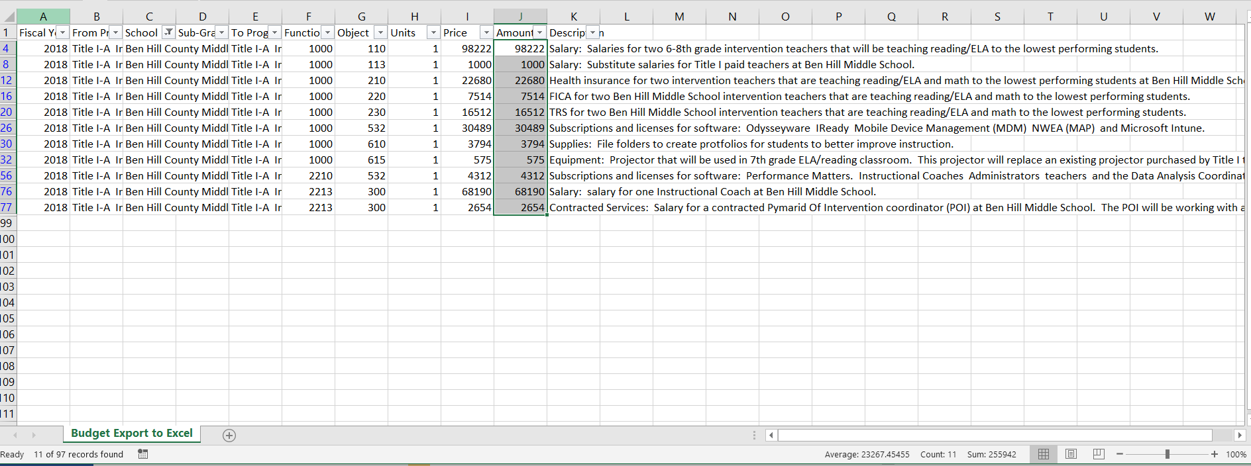

- Another way to check the total of a column is to use the Auto Sum feature. Highlight all the cells under the “Amount” column and select AutoSum. The “total” for all the highlighted cells will appear in the last cell.
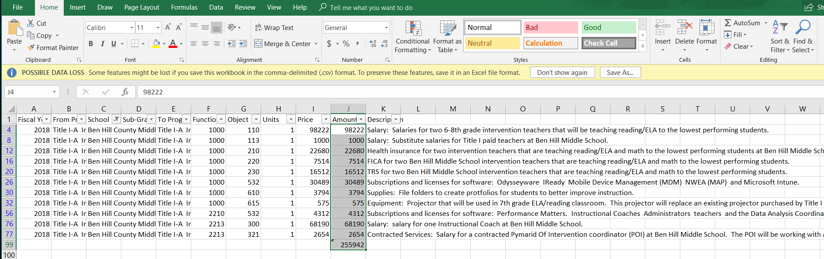

- Back to filtering the schools, select the filter option under the school column. Unselect the previous school and select the next school on the list. The data will be filtered to include only the data for the selected school. Select the first cell under the “Amount” column and highlight the cells. The amount budgeted to the school in the detailed budget can be found at the bottom of the spreadsheet. Continue this process until all school allocations have been checked.
Set Asides

Next Steps: Tracking Budget Amendment-How to add a column for your amendment.
- Download a copy of the district’s budget using steps 1-6. Sort the spreadsheet by school.
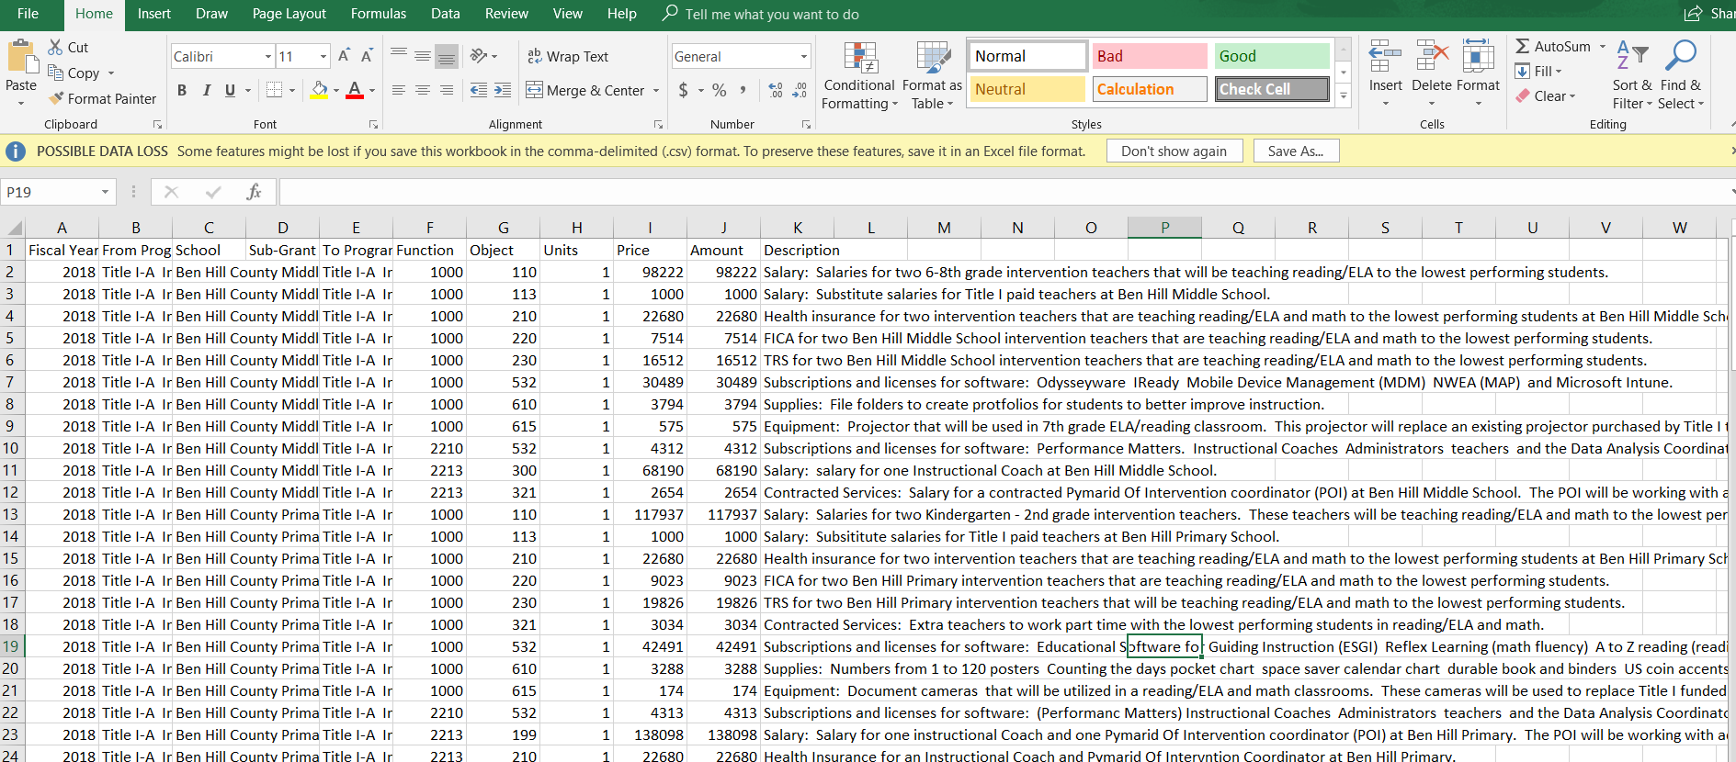

- Click column K. All cells in Column K will be highlighted. Right click on Column K and select Insert.
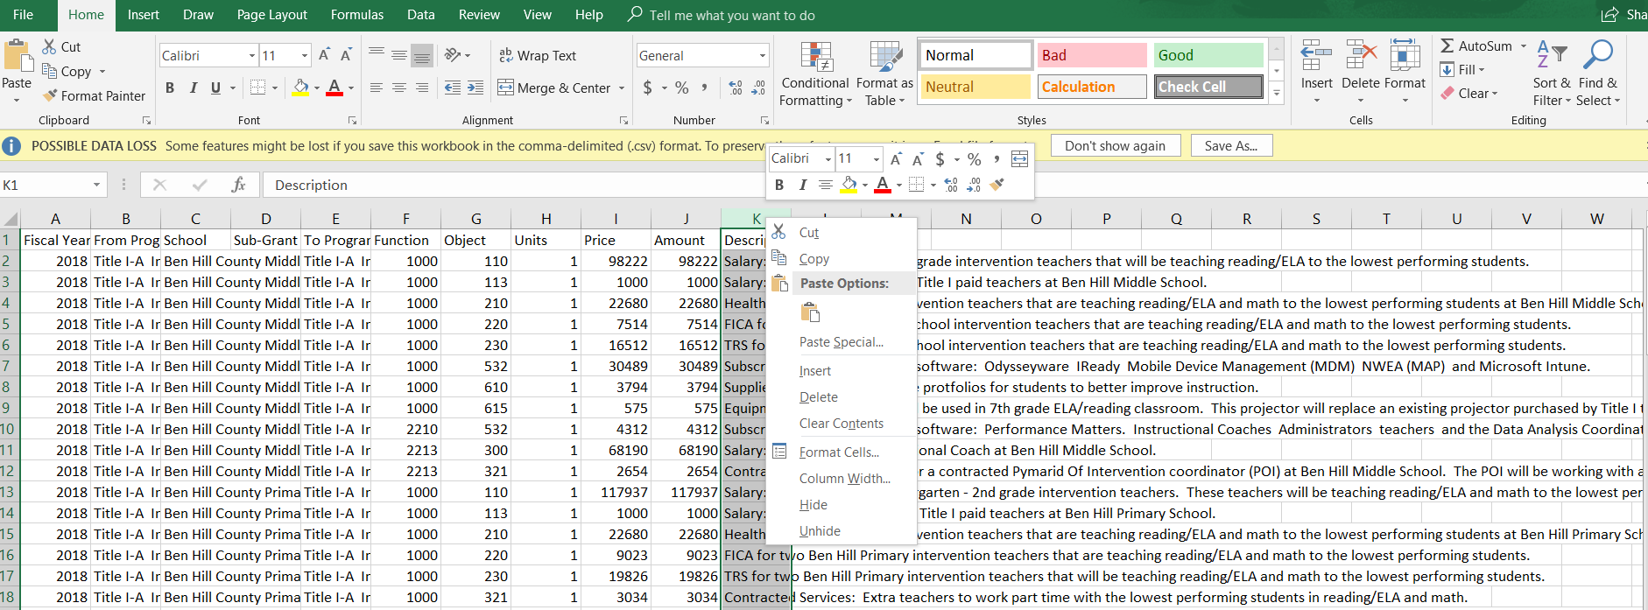

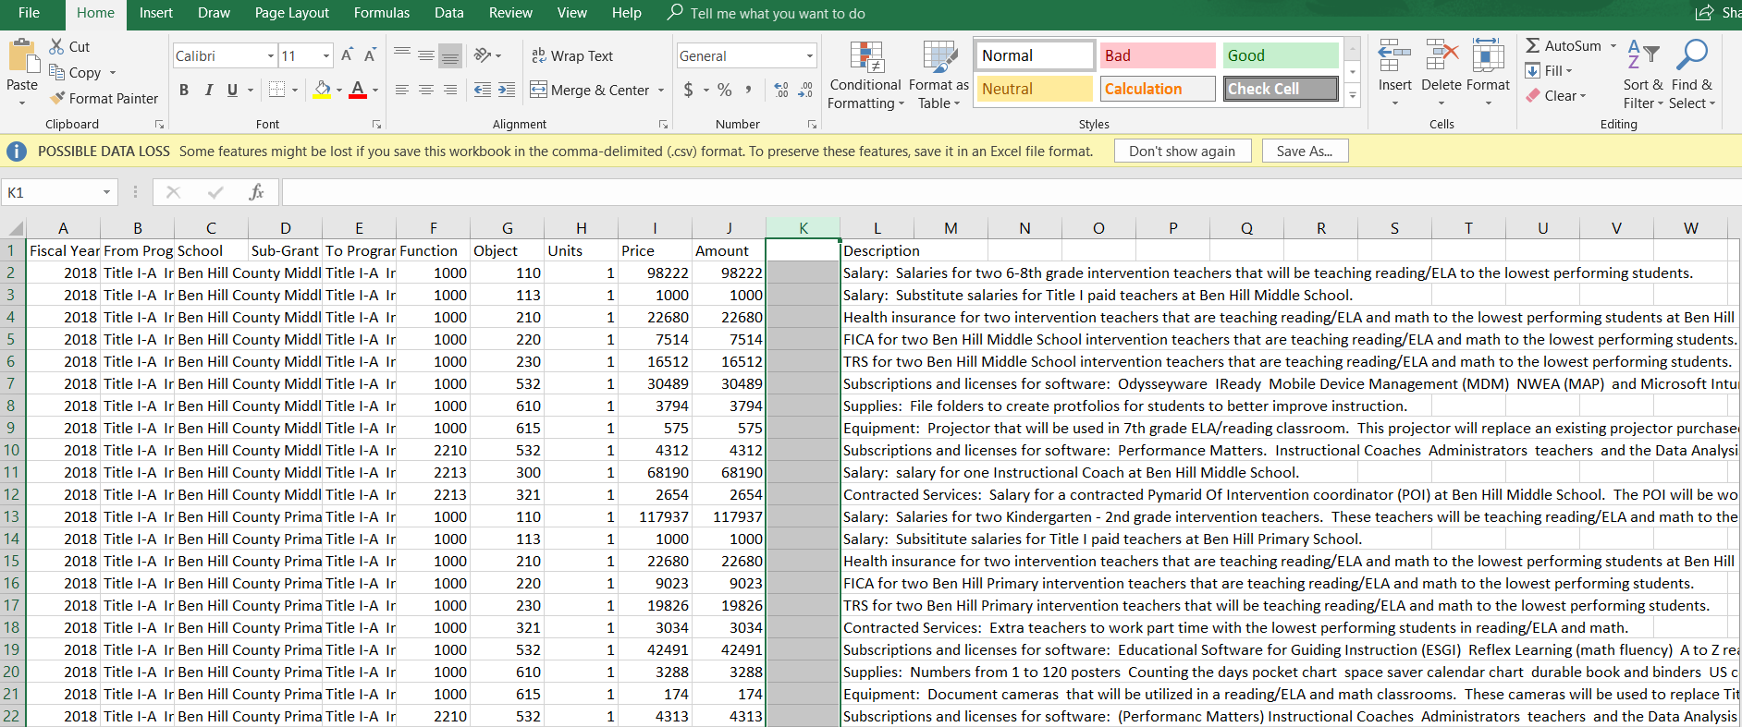
- A column has been inserted into the spreadsheet.

- Name column K “Change” or “Amendment #1” or “Amendment #2”

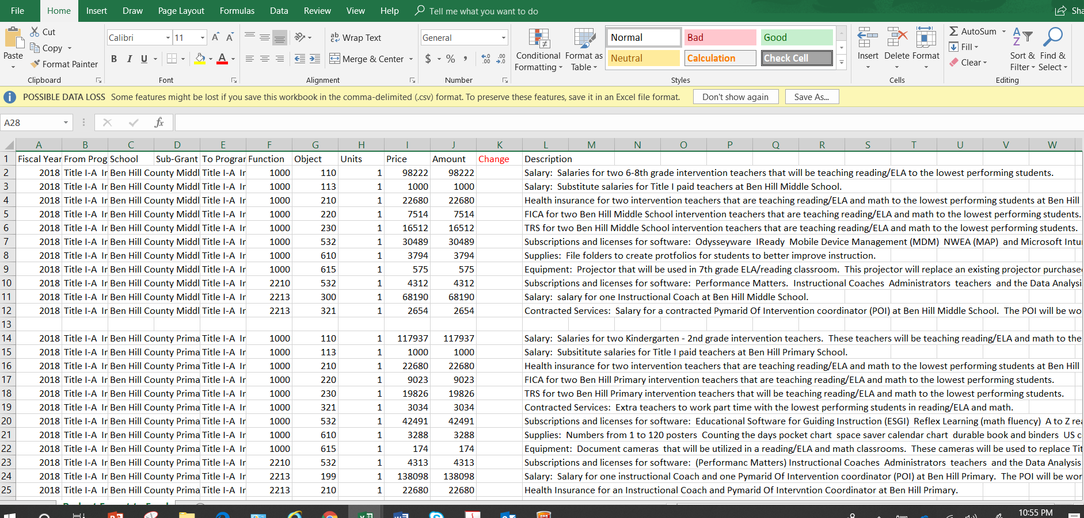

- Any changes to the school’s budget can be changed to the spreadsheet prior to making the changes in the ConApp. Using this method is an easy way to track any changes to the budget.

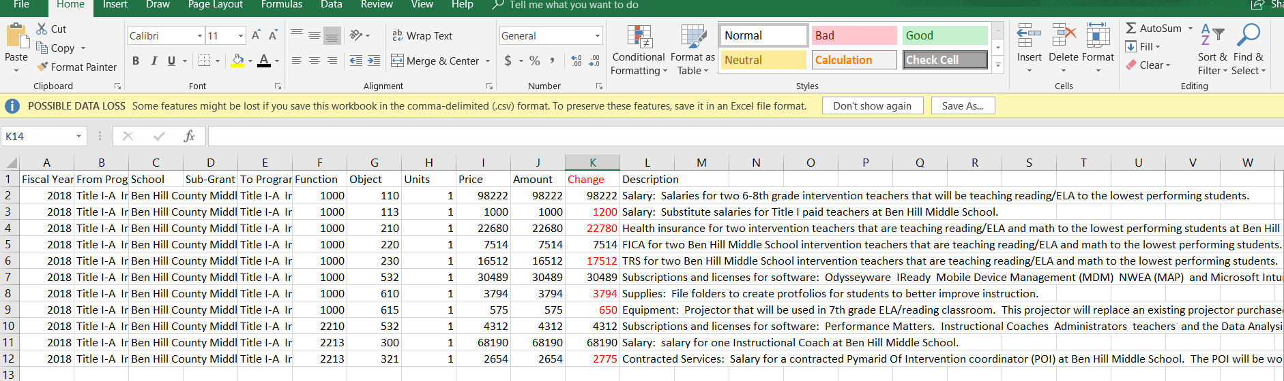

It helps to make the font red to indicate any changes in the budget. Once the changes have been completed in the ConApp, download a new spreadsheet to check the totals on the School Allocation Tab with the detailed budget.
This spreadsheet can be sent to the Area Specialist to highlight changes in the budget amendment to expedite the approval process.

Pivot Table Instructions
Below are instructions for converting a Title I budget that is in an Excel format into a Pivot Table. Pivot Tables can make it easier to check budget totals if set up correctly.
Convert a Title I Budget to an Excel spreadsheet (see page 1).
Click the Insert tab.

Click the Pivot Table tab (far left on the tool bar)
- Popup screen “Create Pivot Table” will appear – Click “OK”

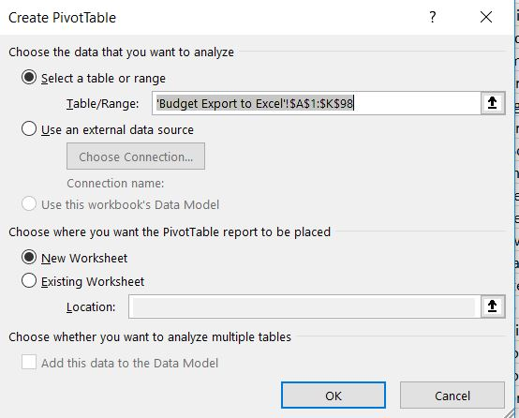

Right side of the Pivot Table screen you will see “Pivot Table Fields”
- Move “School” to the “Rows” box
  - Left click “School” and hold down
  - While holding down, move “School” to the “Rows” box and release left click
- Move “Amount” to “Values” box (to move, follow the directions stated for moving “School” above)
  - This should display each school’s total allocation
  - The “blank” amount should be the total Set-Aside amount
- Move “Function” into the “Columns” box
- Move “Object” into the “Columns” box
  - This should display the totals for each function and object code
  - The “(blank)” line item represents the LEA’s Set Aside amounts by function/object codes

