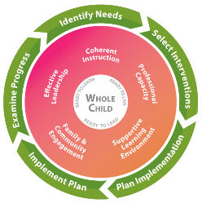
FY20 Cross-Functional Monitoring
Indicator: Notice to Parents of English Learners (ELs)
Participating in Supplemental English Language Supports

Optional Checklist

School System: ____________________________________________________________________

- Total number of EL students in your school system __________ or check here if the number of ELs is fewer than 15

- Did your school system receive a Title III, Part A subgrant for the current fiscal year?

Yes, funding source is Direct Allocation
Yes, LEA Regional Consortium
No

- Is your school system participating in the Consolidation of Funds initiative?

Yes, these federal funds are being consolidated: _____________________________________
No

- Is your school system using Title I, Part A and/or Title III, Part A funds to supplement the English to Speakers of Other Languages (ESOL) program for ELs who could benefit from additional English Language Development (ELD) support?

Yes. (Please ensure that your school system is notifying parents of ELs who are receiving supplemental EL language support in addition to the ESOL language program. Visit the Parents of ELs webpage for a sample notification in multiple languages.)

No. (Please write a rationale below why Title I, Part A and/or Title III, Part A funds were not used for supplemental EL language support, or check the box(es) that apply.)

- Based on data, ELs are making English language proficiency progress and do not need supplemental support in addition to the ESOL language program.
- There is a need; however, the District Improvement Planning process identified a higher priority.
- The school system is using local / state funds to assist ELs.
- The ELs identified in need of support are enrolled in non-Title I schools.
- Other reasons: (Please note that school systems participating in the Consolidation of Funds Initiative are not exempt from notifying parents.)

_________________________________________________________________________
_________________________________________________________________________

