
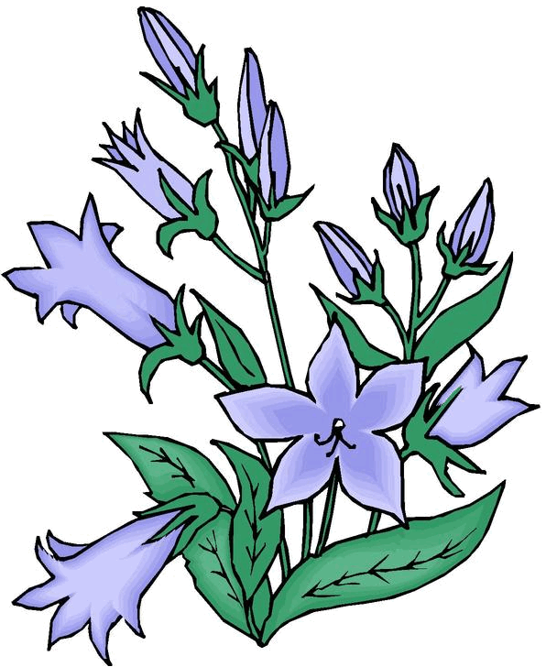

Volume (Click to change text) (Name) School April 2012

The winner of the 2011-12 Georgia Peach Award for Teen Readers is:

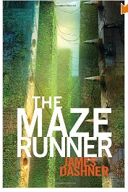
The Maze Runner by James Dasher
Boys come to the Glade via an empty freight elevator with no memory of how they got there or of their prior lives. This disorientation is made more frightening when they realize that to survive they must lock themselves in every night to avoid the horrors of the Grievers, beings that are part machine, part animal—and altogether deadly. The boys in the Glade send out Runners each day to find a way out through the Maze that surrounds their one patch of safety, with no success. Life goes on until one day the elevator delivers a girl. She brings a message: She is the last child to be sent, and there will be no more deliveries of food or supplies. Now the Glade is cut off, and as the Grievers gather for an all-out attack it's clear that it's now or never—the Maze must be solved. From Kirkus

Writing Contests for Teens
AASL and Figment.com, a free online community for teens to create, discover, and share new reading and writing, celebrate School Library Month by presenting four writing contests for teens. In honor of this year's theme "Create Your Own Story," Figment invites students 13 and up to participate in story writing contests to be judged by some of the YA literature's most exciting authors - Alyson Noel, Lauren Oliver, Paolo Bacigalupi, and Gayle Forman.
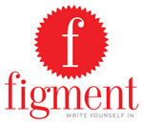Each week in April a new contest prompt in a different genre of creative fiction will be announced. Figment users will vote to select the finalists and then that week's guest author judge will select the winner. Winners of each weekly contest will receive autographed books from that week's judge and one grand prize winner will receive a Kindle. All finalists and winners will be featured on the Figment and AASL websites

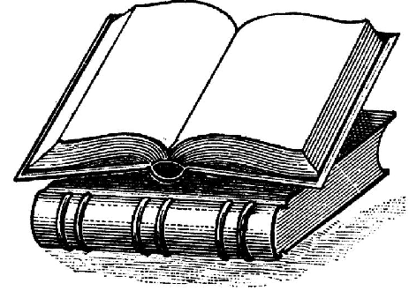

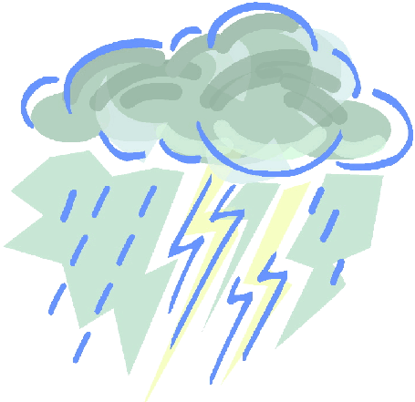
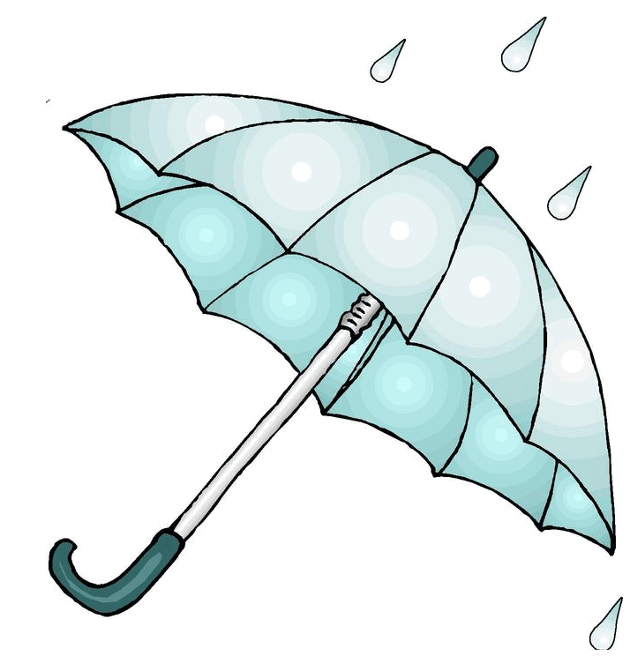

Literary Birthdays:

Washington Irving ……….. April 3

Maya Angelou ..……………... April 4

Booker T. Washington …….. April 5

Gary Soto ……………………April 12

Thomas Jefferson ……….…..April 13

Eudora Welty..……………… April 13

Henry James ……………… April 15

Thornton Wilder …………… April 17

Charlotte Bronte ……………. April 21

Henry Fielding April 22

William Shakespeare ………. April 23

Robert Penn Warren April 24
Harper Lee ……………. …April 28


l

Have you tried?

