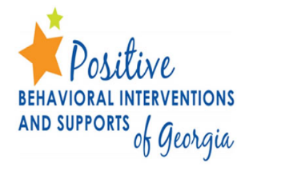 | Georgia Department of Education  Early Learning Tier I PBIS  Systems of Support  TFI Action Plan Guiding Questions

TFI Feature: 1.7 Professional Development
Question 1 | Who will train staff and students on revised Tier I SW-PBIS Early Learning Systems of Supports?  - Behavior Flow Chart  - Minor Office Discipline Referral Form  - Behavior Definitions  - Acknowledgement System  - Behavior Expectation Matrix  - Communication Plan)?
Question 2 | How will the training be redelivered?  - Staff: Teachers grade level planning period, Pre or Post Planning, Staff Meetings, etc.  - Students: Students school-wide assembly, PBIS Kick-off, etc.
Question 3 | When will the training take place (location, date & time)?  - Staff  - Students

