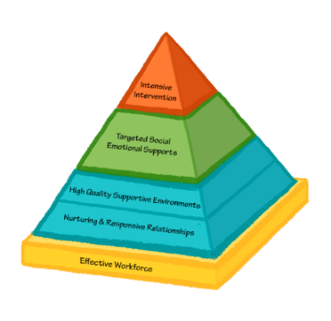**OBJECTIVES:**

* Understand the meaning of self-regulation
* Understand how children and adults react and respond in the

different states of the brain

* Understand the importance of teaching children how to self-regulate
* Learn strategies for helping children self-regulate

National Center for Pyramid Model Innovations <https://challengingbehavior.cbcs.usf.edu/>

|  |  |
| --- | --- |
| Self-Regulation | Self-Composure |
| Self-Regulation is the ability to control impulses, manage emotional upset, and exercise self-discipline. | Self-Composure is the process of moving yourself from the lower centers of your brain to the higher centers of your brain so you can teach and model appropriate behavior. |

**How do you self regulate?**

**____________________________________________________________________________**

**____________________________________________________________________________**

**____________________________________________________________________________**

|  |
| --- |
| Understanding the Brain |

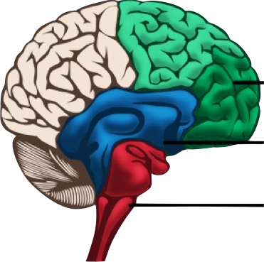

**The Brain**

**Executive State**

* Survival State - primitive part of the brain that

controls our breathing

**Emotional State**

* Emotional State - the feelings part of our brain
* Executive State - the thinking brain, our CEO,

**Survival State**

our executive function

|  |  |  |  |
| --- | --- | --- | --- |
| Understanding the Brain | | | |
|  | **Characteristics** | **Behaviors** | **Reaction/ Response** |
| Survival State | * Defend or Attack * Fight or Flight * Irrational * Illogical | * Hitting * Kicking * Throwing * Pushing * Biting * Withdrawing * Running away | Teach and reassure safety.  Encourage deep, calming *breathes*. |
| Emotional State | * “Feelings” * Memory * Learning * Motivation | * Whining * Pouting * Complaining * Name-calling * Blaming * Judging | Provide empathy and understanding. |
| Executive State | * Thinking brain * Attention * Learning * Creates options * Make choices * Most rational and logical | * Considers options * Problem solving * Seeks help * Asks questions * Emotional & behavioral control | How we respondto children will either move them up to the higher centers of the brain or to the lower centers of our brain. |

|  |  |
| --- | --- |
| Teachable Moments | |
|  | This curve represents an emotional situation for a child. The green arrows represent the executive state of the brain when a child is engaged without any emotional conflict or dysregulation. The blue arrow represents the beginning of movement to the emotional state of the brain. The purple represents further. The red arrow represents the height of emotional dysregulation. |

**The Marshmallow Experiment**

In the 1960s, Psychologists Walter Mischel and Ebbe Ebbesen at Stanford University carried out this Marshmallow Experiment. Only 1/3 of 600 children managed to wait the full 15 minutes to get the second marshmallow in their experiment. The same children were studied later in life. Those children that were able to wait longer for a second marshmallow did better in school, achieved more, and were physically healthier. What we should learn from this, is most students are not able to self manage naturally. Instead of expecting children to magically acquire self control, we must model and teach it to them. “

**Anger Management**

* All emotions are okay.
* Anger can interfere with playing and learning.
* Recognize anger in self and others.
* Learn how to calm down.
* Understand appropriate ways to express anger.

_______________________________________________________

_______________________________________________________

_______________________________________________________

_______________________________________________________

_______________________________________________________

**Anger Management Materials and Activities**

* Children’s Books – SEEDS for Story Time <http://www.decal.ga.gov/InstructionalSupports/Seeds.aspx>
* Visuals Posted
* Scripted Stories
* Social Stories
* Breathing Techniques
* Games
* Takeaway
* Takeaway

______________________________________________________

______________________________________________________

______________________________________________________

______________________________________________________

______________________________________________________

**Problem Solving**

* Model and label problem solving steps within interactions between children across the day.
* Prompt children to try other solutions if their first solution does not work.
* Post visual reminders about the problem-solving steps and solutions
* Prompt children to generate solutions to common social problems.
* Provide positive descriptive acknowledgement to children using problem solving skills.

____________________________________________________

____________________________________________________

____________________________________________________

____________________________________________________

____________________________________________________

**Activity**

|  |  |  |  |
| --- | --- | --- | --- |
| **Step 1 – What is my problem?** | **Step 2 – What are some solutions?** | **Step 3 – What would happen next?** | **Step 4 – Try the solution.** |
| Request Paintbrush |  |  |  |
| Table Space |  |  |  |
| Broken Paintbrush |  |  |  |
| Ice Cream |  |  |  |

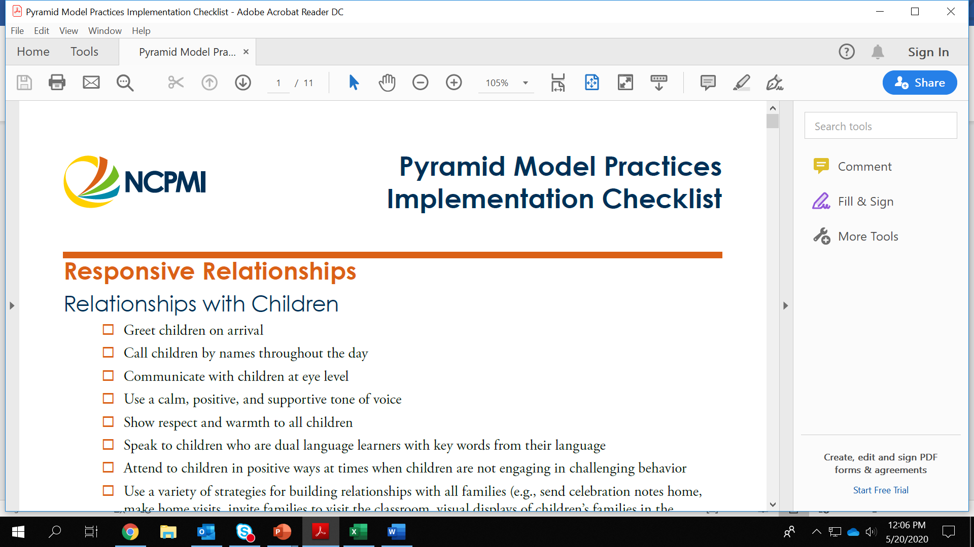IMPLEMENTATION CHECKLIST SELF-REGULATION AND ANGER MANAGEMENT

Teach children that all emotions are okay, provide examples of how to appropriately express their

emotions

Teach children to use a variety of strategies to calm down when they are angry or upset

Model and label your own emotions and provide action statements to model how you appropriately

react to and express the emotions

Help children recognize cues of emotional escalation in themselves

Guide children in strategies to calm down when they are feeling angry or upset

Provide positive descriptive acknowledgement on occasions when children state they are feeling

upset or angry but are remaining calm or using self-regulation strategies

PROBLEM SOLVING

Teach children to name and use a variety of solutions

Specifically teach the steps for solving problems

Prompt children to generate solutions to common social problems

“Problematizes” situations throughout the day to allow children opportunities to generate solutions

Post visual reminders about the problem-solving steps and solutions

Prompt children to try other solutions until the situation is appropriately resolved

Model and label problem solving steps within interactions between children across the day

Acknowledge and give specific positive descriptive acknowledgement to children using problem

solving skills

Prompt children to reflect on their own problem-solving efforts

Notes and Ideas: