Print on school district letter head.

Title I, Part C – Education of Migratory Children
Program Evaluation Summary

Created by the Enter district here School District

YYYY-YYYY School Year

Date: Enter date here

Background Information

The Title I, Part C – Education of Migratory Children is a federally funded program designed to support comprehensive educational programs for migratory children to help reduce the educational disruption and other problems that result from repeated moves. Each year, school districts receiving MEP allocations must identify the special educational needs of migratory children and youth and determine the specific services that will help migratory children achieve the State’s measurable outcomes and performance targets. Through the Georgia MEP Continuous Improvement Cycle, districts analyze migrant student performance on local assessments, state assessments, and within the current MEP funded services. This annual review supports each district with the identification of the needs of migratory children and youth, the prioritization of those needs, and the design of services to address those needs through MEP funded support or coordination of services with other programs, agencies, and organizations. During this entire process, the needs of Priority for Services (PFS) students are addressed first.
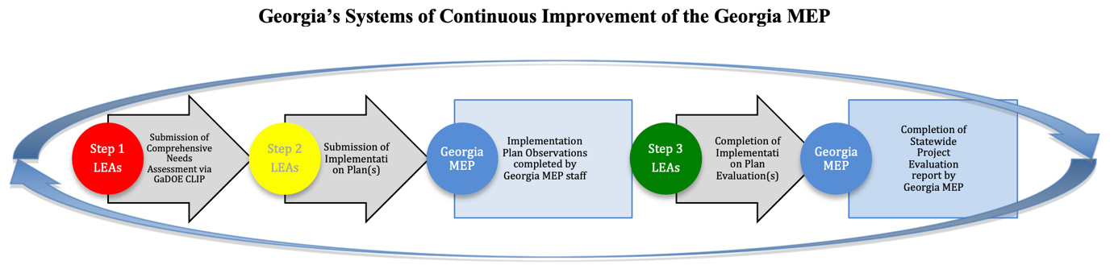
During the most current statewide Comprehensive Needs Assessment conducted in Georgia, the following measurable program outcomes (MPO) were identified in the resulting Service Delivery Plan. School district plans are directly connected to these MPOs:
MPO #1: The Georgia Migrant Education Program will improve school readiness by providing developmentally appropriate at-home or facility-based projects focused on early literacy and mathematics. Improvement will be measured by district-level implementation plans (IP) showing an incremental 5%-point growth/improvement for students served during the academic year and summer.
MPO #2: The Georgia Migrant Education Program will provide OSY and DO projects and services at the individual and group level based on needs outlined in the OSY and DO profile. Progress will be measured by district-level implementation plans (IP) showing an incremental 5%-point growth/improvement for OSY and DO served during the academic year and summer.
MPO #3: Migratory students in elementary, middle and high school will meet or exceed proficiency in Reading within the framework of the Georgia Standards of Excellence (GSE) for Reading as measured by district-level implementation plans (IP) showing an incremental 5%-point growth/improvement for students served during the academic year and summer.
MPO #4: Migratory students in elementary, middle and high school will meet or exceed proficiency in Writing within the framework of the Georgia Standards of Excellence (GSE) for Writing as measured by district-level implementation plans (IP) showing an incremental 5% point growth/improvement for students served during the academic year and summer.
MPO #5: Migratory students in elementary, middle and high school will meet or exceed proficiency in Mathematics within the framework of the Georgia Standards of Excellence (GSE) for Mathematics as measured by district-level implementation plans (IP) showing an incremental 5%-point growth/improvement for students served during the academic year and summer.

Program Evaluation Summary
During the YYYY-YYYY school year, the following needs were identified for migratory children and youth in our district:

During the YYYY-YYYY school year, the following Implementation Plans were implemented to support K-12 migrant students in our district:
Name of Plan | Grade Level Age Group | Number of PFS Children Served | Number of PFS children or youth on track and/or meeting or exceeding the projected outcome of the plan | Number of Non-PFS children or youth served | Number of Non-PFS children or youth on track and/or meeting or exceeding the projected outcome of the plan
During the YYYY-YYYY school year, the following Implementation Plans were implemented to support migrant preschool children, out-of-school youth, and drop-outs:
Name of Plan | Total Number of Participants | Number of PFS Children Served | Number of PFS children or youth on track and/or meeting or exceeding the projected outcome of the plan | Number of Non-PFS children or youth served | Number of Non-PFS children or youth on track and/or meeting or exceeding the projected outcome of the plan
The following data is a summary of migratory children and youth’s performance on the most recent local assessments (benchmarks, final exams, unit tests, MEP Pre/Post assessments, etc.):

Name of Local Assessment | Date | Grade Level | Number of PFS Students Not Meeting Expectation | Number of PFS Students on track and/or Meeting or Exceeding Expectation | Number of Non-PFS Students Not Meeting Expectation | Number of Non-PFS Students on track and/or Meeting or Exceeding Expectation | % of Migrant Students on track and/or Meeting or Exceeding Expectation | % of Non-Migrant Students on track and/or Meeting or Exceeding Expectation
 | Enter date
 | Enter date
 | Enter date
 | Enter date
 | Enter date
 | Enter date
 | Enter date
 | Enter date
 | Enter date
 | Enter date
 | Enter date

The following data is a summary of migratory children and youth’s performance on the most recent State assessments:
Name of State Assessment | Date | Grade Level | Number of PFS Students Not Meeting Expectation | Number of PFS Students on track and/or Meeting or Exceeding Expectation | Number of Non-PFS Students Not Meeting Expectation | Number of Non-PFS Students on track and/or Meeting or Exceeding Expectation | % of Migrant Students on track and/or Meeting or Exceeding Expectation | % of Non-Migrant Students on track and/or Meeting or Exceeding Expectation
 | Enter date
 | Enter date
 | Enter date
 | Enter date
 | Enter date
 | Enter date
 | Enter date
 | Enter date
 | Enter date
 | Enter date
 | Enter date

The following is a summary of current migrant student’s classroom performance (% of students with a C or higher on the most recent report card):

PFS | 1st | 2nd | 3rd | 4th | 5th | 6th | 7th | 8th | 9th | 10th | 11th | 12th
Reading/ELA
Mathematics
Non-PFS
Reading/ELA
Mathematics

Written Evaluation Summary
Characteristics of MEP Children and Youth in the District
This is where the district provides/reports what they know about the unique special academic needs of the MEP participants in the district. Include the needs of preschool children and out-of-school youth/drop-outs in addition to K-12 students.
ENTER YOUR NARRATIVE HERE

Review of Implementation Plans and Observations of the Plans
This is where the district presents the progress of the current/previous implementation plans, the fidelity of implementation of the plans, and any results or revisions that resulted from the observations.
ENTER YOUR NARRATIVE HERE

Review of Support Services Provided to MEP Children and Youth
This is where the district reviews the types of support services that have been provided to MEP participants.
ENTER YOUR NARRATIVE HERE

Review of Summary Data from Program Evaluation and other Local Data
This is where the district reviews the data from the Program Evaluation, teacher anecdotal notes, and Implementation Plan evaluations.
ENTER YOUR NARRATIVE HERE

Review of Parent Feedback
This is where the district reviews parent suggestions and feedback from PAC meetings during the year in addition to suggestions and feedback from the parents on this CNA Team.
ENTER YOUR NARRATIVE HERE

